# 01 / Azure PostgreSQL Developer Guide

Welcome to THE comprehensive guide to developing [PostgreSQL](https://www.postgresql.org/)-based applications on [Microsoft Azure](https://portal.azure.com/)! Whether creating a production application or improving an existing enterprise system, this guide will take developers and architects through the fundamentals of PostgreSQL application development to more advanced architecture and design. From beginning to end, it is a content journey designed to help ensure current or future PostgreSQL systems are performing at their best even as their usage grows and expands.

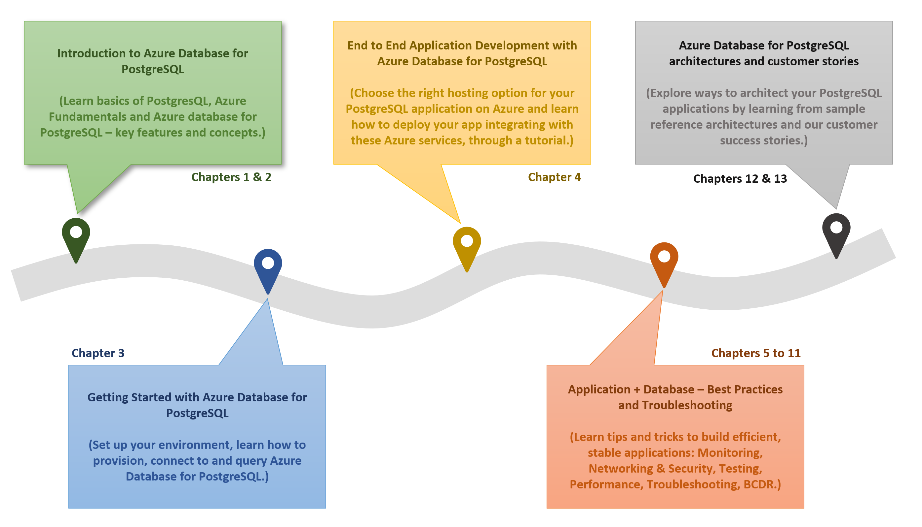

The diagram shows the progression of development evolution in the guide.

The topics and flow contained in this guide cover the advantages of migrating to or leveraging various simple to use, valuable Azure cloud services in PostgreSQL architectures. Be prepared to learn how easy and quick it is to create applications backed by [Azure Database for PostgreSQL Flexible Server](https://learn.microsoft.com/azure/postgresql/flexible-server/overview). In addition to building customized services, developers will also be able to leverage the vast number of value-add services available in the [Azure Marketplace](https://azuremarketplace.microsoft.com/marketplace/). Throughout this developer journey, strive to leverage the vast number of resources presented rather than going at it alone!

Because every company and project is unique, this guide provides insightful service descriptions and tool comparisons to allow the reader to make choices that fit their environment, system, and budget needs. Proven industry architecture examples provide best practice jumpstarts allowing for solid architecture foundations and addressing potential compliance needs.

Development teams will understand best practices and efficient architecture and security practices – avoiding the problems and costs of poor design. Teams will gain the knowledge to automate builds, package, test, and deliver applications based on PostgreSQL to various hosting environments. By leveraging continuous integration and deployment (CI/CD), costs related to manual deployment tasks can be reduced or completely removed.

Many steps in the application lifecycle go beyond simply building and deploying an application. This guide will cover how easy it is to monitor system uptime and performance in the various Azure services. Administrators will appreciate the realistic and straightforward troubleshooting tips that help keep downtime to a minimum and users happy.

The ultimate goal is to successfully deploy a stable, performant PostgreSQL application running securely in Microsoft Azure using cloud best practices. Let’s start the journey!

# 02 / Introduction to Azure Database for PostgreSQL Flexible Server

Before jumping into Azure Database for PostgreSQL Flexible Server, it is important to understand some PostgreSQL history. Also, it is important to cover the various PostgreSQL hosting options and their pros and cons. As part of this guide, we will cover Artificial Intelligence (AI) and how Azure Database for PostgreSQL Flexible Server plays in this exciting space.

## What is PostgreSQL?

[PostgreSQL](https://www.postgresql.org/) is an open source object-relational database management system based on [Structured Query Language (SQL)](https://en.wikipedia.org/wiki/SQL). PostgreSQL supports a rich set of SQL query capabilities and offers excellent performance and security for multiple data workloads. Its ability to run on all major operating systems combined with the abilty to extend via addons have made PostgreSQL a popular option with many organizations. Customers can use existing programming frameworks and languages to connect easily with PostgreSQL databases. Reference the latest [PostgreSQL Feature Matrix](https://www.postgresql.org/about/featurematrix/) for a more in-depth review of PostgreSQL’s features.

## Comparison with other RDBMS offerings

Though PostgreSQL has a distinct set of advantages, it does compete with other typical relational database offerings. Though the emphasis of this guide is operating PostgreSQL on Azure to architect scalable applications, it is important to be aware of other potential offerings such as [MySQL](https://www.mysql.com/) and [MariaDB](https://mariadb.org/).

In addition to the most popular relational database systems, new products have emerged to support vector-based systems for AI purposes. Because PostgresSQL also has this capability, it will be important to review these other offerings and how PostgreSQL compares to them.

## PostgreSQL hosting options

Like other DBMS systems, PostgreSQL has multiple deployment options for development and production environments.

### On-premises

PostgreSQL is a cross-platform offering, and corporations can utilize their on-premises hardware to deploy highly-available PostgreSQL configurations. PostgreSQL on-premises deployments are highly configurable, but they require upfront hardware capital expenditure and have the disadvantages of hardware/OS maintenance.

One benefit to choosing a cloud-hosted environment over on-premises configurations is there are no significant upfront costs. Organizations can choose to pay monthly subscription fees as pay-as-you-go or to commit to a certain usage level for discounts. Maintenance, OS software updates, security, and support all fall into the responsibility of the cloud provider so IT staff are not required to utilize precious time troubleshooting hardware or software issues.

**Pros**

* Highly configurable environment

**Cons**

* Upfront capital expenditures
* OS and hardware maintenance
* Increased operation center and labor costs
* Time to deploy and scale new solutions

### Cloud IaaS (in a VM)

Migrating an organization’s infrastructure to an IaaS solution helps reduce maintenance of on-premises data centers, save money on hardware costs, and gain real-time business insights. IaaS solutions allow IT resources to scale up and down with demand. They also help to quickly provision new applications and increase the reliability of the existing underlying infrastructure.

IaaS lets organizations bypass the cost and complexity of buying and managing physical servers and datacenter infrastructure. Each resource is offered as a separate service component and only requires paying for resources for as long as they are needed. A cloud computing service provider like Microsoft Azure manages the infrastructure, while organizations purchase, install, configure, and manage their own software—including operating systems, middleware, and applications.

**Pros**

* Highly configurable environment
* Fast deployment of additional servers
* Reduction in operation center costs

**Cons**

* OS and middleware administration costs

### Containers

While much more lightweight, containers are similar to VMs and can be started and stopped in a few seconds. Containers also offer tremendous portability, making them ideal for developing an application locally on a development machine and then hosting it in the cloud, in test, and later in production. Containers can even run on-premises or in other clouds. This flexibility is possible because the development environment machine travels with the container. The application runs in a consistent manner. Containerized applications are flexible, cost-effective, and deploy quickly.

PostgreSQL offers a [Docker image](https://hub.docker.com/_/postgres) to operate PostgreSQL in customized and containerized applications. A container-based PostgreSQL instance can persist data to the hosting environment via the container runtime, allowing for high availability across container instances and environments.

**Pros**

* Application scalability
* Portability between environments
* Automated light-weight fast deployments
* Reduced operating costs

**Cons**

* Networking and configuration complexity
* Container monitoring

### Cloud PaaS

PostgreSQL databases can be deployed on public cloud platforms by utilizing VMs, container runtimes, and Kubernetes. However, these platforms require a middle ground of customer management. If a fully managed environment is required, cloud providers offer their own managed PostgreSQL products, such as Amazon RDS for PostgreSQL and Google Cloud SQL for PostgreSQL. Microsoft Azure offers Azure Database for PostgreSQL Flexible Server.

## Hosting PostgreSQL on Azure - benefits and options

Now that the benefits of PostgreSQL and a few common deployment models have been presented, this section explains approaches to hosting PostgreSQL specifically on Microsoft Azure and the many advantages of the Microsoft Azure platform.

### Advantages of choosing Azure

Millions of customers worldwide trust the Azure platform, and there are over 90,000 Cloud Solution Providers (CSPs) partnered with Microsoft to add extra benefits and services to the Azure platform. By leveraging Azure, organizations can easily modernize their applications, expedite application development, and adapt application requirements to meet the demands of their users.

By offering solutions on Azure, ISVs can access one of the largest B2B markets in the world. Through the [Azure Partner Builder’s Program](https://partner.microsoft.com/marketing/azure-isv-technology-partners), Microsoft assists ISVs with the tools and platform to offer their solutions for customers to evaluate, purchase, and deploy with just a few clicks of the mouse.

Microsoft’s development suite includes such tools as the various [Visual Studio](https://visualstudio.microsoft.com/) products, [Azure DevOps](https://dev.azure.com/), [GitHub](https://github.com/), and low-code [Power Apps](https://powerapps.microsoft.com/). All of these contribute to Azure’s success and growth through their tight integrations with the Azure platform. Organizations that adopt modern tools are 65% more innovative, according to a [2020 McKinsey & Company report.](https://azure.microsoft.com/mediahandler/files/resourcefiles/developer-velocity-how-software-excellence-fuels-business-performance/Developer-Velocity-How-software-excellence-fuels-business-performance-v4.pdf)

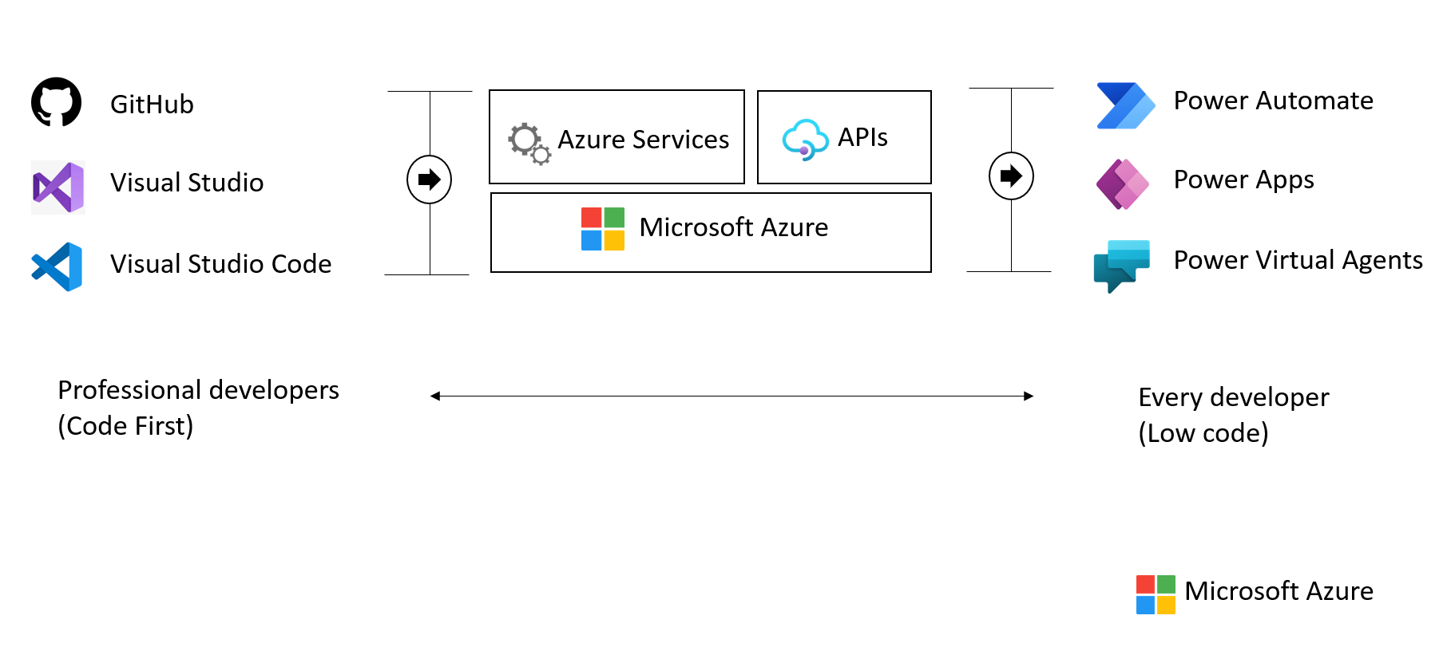

This image demonstrates common development tools on the Microsoft cloud platform to expedite application development.

To facilitate developers’ adoption of Azure, Microsoft offers a [free subscription](https://azure.microsoft.com/free/search/) with $200 credit, applicable for thirty days; year-long access to free quotas for popular services, including Azure Database for PostgreSQL Flexible Server; and access to always free Azure service tiers. Create an Azure free account and get access to [750 hours of Azure Database for PostgreSQL Flexible Server on a Burstable B1MS instance with 32GB storage for free](https://learn.microsoft.com/azure/postgresql/flexible-server/how-to-deploy-on-azure-free-account).

### PostgreSQL on Azure hosting options

The concepts Infrastructure as a Service (IaaS) and Platform as a Service (PaaS) typically define the public cloud provider and the enterprise customer resource responsibilities. Both approaches are common ways to host PostgreSQL on Azure.

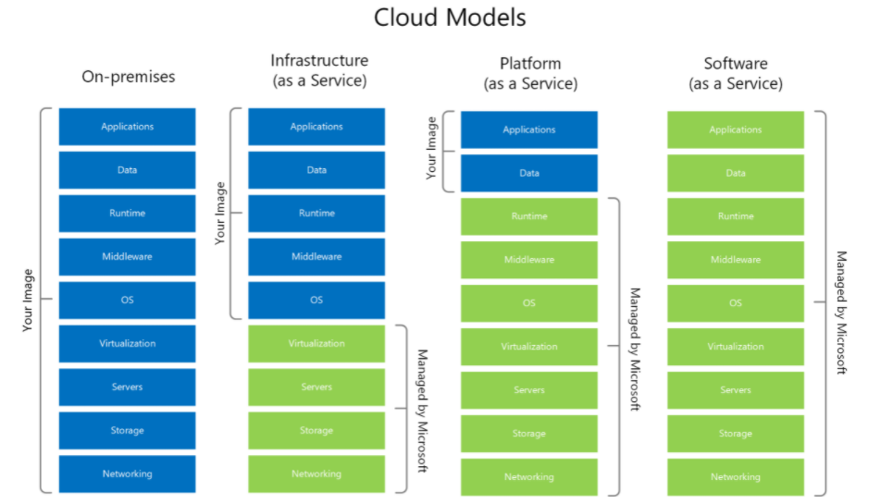

This diagram shows the cloud adoption strategy.

#### IaaS (VMs)

In the IaaS model, organizations deploy PostgreSQL on Azure Virtual Machines. This model allows the customer to choose when to patch the VM OS, the PostgreSQL engine, and install other software such as antivirus utilities when required. Microsoft is responsible for the underlying VM hardware that constitutes the Azure infrastructure. Customers are responsible for all other maintenance.

Because IaaS PostgreSQL hosting gives greater control over the PostgreSQL database engine and the OS, many organizations choose to lift and shift on-premises solutions while minimizing capital expenditure.

#### IaaS (Containers)

Although VMs are typically considered the primary IaaS approach, containerizing PostgreSQL instances and applications can also be included in this approach. Modernizing applications allows for more opportunities for deployment and management with Kubernetes and container hosting environments coming into the picture. Azure provides Azure Kubernetes Service (AKS) and, as explored below, several other PaaS-based approaches to hosting PostgreSQL and application containers.

#### PaaS (DBaaS)

In the PaaS model, organizations deploy a fully managed PostgreSQL environment on Azure. Unlike IaaS, they cede control over patching the PostgreSQL engine and OS to the Azure platform, and Azure automates many administrative tasks, like providing high availability, backups, and protecting data.

Like IaaS, customers are still responsible for managing query performance, database access, and database objects, such as indexes. PaaS is suitable for applications where the PostgreSQL configuration exposed by Azure is sufficient, and access to the OS and filesystem is unnecessary.

The Azure DBaaS PostgreSQL offering is [Azure Database for PostgreSQL Flexible Server](https://azure.microsoft.com/services/PostgreSQL/#features). It supports many of the common administration tools and programming languages.

#### PaaS (Containers)

In addition to the IaaS and PaaS options mentioned above, it is possible to choose to host container based instances inside PaaS-based services such as Azure Container Instances and Azure App Services.

#### Video reference

For a video comparison of cloud hosting models, please refer to [Microsoft Learn.](https://docs.microsoft.com/learn/modules/cmu-cloud-computing-overview/4-building-blocks)

## Introduction to Azure resource management

With a firm understanding of why millions of organizations choose Azure, and the database deployment models (IaaS vs. PaaS), the next step is to provide more detail about **how** developers interact with Azure.

The [Azure Fundamentals Microsoft Learn Module](https://docs.microsoft.com/learn/modules/intro-to-azure-fundamentals/) demonstrates how IaaS and PaaS classifies Azure services. Moreover, Azure empowers flexible *hybrid cloud* deployments and supports a variety of common tools, such as Visual Studio, PowerShell, and the Azure CLI, to manage Azure environments.

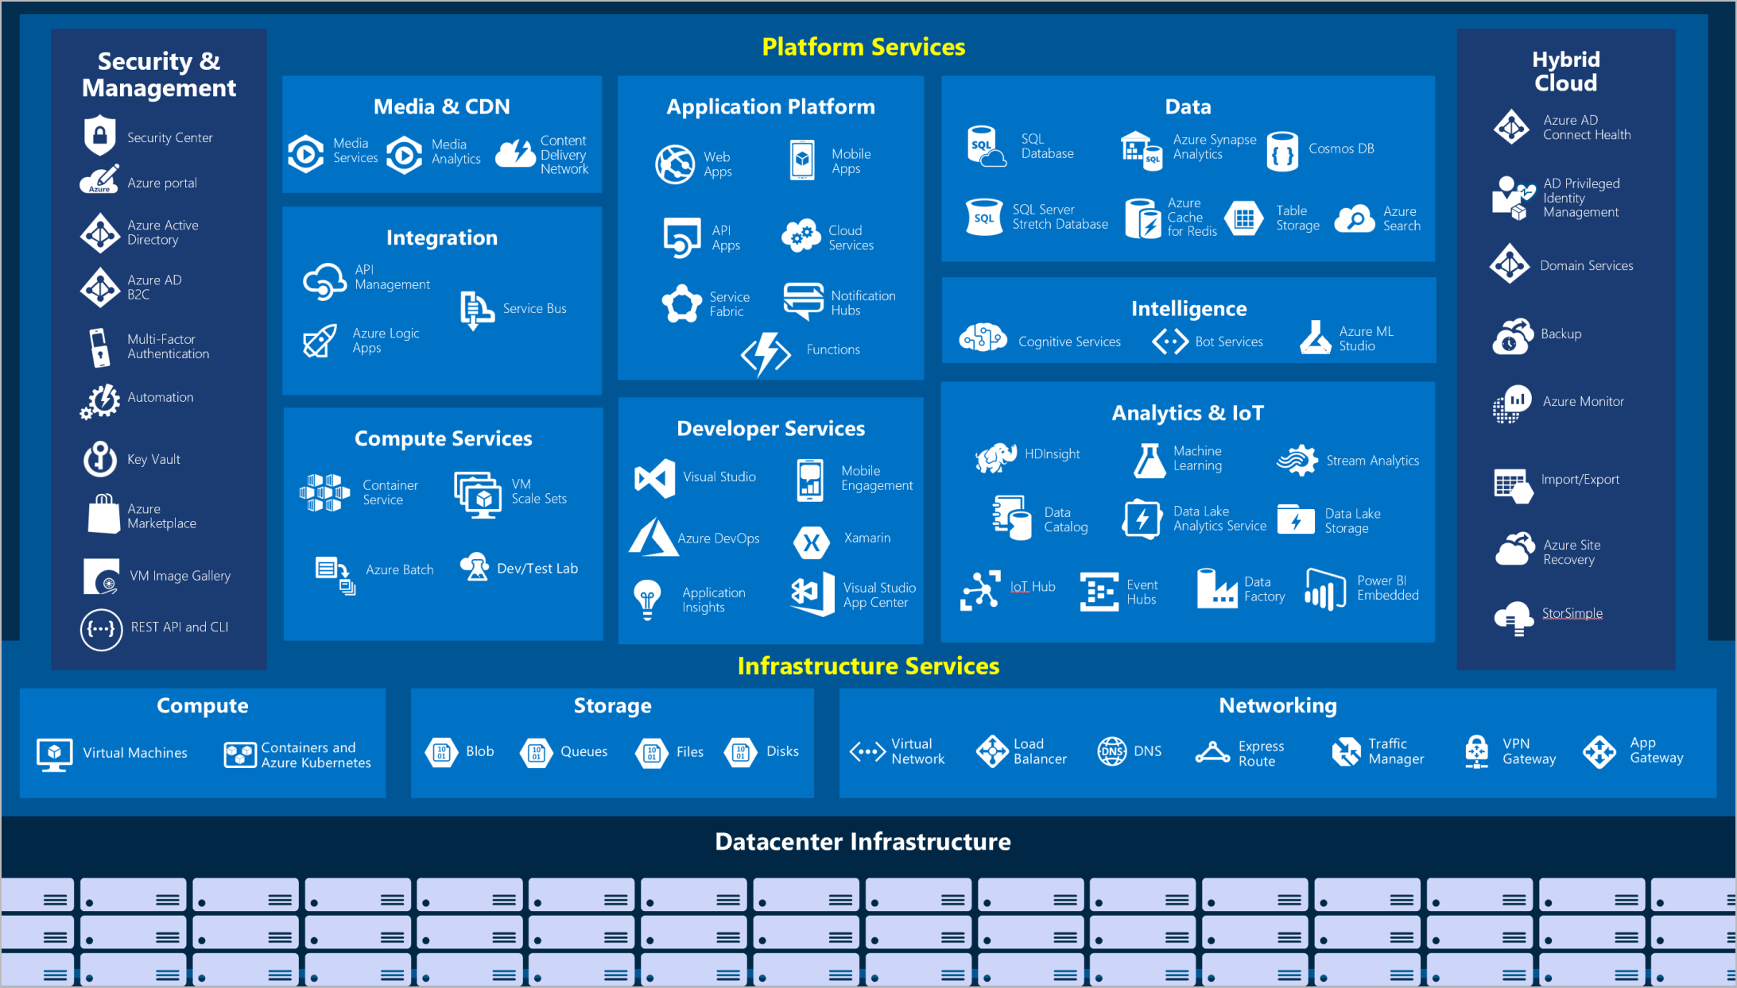

IaaS and PaaS Azure service classification and categories

The following table outlines some of the Azure services used in application developer scenarios that will be discussed in further detail in later sections of this guide.

* [**Virtual Machines (IaaS)**](https://docs.microsoft.com/azure/virtual-machines/windows/overview): Begin by running a PHP sample application on an Azure Windows Server Virtual Machine.
* [**Azure App Service (PaaS)**](https://docs.microsoft.com/azure/app-service/overview): Deploy the PHP application to Azure App Service, a flexible, simple-to-use application hosting service.
* [**Azure Container Instances (PaaS)**](https://docs.microsoft.com/azure/container-instances/container-instances-overview): *Containerize* apps on the VM to operate in an environment isolated from other development tools installed on the system. Azure Container Instances provides a managed environment to operate containers.
* [**Azure Kubernetes Service (PaaS)**](https://docs.microsoft.com/azure/aks/intro-kubernetes): AKS also hosts containerized apps, but it is optimized for more advanced orchestration scenarios, such as high availability.

For a more comprehensive view, consult the [Azure Fundamentals Microsoft Learn](https://docs.microsoft.com/learn/modules/intro-to-azure-fundamentals/tour-of-azure-services) module.

### The Azure resource management hierarchy

Azure provides a flexible resource hierarchy to simplify cost management and security. This hierarchy consists of four levels:

* [**Management groups**](https://docs.microsoft.com/azure/governance/management-groups/overview): Management groups consolidate multiple Azure subscriptions for compliance and security purposes.
* **Subscriptions**: Subscriptions govern cost control and access management. Azure users cannot provision Azure resources without a subscription.
* [**Resource groups**](https://docs.microsoft.com/azure/azure-resource-manager/management/manage-resource-groups-portal): Resource groups consolidate the individual Azure resources for a given deployment. All provisioned Azure resources belong to one resource group. In this guide, it will be required to provision a *resource group* in an *subscription* to hold the required resources.
  + Resource groups are placed in a geographic location that determines where metadata about that resource group is stored.
* **Resources**: An Azure resource is an instance of a service. An Azure resource belongs to one resource group located in one subscription.
  + Most Azure resources are provisioned in a particular region.
* 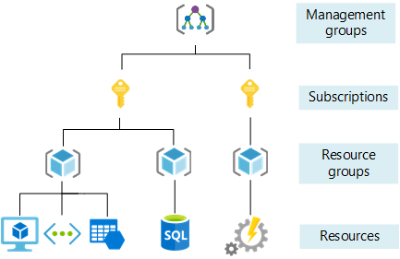
* This image shows Azure resource scopes.

### Create landing zone

An [Azure landing zone](https://docs.microsoft.com/azure/cloud-adoption-framework/ready/landing-zone/) is the target environment defined as the final resting place of a cloud migration project. In most projects, the landing zone should be scripted via ARM templates for its initial setup. Finally, it should be customized with PowerShell or the Azure Portal to fit the workload’s needs. First-time Azure users will find creating and deploying to DEV and TEST environments easy.

To help organizations quickly move to Azure, Microsoft provides the Azure landing zone accelerator, which generates a landing zone ARM template according to an organization’s core needs, governance requirements, and automation setup. The landing zone accelerator is available in the Azure portal.

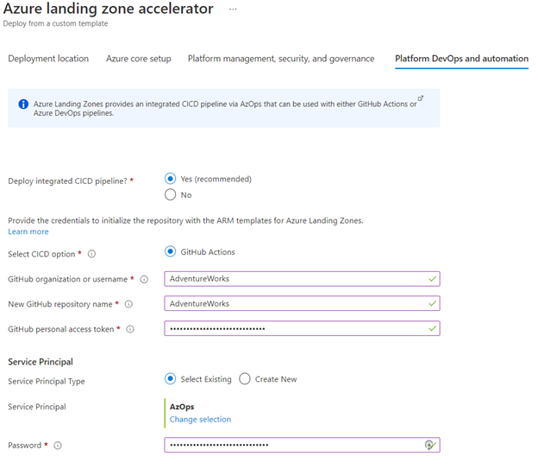

This image demonstrates the Azure landing zone accelerator in the Azure portal, and how organizations can optimize Azure for their needs and innovate.

### Automating and managing Azure services

When it comes to managing Azure resources, there are many potential options. [Azure Resource Manager](https://docs.microsoft.com/azure/azure-resource-manager/management/overview) is the deployment and management service for Azure. It provides a management layer that enables users to create, update, and delete resources in Azure subscriptions. Use management features, like access control, locks, and tags, to secure and organize resources after deployment.

All Azure management tools, including the [Azure CLI](https://docs.microsoft.com/cli/azure/what-is-azure-cli), [Azure PowerShell](https://docs.microsoft.com/powershell/azure/what-is-azure-powershell?view=azps-7.1.0) module, [Azure REST API](https://docs.microsoft.com/rest/api/azure/), and browser-based Portal, interact with the Azure Resource Manager layer and [Identity and access management (IAM)](https://docs.microsoft.com/azure/role-based-access-control/overview) security controls.

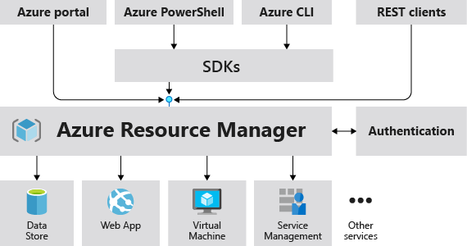

This image demonstrates how the Azure Resource Manager provides a robust, secure interface to Azure resources.

Access control to all Azure services is offered via the [Azure role-based access control (Azure RBAC)](https://docs.microsoft.com/azure/role-based-access-control/overview) natively built into the management platform. Azure RBAC is a system that provides fine-grained access management of Azure resources. Using Azure RBAC, it is possible to segregate duties within teams and grant only the amount of access to users that they need to perform their jobs.

### Azure management tools

The flexibility and variety of Azure’s management tools make it intuitive for any user, irrespective of their skill level with specific technologies. As an individual’s skill level and administration needs mature, Azure has the right tools to match those needs.

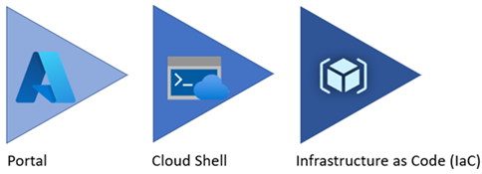

Azure service management tool maturity progression.

#### Azure portal

As a new Azure user, the first resource a person will be exposed to is the Azure Portal. The **Azure Portal** gives developers and architects a view of the state of their Azure resources. It supports extensive user configuration and simplifies reporting. The [**Azure mobile app**](https://azure.microsoft.com/get-started/azure-portal/mobile-app/) provides similar features for users that are away from their main desktop or laptop.

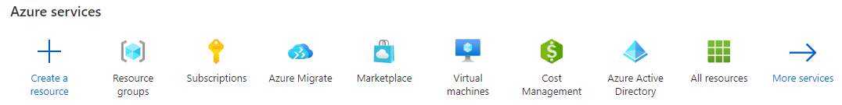

The picture shows the initial Azure service list.

Azure runs on a common framework of backend resource services, and every action taken in the Azure portal translates into a call to a set of backend APIs developed by the respective engineering team to read, create, modify, or delete resources.

##### Azure Marketplace

[Azure Marketplace](https://docs.microsoft.com/marketplace/azure-marketplace-overview) is an online store that contains thousands of IT software applications and services built by industry-leading technology companies. In Azure Marketplace, it is possible to find, try, buy, and deploy the software and services needed to build new solutions and manage the cloud infrastructure. The catalog includes solutions for different industries and technical areas, free trials, and consulting services from Microsoft partners.

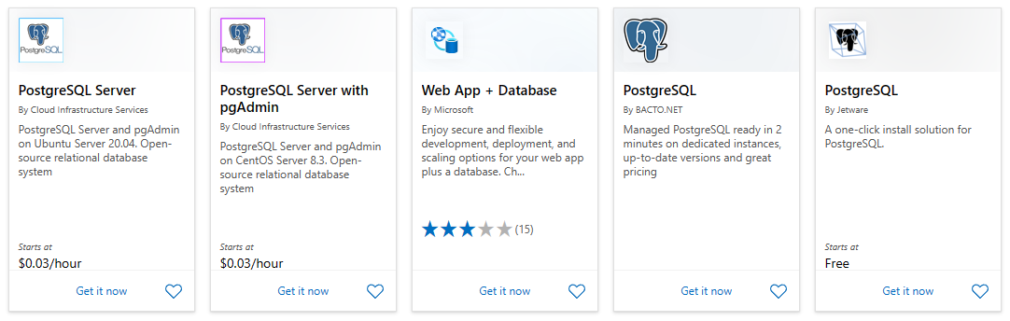

The picture shows an example of Azure Marketplace search results.

##### Evolving

Moving workloads to Azure alleviates some administrative burdens, but not all. Even though there is no need to worry about the data center, there is still a responsibility for service configuration and user access. Applications will need resource authorization.

Using the existing command-line tools and REST APIs, it is possible to build custom tools to automate and report resource configurations that do not meet organizational requirements.

#### Azure PowerShell and CLI

**Azure PowerShell** and the **Azure CLI** (for Bash shell users) are useful for automating tasks that cannot be performed in the Azure portal. Both tools follow an *imperative* approach, meaning that users must explicitly script the creation of resources in the correct order.

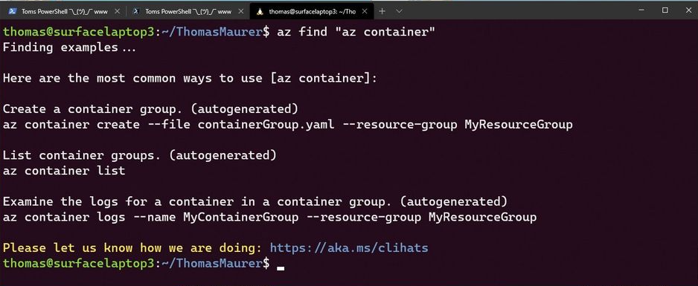

Shows an example of the Azure CLI.

There are subtle differences between how each of these tools operates and the actions that can be accomplished. Use the [Azure command-line tool guide](https://docs.microsoft.com/azure/developer/azure-cli/choose-the-right-azure-command-line-tool) to determine the right tool to meet the target goal.

#### Azure CLI

It is possible to run the Azure CLI and Azure PowerShell from the [Azure Cloud Shell](https://shell.azure.com), but it does have some limitations. It is also possible to run these tools locally.

To use the Azure CLI, [download the CLI tools from Microsoft.](https://docs.microsoft.com/cli/azure/install-azure-cli)

To use the Azure PowerShell cmdlets, install the Az module from the PowerShell Gallery, as described in the [installation document.](https://docs.microsoft.com/powershell/azure/install-az-ps?view=azps-6.6.0)

##### Azure Cloud Shell

The Azure Cloud Shell provides Bash and PowerShell environments for managing Azure resources imperatively. It also includes standard development tools, like Visual Studio Code, and files are persisted in an Azure Files share.

Launch the Cloud Shell in a browser at <https://shell.azure.com>.

#### PowerShell Module

The Azure portal and Windows PowerShell can be used for managing the Azure Database for PostgreSQL Flexible Server. To get started with Azure PowerShell, install the [Azure PowerShell cmdlets](https://learn.microsoft.com/powershell/module/az.postgresql/?view=azps-11.0.0) for PostgreSQL with the following PowerShell command in an administrator-level PowerShell window:

Install-Module -Name Az.PostgreSQL

#### Infrastructure as Code

[Infrastructure as Code (IaC)](https://docs.microsoft.com/devops/deliver/what-is-infrastructure-as-code) provides a way to describe or declare what infrastructure looks like using descriptive code. The infrastructure code is the desired state. The environment will be built when the code runs and completes. One of the main benefits of IaC is that it is human readable. Once the environment code is proven and tested, it can be versioned and saved into source code control. Developers can review the environment changes over time.

##### ARM templates

[ARM templates](https://docs.microsoft.com/azure/azure-resource-manager/templates/) can deploy Azure resources in a *declarative* manner. Azure Resource Manager can potentially create the resources in an ARM template in parallel. ARM templates can be used to create multiple identical environments, such as development, staging, and production environments.

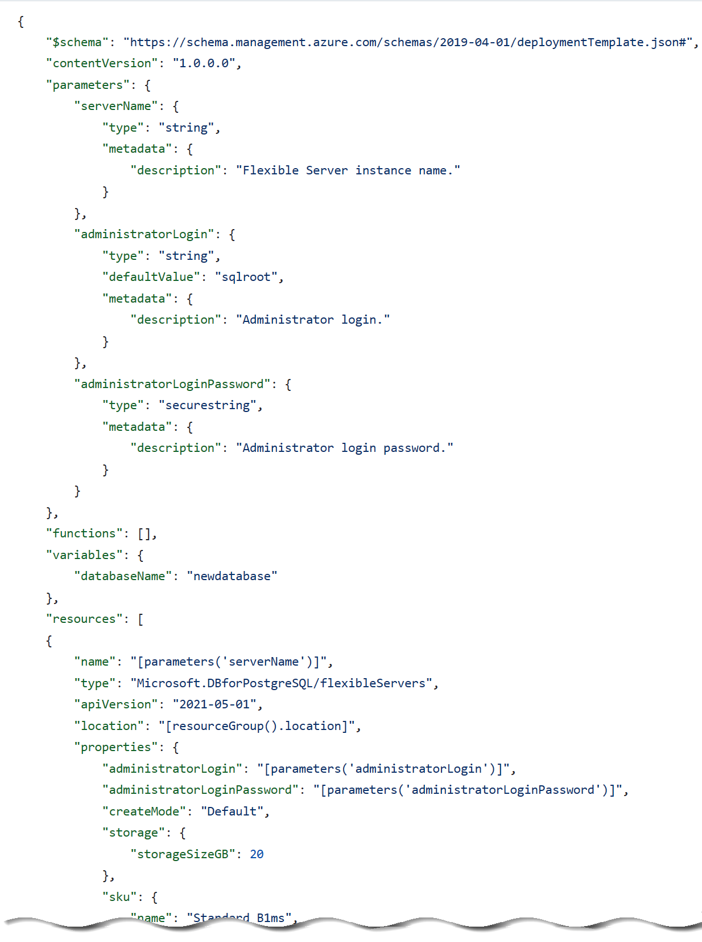

The picture shows an example of an ARM template JSON export.

##### Bicep

Reading, updating, and managing the ARM template JSON code can be difficult for a reasonably sized environment. What if there was a tool that translates simple declarative statements into ARM templates? Better yet, what if there was a tool that took existing ARM templates and translated them into a simple configuration? [Bicep](https://docs.microsoft.com/azure/azure-resource-manager/bicep/overview) is a domain-specific language (DSL) that uses a declarative syntax to deploy Azure resources. Bicep files define the infrastructure to deploy to Azure and then use that file throughout the development lifecycle to repeatedly deploy infrastructure changes. Resources are deployed consistently.

By using the Azure CLI it is possible to decompile ARM templates to Bicep using the following:

az bicep decompile --file template.json

Additionally, the [Bicep playground](https://aka.ms/bicepdemo) tool can perform similar decompilation of ARM templates.

[Explore the Bicep template benefits](https://docs.microsoft.com/azure/azure-resource-manager/bicep/overview?tabs=bicep)

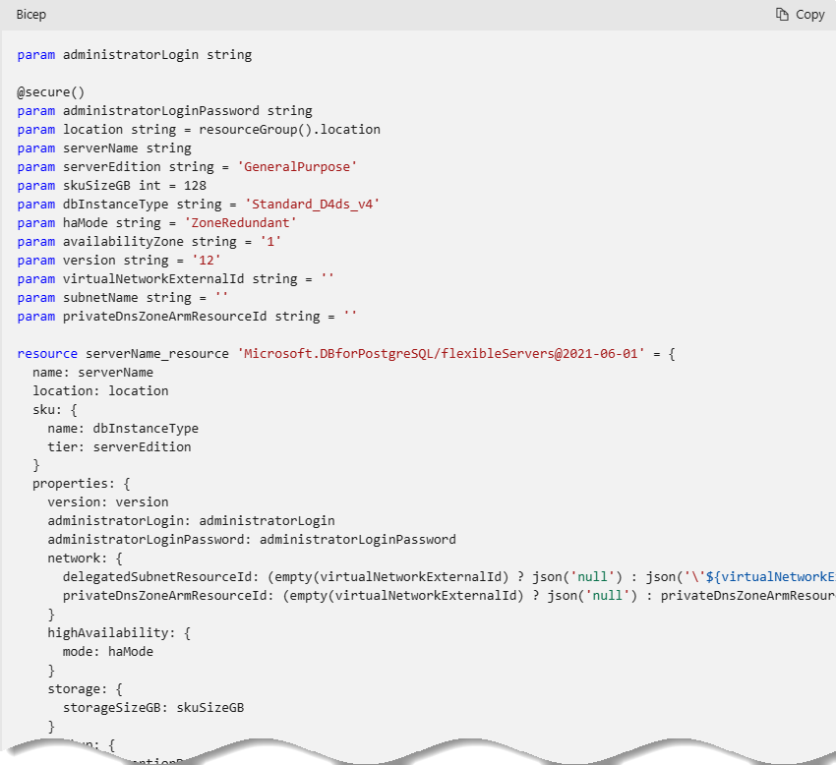

This image demonstrates part of a sample Bicep template for provisioning Azure Database for PostgreSQL Flexible Server.

##### Terraform

[Hashicorp Terraform](https://www.terraform.io/) is an open-source tool for provisioning and managing cloud infrastructure. [Terraform](https://docs.microsoft.com/azure/developer/terraform/overview) is adept at deploying infrastructure across multiple cloud providers. It enables developers to use consistent tooling to manage each infrastructure definition.

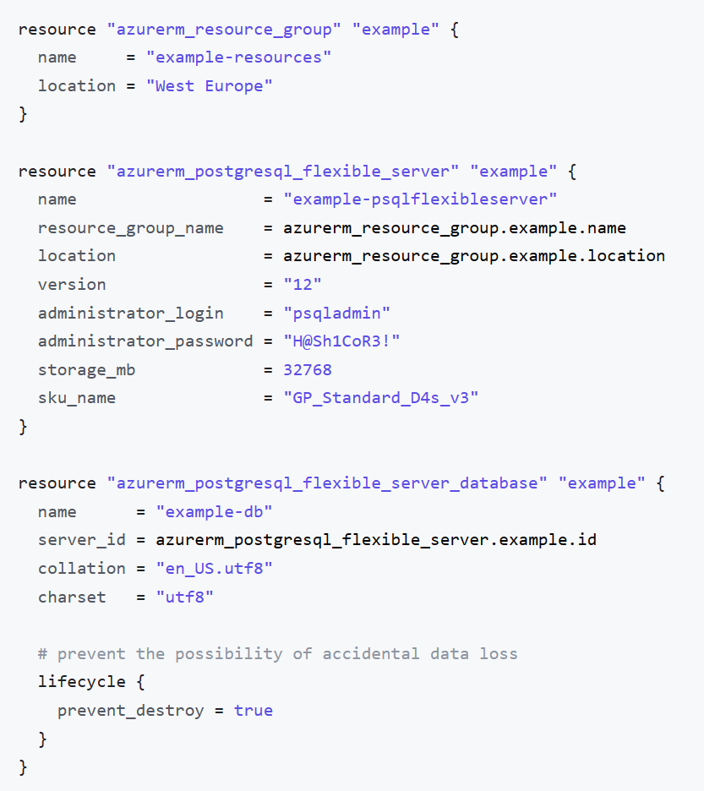

This image demonstrates part of a sample Terraform template for provisioning Azure Database for PostgreSQL Flexible Server.

#### Other tips

Azure administrators should consult with cloud architects and financial and security personnel to develop an effective organizational hierarchy of resources. Here are some best practices to follow for Azure deployments.

* **Utilize Management Groups** Create at least three levels of management groups.
* **Adopt a naming convention:** Names in Azure should include business details, such as the organization department, and operational details for IT personnel, like the workload.
* **Adopt other Azure governance tools:** Azure provides mechanisms such as [resource tags](https://docs.microsoft.com/azure/azure-resource-manager/management/tag-resources?tabs=json) and [resource locks](https://docs.microsoft.com/azure/azure-resource-manager/management/lock-resources?tabs=json) to facilitate compliance, cost management, and security.

### Azure deployment resources

#### Support

Azure provides [multiple support plans for businesses](https://azure.microsoft.com/support/plans/), depending on their business continuity requirements. There is also a large user community:

* [StackOverflow Azure Tag](https://stackoverflow.com/questions/tagged/azure)
* [Azure on Twitter](https://twitter.com/azure)
* Move to Azure efficiently with customized guidance from Azure engineers. [FastTrack for Azure](https://azure.microsoft.com/programs/azure-fasttrack/)

#### Training

* [Azure Certifications and Exams](https://docs.microsoft.com/learn/certifications/browse/?products=azure)
* [Microsoft Learn](https://docs.microsoft.com/learn/)
  + [Azure Fundamentals (AZ-900) Learning Path](https://docs.microsoft.com/learn/paths/az-900-describe-cloud-concepts/)

## Introduction to Azure Database for PostgreSQL Flexible Server

Developers can deploy PostgreSQL on Azure through Virtual Machines (IaaS) or Azure Database for PostgreSQL Flexible Server (PaaS). Azure Database for PostgreSQL Flexible Server offers high availability, automated backups, and meets compliance requirements. Operational administrators do not have the operational overhead of managing the OS and the DB engine. They do not need to worry about OS patching, database backups, or server security. Administrators only need to manage the applications and data. Developers can focus on schema design, building queries, and optimizing query performance.

Azure Database for PostgreSQL Flexible Server supports PostgreSQL Community Editions 11 through 16, making it flexible for most migrations.

**Control Plane** As the image below demonstrates, Azure Resource Manager handles resource configuration, meaning that standard Azure management tools, such as the CLI, PowerShell, and ARM templates, are still applicable. This is commonly referred to as the *control plane*.

**Data Plane** For managing database objects and access controls at the server and database levels, standard PostgreSQL management tools, such as [pgAdmin](https://www.pgadmin.org/), still apply. This is known as the *data plane*.

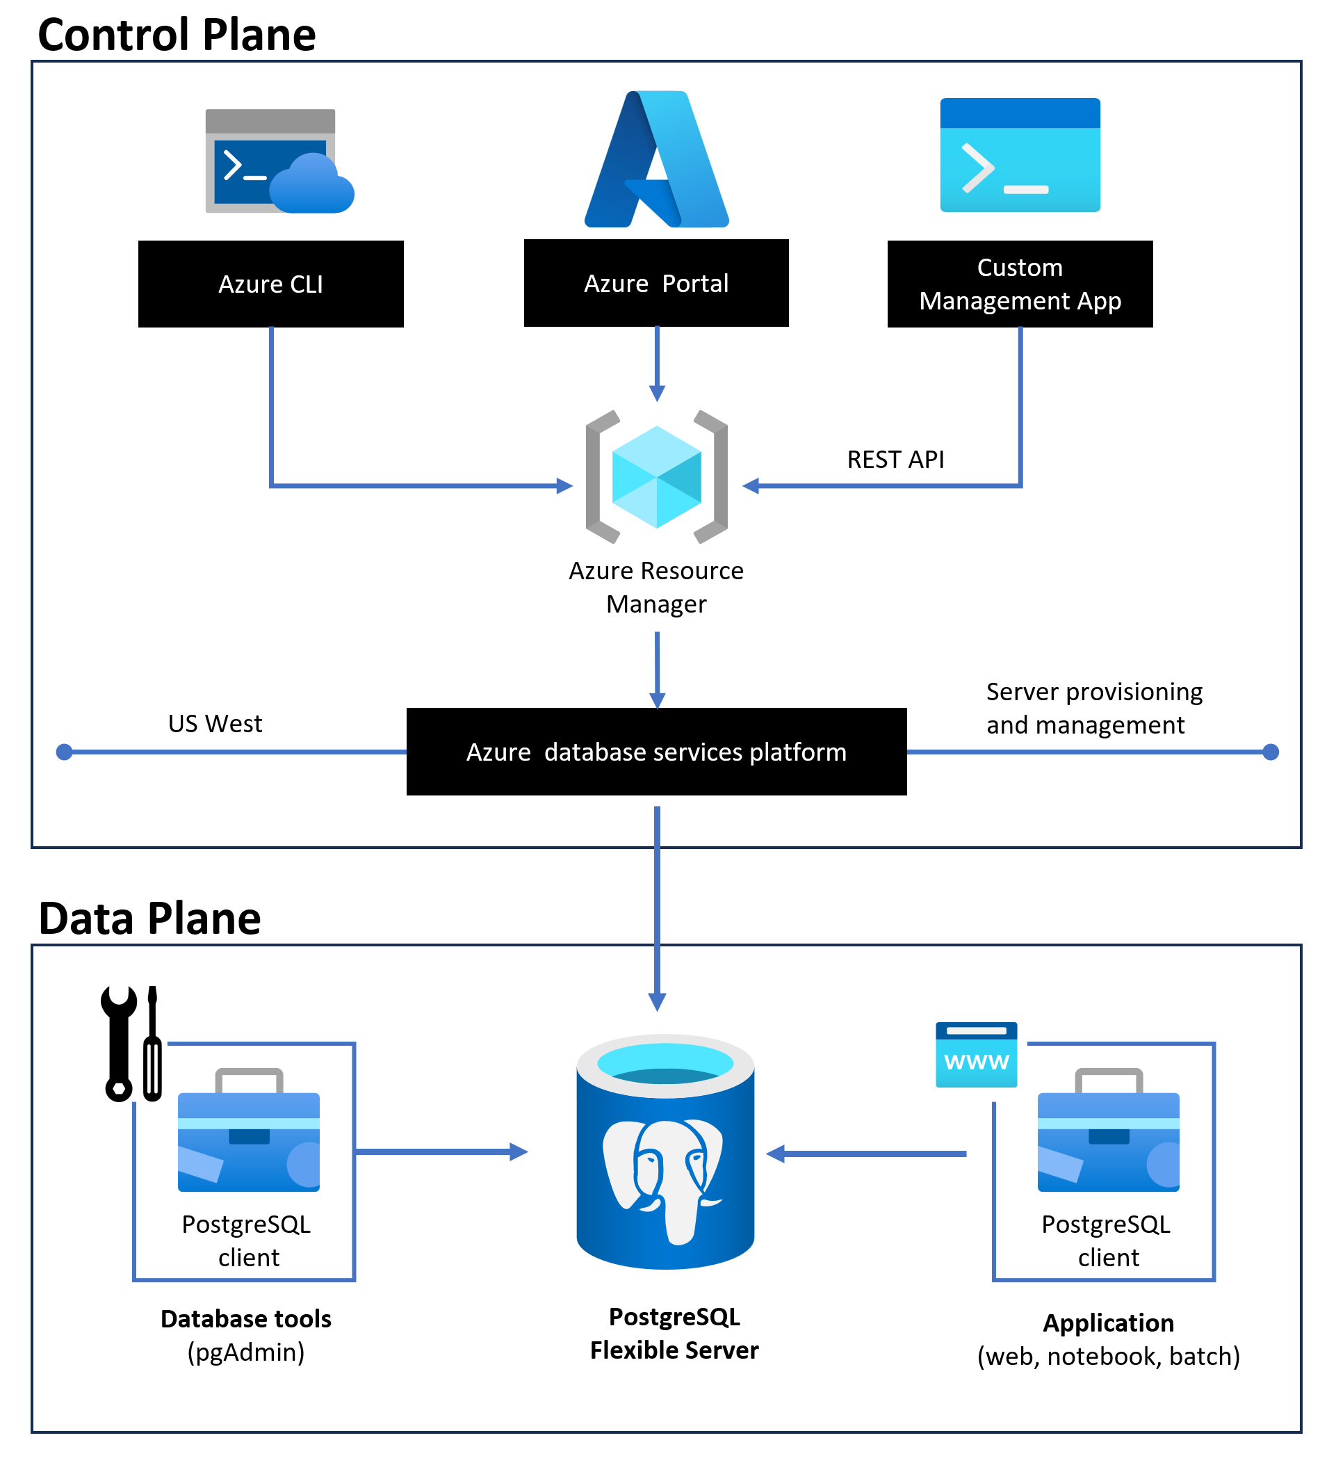

This image demonstrates the control and data plane for Azure Database for PostgreSQL Flexible Server.

### Azure Database for PostgreSQL Flexible Server deployment options

Azure Database for PostgreSQL Flexible Server provides two options for deployment: Single Server and Flexible Server. Below is a summary of these offerings. For a more comprehensive comparison table, please consult the article [Choose the right PostgreSQL Server option in Azure](https://learn.microsoft.com/azure/postgresql/flexible-server/concepts-compare-single-server-flexible-server).

 **Note:** This guide will be focused on Flexible Server and will not explore Single Server or the Cosmos DB database for PostgresSQL.

##### Flexible Server video introduction

 **Watch:** [Introduction to Azure Database for PostgreSQL Flexible Server](https://youtu.be/NSEmJfUgNzE)

### Cost management

Cost management is one of the advantages of Flexible Server: it supports a [*burstable* tier](https://learn.microsoft.com/azure/postgresql/flexible-server/concepts-compute-storage), which is based on the B-series Azure VM tier and is optimized for workloads that do not continually use the CPU. [Flexible Server instances can also be paused](https://learn.microsoft.com/azure/postgresql/flexible-server/how-to-stop-start-server-portal). The image below shows how Flexible Server works for a non-high availability arrangement.

*Locally-redundant storage* replicates data within a single [availability zone](https://docs.microsoft.com/azure/availability-zones/az-overview). *Availability zones* are present within a single Azure region (such as East US) and are geographically isolated. All Azure regions that support availability zones have at least three zones.

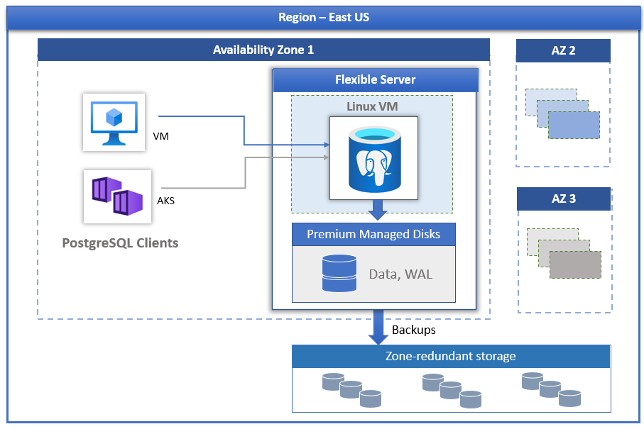

This image demonstrates how PostgreSQL Flexible Server works, with compute, storage, and backup storage.

Here are a few other notable advantages of Flexible Server.

* [User-scheduled service maintenance:](https://learn.microsoft.com/azure/postgresql/flexible-server/concepts-maintenance) Flexible Server allows database administrators to set a day of the week and a time for Azure to perform service maintenance and upgrades, **per server**. Providing notifications five days before a planned maintenance event, Flexible Server caters to the needs of IT operations personnel.
* 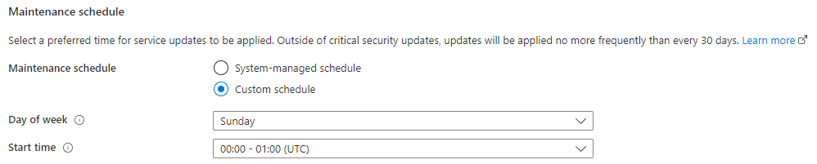
* This image demonstrates how to set a custom maintenance schedule in Flexible Server.
* [Network security:](https://learn.microsoft.com/azure/postgresql/flexible-server/concepts-security) Applications access Flexible Server through the public Internet (though access is governed by firewall ACLs), or through private IP addresses in an Azure Virtual Network. Moreover, TLS support keeps traffic encrypted, irrespective of the chosen network access model.
* [Automatic backups:](https://learn.microsoft.com/azure/postgresql/flexible-server/concepts-backup-restore) Azure automates database backups, encrypts them, and stores them for a configurable period.
* 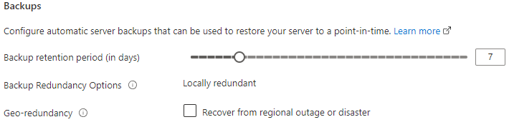
* This image demonstrates how to configure Flexible Server automatic backups.
* [Read replicas:](https://learn.microsoft.com/azure/postgresql/flexible-server/concepts-read-replicas) Read replicas help teams scale their applications by providing read-only copies of the data updated on the master node. Often, applications that run on elastic, autoscaling services, like Azure App Service, couple well with read replicas.
* [Input-output operations per second (IOPS):](https://learn.microsoft.com/azure/postgresql/flexible-server/concepts-compute-storage#iops) IOPS can be configured based on your performance needs.
* 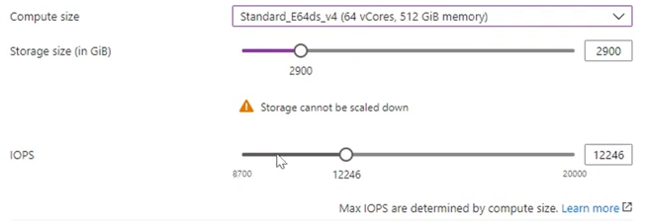
* This image demonstrates server IOPS configuration.

##### Flexible Server pricing & TCO

The PostgreSQL Flexible Server tiers offer a storage range between 32 GiB and 32 TiB and the same backup retention period range of 1-35 days. However, they differ in core count and memory per vCore. Choosing a compute tier affects the database IOPS and pricing.

* **Burstable**: This tier corresponds to a B-series Azure VM. Instances provisioned in this tier have 1-20 vCores. It is ideal for applications that do not utilize the CPU consistently.
* **General Purpose**: This tier corresponds to a Ddsv4-series Azure VM. Instances provisioned in this tier have 2-96 vCores and 4 GiB memory per vCore. It is ideal for most enterprise applications requiring a strong balance between memory and vCore count.
* **Memory Optimized**: This tier corresponds to an Edsv4-series Azure VM. Instances provisioned in this tier have 2-96 vCores and 8 GiB memory per vCore. It is ideal for high-performance or real-time workloads that depend on in-memory processing.

To estimate the TCO for Azure Database for PostgreSQL Flexible Server:

1. Use the [Azure Pricing Calculator](https://azure.microsoft.com/pricing/calculator/).

*  **Note:** The [Azure TCO Calculator](https://azure.microsoft.com/pricing/tco/calculator/) can be used to estimate the cost savings of deploying PaaS Azure PostgreSQL over the same deployment in an on-premises data center.

1. Indicate the configuration of on-premises hardware and the Azure landing zone, adjust calculation parameters, like the cost of electricity, and observe the potential savings.

##### Flexible Server Unsupported Features

Azure provides a [detailed list of the limitations of Flexible Server](https://learn.microsoft.com/azure/postgresql/flexible-server/concepts-limits). Here are a few notable ones.

* Users are not provided host or OS access to view or modify configuration files such as postgresql.conf
* You can’t create or load your own extension in Azure Database for PostgreSQL.

## Migrate to Azure Database for Flexible Server

### From Single Server to Flexible Server

As Single Server will be retired in the future, you will at some point need to move your instances to Flexible Server. There are several ways to do this including:

* Database tools
  + [Azure Database Migration Service (DMS)](https://learn.microsoft.com/azure/dms/tutorial-postgresql-azure-postgresql-online)
  + [pgcopydb](https://github.com/dimitri/pgcopydb)
  + [pg_dump and dp_restore](https://learn.microsoft.com/azure/postgresql/migrate/how-to-migrate-using-dump-and-restore)
* [Azure Portal](https://learn.microsoft.com/azure/postgresql/migrate/how-to-migrate-single-to-flexible-portal)
* [Azure CLI](https://learn.microsoft.com/azure/postgresql/migrate/how-to-migrate-single-to-flexible-cli)

When migrating, to Flexible Server, you will need to ensure you have met all the [migration prerequisites](https://learn.microsoft.com/azure/postgresql/migrate/concepts-single-to-flexible#migration-prerequisites).

### From on-premises to Flexible Server

Like the migration from Single Server, migrations from sources running on-premises will require the movement of database artifacts and data.

Again, verify that the source system meets the migration requirements listed in the [Azure documentation](https://learn.microsoft.com/azure/postgresql/migrate/concepts-single-to-flexible#migration-prerequisites).

In addition to the migration pre-requisities, you must also ensure that a network path exists between the on-premises instance/tool and the remote Azure Database for PostgreSQL instance. This can be more complicated than at first glance depending on a number of different network topology possibilies.

### Offline vs Online migrations

For smaller and less used databases, the migration process is likely to be quick and effortless. However, in larger and more heavily used environments, the choice of how you migrate will be a vital decision to ensure applications and end users are not subject to lengty downtime and productivity loss.

You can choose between the two following paths:

* **Offline Migration** – In an offline migration, all applications connecting to your single server are stopped and the database(s) is copied to flexible server.
* **Online Migration** - In an online migration, applications connecting to your single server aren’t stopped while database(s) are copied to flexible server. The initial copy of the databases is followed by replication to keep flexible server in sync with the single server. A cutover is performed when the flexible server is in complete sync with the single server resulting in minimal downtime.

## 02 / Summary

This module explained everyday use cases for PostgreSQL and illustrated the typical IaaS and PaaS deployment approaches. Additional hybrid approaches to hosting PostgreSQL applications and databases on Microsoft Azure were discussed as well. The reader was introduced to the core approaches to managing Microsoft Azure resources, including imperative tools (like the Azure CLI and Azure PowerShell) and declarative tools (like ARM templates and Terraform).

Using one or more of the various tools presented, will assist in getting the database instance(s) migrated to Azure Database for PostgreSQL in the most efficient manner possible.

The emphasis of this guide will continue to be on the advantages of Azure Database for PostgreSQL Flexible Server. Flexible Server is the most commonly recommended Azure Database for PostgreSQL offering.

# 03 / Getting Started - Setup and Tools

With a firm understanding of PostgreSQL and other offerings available in Azure, it is time to review how to start using these various services in applications. In this chapter, we explore how to get Azure subscriptions configured and ready to host PostgreSQL applications. Common PostgreSQL application types and the various tools to simplify their deployment will reviewed. Sample code will make it easier to get started faster and understand high-level concepts.

## Azure free account

Azure offers a [$200 free credit for developers to trial Azure](https://azure.microsoft.com/free) or jump right into a Pay-as-you-go subscription. The free account includes credits for 750 compute hours of Azure Database for PostgreSQL Flexible Server - Flexible Server. [Innovate faster with fully managed PostgreSQL and an Azure free account.](https://learn.microsoft.com/azure/postgresql/flexible-server/how-to-deploy-on-azure-free-account)

## Azure subscriptions and limits

As explained in the [Introduction to Azure resource management](../02_IntroToPostgreSQL/02_02_Introduction_to_Azure_resource_mgmt.md), subscriptions are a critical component of the Azure hierarchy: resources cannot be provisioned without an Azure subscription, and although the cloud is highly scalable, it is not possible to provision an unlimited number of resources. A set of initial limits applies to all Azure subscriptions. However, the limits for some Azure services can be raised, assuming that the Azure subscription is not a free trial. Organizations can raise these limits by submitting support tickets through the Azure Portal. Limit increase requests help tell Microsoft capacity planning teams to understand if they need to provide more capacity when needed.

Since most Azure services are provisioned in regions, some limits apply at the regional level. Developers must consider both global and regional subscription limits when developing and deploying applications.

Consult [Azure’s comprehensive list of service and subscription limits](https://docs.microsoft.com/azure/azure-resource-manager/management/azure-subscription-service-limits) for more details.

## Azure authentication

As mentioned previously, Azure Database for PostgreSQL Flexible Server consists of a data plane (data storage and data manipulation) and a control plane (management of the Azure resource). Authentication is separated between the control plane and the data plane as well.

In the control plane, Microsoft Entra authenticates users and determines whether users are authorized to operate against an Azure resource. Review Azure RBAC in the Introduction to Azure resource management section for more information.

The built-in PostgreSQL account management system governs access for administrator and non-administrator users in the data plane. Moreover, Azure Database for PostgreSQL supports security principals in Microsoft Entra, like users and groups, for data-plane access management. Using AAD data-plane access management allows organizations to enforce credential policies, specify authentication modes, and more. Refer to the [Microsoft docs](https://learn.microsoft.com/azure/postgresql/flexible-server/concepts-azure-ad-authentication) for more information.

## Development editor tools

Developers have various code editor tools to choose from to complete their IT projects. Commercial organizations and OSS communities have produced tools and plug-ins making Azure application development efficient and rapid. A very popular tool is Visual Studio Code (VS Code). VS Code is an open-source, cross-platform text editor. It offers useful utilities for various languages through extensions. Download VS Code from the [Microsoft download page.](https://code.visualstudio.com/download)

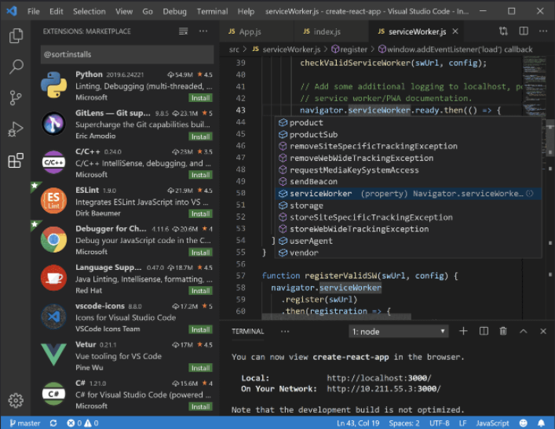

A simple screenshot of Visual Studio Code.

The [PostgreSQL](https://marketplace.visualstudio.com/items?itemName=ms-ossdata.vscode-postgresql) extension allows developers to:

* Connect to PostgreSQL instances
* Manage connection profiles
* Connect to a different Postgres instance or database in each tab
* View object DDL with ‘Go to Definition’ and ‘Peek Definition’
* Write queries with IntelliSense
* Run queries and save results as JSON, csv, or Excel

Consider adding it to Visual Studio Code environment to make working with PostgreSQL instances more efficient.

When you are done developing for the day, you can stop Flexible Server. This feature helps keep the organizational costs low.

## Resources

* [App Service overview](https://docs.microsoft.com/azure/app-service/overview)
* [Azure App Service plan overview](https://docs.microsoft.com/azure/app-service/overview-hosting-plans)
* [Plan and manage costs for Azure App Service](https://docs.microsoft.com/azure/app-service/overview-manage-costs)

## Create a Flexible Server database

The focus of this guide is on demonstrating practical uses of PostgreSQL Flexible Server, such as querying Flexible Server with common languages and administrative tools. This section illustrates how to deploy PostgreSQL Flexible Server using various Azure management tools in preparation to follow the guide application samples.

### Azure portal

Azure provides a [Quickstart document](https://learn.microsoft.com/azure/postgresql/flexible-server/quickstart-create-server-portal) for users who want to use the Azure portal to provision Flexible Server. While this is a great opportunity to explore the configuration parameters of Azure Database for Flexible Server, IaC approaches, like the imperative Azure CLI or the declarative ARM template, are preferable to create deployments that can easily be replicated in other environments.

### Azure CLI

The Azure CLI az postgresql flexible-server set of commands is very robust. [Azure’s quickstart guide](https://learn.microsoft.com/azure/postgresql/flexible-server/flexible-server/quickstart-create-server-cli) demonstrates how the az postgresql flexible-server create and az postgresql flexible-server db create commands can automatically populate server parameters.

 **Note:** It is possible to exercise greater control over these commands by reviewing the documentation for the [flexible-server create](https://learn.microsoft.com/cli/azure/postgres/flexible-server?view=azure-cli-latest#az-postgres-flexible-server-create) and [flexible-server db create](https://learn.microsoft.com/cli/azure/postgres/flexible-server/db?view=azure-cli-latest#az-postgres-flexible-server-db-create) commands.

Running the CLI commands from [Azure Cloud Shell](https://shell.azure.com) is preferable, as the context is already authenticated with Azure.

### ARM template

Azure provides a [Quickstart document](https://learn.microsoft.com/azure/postgresql/flexible-server/quickstart-create-server-arm-template) with a basic ARM template for a Flexible Server deployment. We have also provided an ARM template to support the applications explored in this guide (https://github.com/Azure/azure-PostgreSQL/tree/master/DeveloperGuide/step-0-create-development-vm/basic-template/template.json). The Azure sample template requires additional parameters to run. It can be deployed with the New-AzResourceGroupDeployment PowerShell command in the Quickstart or the az deployment group create CLI command.

### Bicep

Bicep is a declarative language for describing and deploying Azure resources. It offers concise syntax, reliable type safety, and support for code reuse. Bicep is a domain-specific language (DSL) used to deploy Azure resources declaratively. It is a transparent abstraction over Azure Resource Manager (ARM) templates. Bicep uses the same template language as ARM and JSON but with a cleaner syntax and improved type safety. Bicep is a great way to deploy Azure resources, including Azure Database for PostgreSQL Flexible Server. Azure provides a [Quickstart document](https://learn.microsoft.com/azure/postgresql/flexible-server/quickstart-create-server-bicep) with Bicep code for a Flexible Server deployment.

### Terraform

Terraform is a third-party open-source infrastructure as code software tool that enables you to safely and predictably create, change, and improve infrastructure. Azure documentation provides an [article](https://learn.microsoft.com/en-us/azure/developer/terraform/deploy-postgresql-flexible-server-database?tabs=azure-cli) outlining Terraform code for a Flexible Server deployment.

## Connect, create and query Azure Database for PostgreSQL Flexible Server using pgAdmin

This section explains how to connect to and perform queries against Azure Database for PostgreSQL Flexible Server using PostgreSQL pgAdmin, a UI-based management tool.

There are multiple ways of accomplishing each database task in pgAdmin, including (but limited to), GUI-based forms, the query tool and the interactive shell (PSQL tool). This section will demonstrate the use of many of these tools within pgAdmin.

### Setup

Follow one of the methods in the [Create a Flexible Server database](./03_00_Getting_Started_Provision_PostgreSQL_Flexible_Server.md) document to create a Flexible Server resource. Remember the admin username and password for the Flexible Server resource for use later in this section.

Download pgAdmin tool from the [pgAdmin Downloads](https://www.pgadmin.org/download/). Alternatively, you can use a package manager like [Chocolatey](https://community.chocolatey.org/packages/pgadmin4) and [WinGet](https://winget.run/search?query=pgAdmin) for Windows-based machines, as well as [Homebrew](https://formulae.brew.sh/cask/pgadmin4) for macOS. For Linux-based machines, you can use **yum** or **apt-get** to install pgAdmin.

|  |
| --- |
| The pgAdmin splash screen. |

The pgAdmin splash screen.

### Connect pgAdmin to Azure Database for PostgreSQL Flexible Server

1. In the [Azure Portal](https://portal.azure.com), navigate to the Flexible Server resource created in the previous section.
2. From the left-hand menu, select **Connect**.
3. On the **Connect** screen, locate and expand the **pgAmin 4** section to find instructions on how to add a connection to the server in the pgAdmin software.

|  |
| --- |
| * pgAdmin instructions are displayed on the Connect screen of the Flexible Server resource in the Azure Portal. |

* pgAdmin instructions are displayed on the Connect screen of the Flexible Server resource in the Azure Portal.

1. On your desktop, open the pgAdmin application and follow the instructions from the Azure Portal.

|  |
| --- |
| * The pgAdmin application displays with a connection to the Azure Database for PostgreSQL Flexible Server. |

* The pgAdmin application displays with a connection to the Azure Database for PostgreSQL Flexible Server.

### Create and connect to a new database in the Flexible Server instance using the Query Tool

1. In the pgAdmin application, expand the **Servers** node in the Object Explorer pane.
2. Expand the Flexible Server resource node.
3. Expand the **Databases** node.
4. Right-click on the **postgres** admin database and select **Query Tool**.

|  |
| --- |
| * The pgAdmin Object explorer displays with the context menu open on the postgres database. Query Tool is selected in the context menu. |

* The pgAdmin Object explorer displays with the context menu open on the postgres database. Query Tool is selected in the context menu.

1. This will open a query window. Paste the following SQL statement into the query window and click the **Execute script** button to create a new database named **inventory**.

* CREATE DATABASE inventory;

|  |
| --- |
| * The pgAdmin Query Tool displays with the SQL statement to create a new database having executed successfully. |

* The pgAdmin Query Tool displays with the SQL statement to create a new database having executed successfully.

1. In the Object Explorer, right-click on the **Databases** node and select **Refresh**. The inventory database will display. Expand the **inventory** node to establish a connection into the new database.

|  |
| --- |
| * The pgAdmin Object Explorer displays with the inventory database expanded to show the database objects. |

* The pgAdmin Object Explorer displays with the inventory database expanded to show the database objects.

1. Close the query tool tab that is connected to the **postgres** database. Do not save the changes.

### Create a table in the inventory database using the interactive shell (PSQL Tool)

1. In the Object Explorer, right-click on the **inventory** database and select **PSQL Tool**.

|  |
| --- |
| * The pgAdmin Object Explorer displays with the context menu open on the inventory database. PSQL Tool is selected in the context menu. |

* The pgAdmin Object Explorer displays with the context menu open on the inventory database. PSQL Tool is selected in the context menu.

1. At the shell prompt, paste the following code and press Enter. The shell will output CREATE TABLE indicating the successful operation.

* CREATE TABLE products (id serial PRIMARY KEY, name VARCHAR(50), quantity INTEGER);

|  |
| --- |
| * The pgAdmin PSQL Tool displays with the SQL statement to create a new table having executed successfully. |

* The pgAdmin PSQL Tool displays with the SQL statement to create a new table having executed successfully.

1. In the Object Explorer, right-click the **inventory** database and select **Refresh**. Expand the **Schemas** item and the **public** node. The products table will display under **Tables**. Expand the **products** node to view the table columns.

|  |
| --- |
| * The pgAdmin Object Explorer displays with the inventory database expanded to show the products table. |

* The pgAdmin Object Explorer displays with the inventory database expanded to show the products table.

1. Keep the PSQL Tool window open for use in the next section.

### Insert data into the inventory table using the PSQL Tool

1. In the PSQL Tool window, paste the following code and press Enter. The shell will output INSERT 0 1 indicating the successful operation.

* INSERT INTO products (name, quantity) VALUES ('banana', 150);

1. Repeat the previous step to insert the following records into the products table.

* INSERT INTO products (name, quantity) VALUES ('orange', 154);  
  INSERT INTO products (name, quantity) VALUES ('apple', 100);  
  INSERT INTO products (name, quantity) VALUES ('kiwi', 200);

|  |
| --- |
| * The pgAdmin PSQL Tool displays with the SQL statements inserting new records having executed successfully. |

* The pgAdmin PSQL Tool displays with the SQL statements inserting new records having executed successfully.

1. Close the PSQL Tool tab.

### Query the inventory table using the Query Tool

1. In Object Explorer, right-click the **products** table and select **Query Tool**.
2. In the query window, enter the following query and then select the **Execute script** button.

* SELECT * FROM products;

|  |
| --- |
| * The pgAdmin Query Tool displays with the SQL statement to query the products table having executed successfully. |

* The pgAdmin Query Tool displays with the SQL statement to query the products table having executed successfully.

1. Keep the Query Tool window open for use in the next section.

### Update data in the inventory table using the Query Tool results grid

The output of the previous query displays ther results in a spreadsheet-like format. This data is editable in-line.

1. Double-click the quantity value for the orange record and change the value to 125. Changed values will be bolded.
2. Select the **Save data changes** button to commit the changes back to the database.

|  |
| --- |
| * The Query Tool displays with the value for orange having been changed to 125. The Save data changes button is highlighted. |

* The Query Tool displays with the value for orange having been changed to 125. The Save data changes button is highlighted.

1. Keep the Query Tool tab open for use in the next section.

### Delete data from the inventory table using the Query Tool

1. In the Query Tool window, replace the content with the following query and then select the **Execute script** button.

* DELETE FROM products WHERE name = 'kiwi';

|  |
| --- |
| * The pgAdmin Query Tool displays with the SQL statement to delete a record from the products table having executed successfully. |

* The pgAdmin Query Tool displays with the SQL statement to delete a record from the products table having executed successfully.

1. Change the query to a select query and notice the kiwi record is no longer present.

* SELECT * FROM products;

|  |
| --- |
| * The pgAdmin Query Tool displays with the SQL statement to query the products table having executed successfully. |

* The pgAdmin Query Tool displays with the SQL statement to query the products table having executed successfully.

1. Close the Query Tool tab.

### Clean up - Delete the database using the pgAdmin Object Explorer

1. Right-click on the **inventory** database, and select **Delete**.

|  |
| --- |
| * The inventory database context window displays with the Delete item highlighted. |

* The inventory database context window displays with the Delete item highlighted.

1. Select **Yes** on the Delete Database confirmation modal dialog.
2. In Object Explorer, notice the **inventory** database is no longer present.

## Connect and query Azure Database for PostgreSQL Flexible Server using the Azure CLI

pgAdmin is not the only method of running queries against your PostgreSQL database. This section explains how to perform queries against Azure Database for PostgreSQL Flexible Server using the Azure CLI and the az postgresql flexible-server utilities and references the steps in the [Quickstart: Connect and query with Azure CLI with Azure Database for PostgreSQL Flexible Server - Flexible Server](https://learn.microsoft.com/azure/postgresql/flexible-server/flexible-server/connect-azure-cli#create-a-database) article.

### Setup

While the Azure article demonstrates how to provision a Flexible Server instance using the CLI, any of the presented provisioning methods in the Create a Flexible Server database section are possible.

### Instructions

The Azure CLI supports running queries interactively, via the az postgresql flexible-server connect command, which is similar to running queries interactively against a PostgreSQL instance through the PostgreSQL CLI. It is also possible to run an individual SQL query or a SQL file using the az postgresql flexible-server execute command.

 **Note:** These commands require the rdbms-connect CLI extension, which is automatically installed if it is not present. If permissions errors are encountered from the Azure Cloud Shell, execute the commands from a local installation of the Azure CLI.

In addition to the queries in the document, it is also possible to run basic admin queries. The statements below create a new user analyst that can read data from all tables in newdatabase.

USE newdatabase;  
CREATE USER 'analyst'@'%' IDENTIFIED BY '[SECURE PASSWORD]';  
GRANT SELECT ON newdatabase.* TO 'analyst'@'%';  
FLUSH PRIVILEGES;

The new analyst user can also connect to newdatabase in the Flexible Server instance. The new user can only query tables in newdatabase.

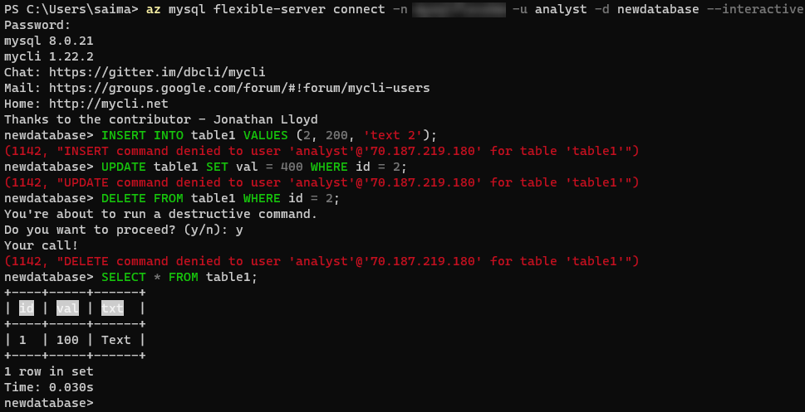

This image demonstrates running queries against the Flexible Server instance using the Azure CLI.

For more details on creating databases and users in Flexible Server, consult [this document.](https://learn.microsoft.com/azure/postgresql/flexible-server/howto-create-users?tabs=flexible-server) Note that it uses the PostgreSQL CLI.

## Language support

Once an editor is selected, the next step is to pick a development language or platform. Below are some quick links:

PHP

Java

Python

Other notable languages for PostgreSQL apps

### PHP

This section describes tools to interact with Azure Database for PostgreSQL Flexible Server through PHP.

#### Connect and query

##### Setup

Follow one of the methods in the Create a Flexible Server database document to create a Flexible Server instance with a database.

Moreover, install PHP from the [downloads page.](https://windows.php.net/download/) These instructions were tested with PHP 8.0.13 (any PHP 8.0 version should work).

The php.ini file needs to uncomment the extension=PostgreSQLi and extension=openssl lines for these steps to work.

A text editor such as Visual Studio Code may also be useful.

Lastly, download the [connection certificate](https://dl.cacerts.digicert.com/DigiCertGlobalRootCA.crt.pem) that is used for SSL connections with the PostgreSQL Flexible Server instance. In these snippets, the certificate is saved to C:\Tools on Windows. Adjust this if necessary.

##### Instructions

Microsoft’s [Quickstart guide](https://learn.microsoft.com/azure/postgresql/flexible-server/flexible-server/connect-php) performs standard CRUD operations against the PostgreSQL instance from a console app. This document modifies the code segments from the guide to provide an encrypted connection to the Flexible Server instance.

The first code snippet creates a table called Products with four columns, including a primary key. Adjust the host, username (most likely sqlroot), password, and db_name (most likely newdatabase) parameters to the values used during provisioning. Moreover, adjust the certificate path in the PostgreSQLi_ssl_set() method.

<?php  
$host = '[SERVER NAME].postgres.database.azure.com';  
$username = 'sqlroot';  
$password = '[PASSWORD]';  
$db_name = 'newdatabase';  
  
//Establishes the connection  
$conn = PostgreSQLi_init();  
PostgreSQLi_ssl_set($conn, NULL, NULL, "C:\Tools\DigiCertGlobalRootCA.crt.pem", NULL, NULL);  
PostgreSQLi_real_connect($conn, $host, $username, $password, $db_name, 5432, PostgreSQLI_CLIENT_SSL);  
if (PostgreSQLi_connect_errno()) {  
die('Failed to connect to PostgreSQL: '.PostgreSQLi_connect_error());  
}  
  
// Run the create table query  
if (pg_query($conn, '  
CREATE TABLE Products (  
`Id` INT NOT NULL AUTO_INCREMENT ,  
`ProductName` VARCHAR(200) NOT NULL ,  
`Color` VARCHAR(50) NOT NULL ,  
`Price` DOUBLE NOT NULL ,  
PRIMARY KEY (`Id`)  
);  
')) {  
printf("Table created\n");  
}  
  
//Close the connection  
PostgreSQLi_close($conn);  
?>

Console output with the message Table created should be displayed.

The second code snippet uses the same logic to start and close an SSL-secured connection. This time, it leverages a prepared insert statement with bound parameters.

<?php  
$host = '[SERVER NAME].postgres.database.azure.com';  
$username = 'sqlroot';  
$password = '[PASSWORD]';  
$db_name = 'newdatabase';  
  
//Establishes the connection  
$conn = PostgreSQLi_init();  
PostgreSQLi_ssl_set($conn, NULL, NULL, "C:\Tools\DigiCertGlobalRootCA.crt.pem", NULL, NULL);  
PostgreSQLi_real_connect($conn, $host, $username, $password, $db_name, 5432, PostgreSQLI_CLIENT_SSL);  
if (PostgreSQLi_connect_errno()) {  
die('Failed to connect to PostgreSQL: '.PostgreSQLi_connect_error());  
}  
  
//Create an Insert prepared statement and run it  
$product_name = 'BrandNewProduct';  
$product_color = 'Blue';  
$product_price = 15.5;  
if ($stmt = PostgreSQLi_prepare($conn, "INSERT INTO Products (ProductName, Color, Price) VALUES (?, ?, ?)")) {  
PostgreSQLi_stmt_bind_param($stmt, 'ssd', $product_name, $product_color, $product_price);  
PostgreSQLi_stmt_execute($stmt);  
printf("Insert: Affected %d rows\n", PostgreSQLi_stmt_affected_rows($stmt));  
PostgreSQLi_stmt_close($stmt);  
}  
  
//Close the connection  
PostgreSQLi_close($conn);  
?>

The console output message Insert: Affected 1 rows should be displayed.

The third code snippet utilizes the pg_query() method, just like the first code snippet. However, it also utilizes the PostgreSQLi_fetch_assoc() method to parse the result set.

<?php  
$host = '[SERVER NAME].postgres.database.azure.com';  
$username = 'sqlroot';  
$password = '[PASSWORD]';  
$db_name = 'newdatabase';  
  
//Establishes the connection  
$conn = PostgreSQLi_init();  
PostgreSQLi_ssl_set($conn, NULL, NULL, "C:\Tools\DigiCertGlobalRootCA.crt.pem", NULL, NULL);  
PostgreSQLi_real_connect($conn, $host, $username, $password, $db_name, 5432, PostgreSQLI_CLIENT_SSL);  
if (PostgreSQLi_connect_errno()) {  
die('Failed to connect to PostgreSQL: '.PostgreSQLi_connect_error());  
}  
  
//Run the Select query  
printf("Reading data from table: \n");  
$res = pg_query($conn, 'SELECT * FROM Products');  
while ($row = PostgreSQLi_fetch_assoc($res)) {  
var_dump($row);  
}  
  
//Close the connection  
PostgreSQLi_close($conn);  
?>

PHP returns an array with the column values for the row inserted in the previous snippet.

The next snippet uses a prepared update statement with bound parameters. It modifies the Price column of the record.

<?php  
$host = '[SERVER NAME].postgres.database.azure.com';  
$username = 'sqlroot';  
$password = '[PASSWORD]';  
$db_name = 'newdatabase';  
  
//Establishes the connection  
$conn = PostgreSQLi_init();  
PostgreSQLi_ssl_set($conn, NULL, NULL, "C:\Tools\DigiCertGlobalRootCA.crt.pem", NULL, NULL);  
PostgreSQLi_real_connect($conn, $host, $username, $password, $db_name, 5432, PostgreSQLI_CLIENT_SSL);  
if (PostgreSQLi_connect_errno()) {  
die('Failed to connect to PostgreSQL: '.PostgreSQLi_connect_error());  
}  
  
//Run the Update statement  
$product_name = 'BrandNewProduct';  
$new_product_price = 15.1;  
if ($stmt = PostgreSQLi_prepare($conn, "UPDATE Products SET Price = ? WHERE ProductName = ?")) {  
PostgreSQLi_stmt_bind_param($stmt, 'ds', $new_product_price, $product_name);  
PostgreSQLi_stmt_execute($stmt);  
printf("Update: Affected %d rows\n", PostgreSQLi_stmt_affected_rows($stmt));  
  
//Close the connection  
PostgreSQLi_stmt_close($stmt);  
}  
  
//Close the connection  
PostgreSQLi_close($conn);  
?>

After executing these commands, the message Update: Affected 1 rows should be displayed.

The final code snippet deletes a row from the table using the ProductName column value. It again uses a prepared statement with bound parameters.

<?php  
$host = '[SERVER NAME].postgres.database.azure.com';  
$username = 'sqlroot';  
$password = '[PASSWORD]';  
$db_name = 'newdatabase';  
  
//Establishes the connection  
$conn = PostgreSQLi_init();  
PostgreSQLi_ssl_set($conn, NULL, NULL, "C:\Tools\DigiCertGlobalRootCA.crt.pem", NULL, NULL);  
PostgreSQLi_real_connect($conn, $host, $username, $password, $db_name, 5432, PostgreSQLI_CLIENT_SSL);  
if (PostgreSQLi_connect_errno()) {  
die('Failed to connect to PostgreSQL: '.PostgreSQLi_connect_error());  
}  
  
//Run the Delete statement  
$product_name = 'BrandNewProduct';  
if ($stmt = PostgreSQLi_prepare($conn, "DELETE FROM Products WHERE ProductName = ?")) {  
PostgreSQLi_stmt_bind_param($stmt, 's', $product_name);  
PostgreSQLi_stmt_execute($stmt);  
printf("Delete: Affected %d rows\n", PostgreSQLi_stmt_affected_rows($stmt));  
PostgreSQLi_stmt_close($stmt);  
}  
  
//Close the connection  
PostgreSQLi_close($conn);  
?>

Congratulations. An SSL-secured connection with Flexible Server was demonstrated, a table was created (DDL), and some CRUD operations were performed against that table (DML).

#### Application connectors

There are two major APIs to interact with PostgreSQL in PHP:

* *PostgreSQLi*, *PostgreSQLi* is an improvement over the earlier *PostgreSQL* API, which does not meet the security needs of modern applications.
* *PDO*, or *PHP Data Objects*, allows applications to access databases in PHP through abstractions, standardizing data access for different databases. PDO works with a database-specific driver, like *PDO_PostgreSQL*.

 **Tip:** *PostgreSQLi* and *PDO* are wrappers over the *PostgreSQLnd* or *libPostgreSQLclient* C libraries: it is highly recommended to use *PostgreSQLnd* as the default backend library due to its more advanced features. *PostgreSQLnd* is the default backend provided with PHP.

Flexible Server and Single Server are compatible with all PHP client utilities for PostgreSQL Community Edition.

#### Resources

1. [Create a PHP web app in Azure App Service](https://aka.ms/php-qs)
2. [Backend libraries for PostgreSQLi and PDO_PostgreSQL](https://www.php.net/manual/en/PostgreSQLinfo.library.choosing.php)
3. [Introduction to PDO](https://www.php.net/manual/en/intro.pdo.php)
4. [PDO_PostgreSQL Reference](https://www.php.net/manual/en/ref.pdo-PostgreSQL.php)
5. [Configure a PHP app for Azure App Service](https://docs.microsoft.com/azure/app-service/configure-language-php?pivots=platform-linux)
6. The [php.ini directives](https://www.php.net/manual/en/ini.list.php) allow for the customization of the PHP environment.

### Java

This section describes tools to interact with Azure Database for PostgreSQL Flexible Server through Java.

#### Connect and query

Refer to the [Quickstart: Use Java and JDBC with Azure Database for PostgreSQL Flexible Server](https://docs.microsoft.com/azure/PostgreSQL/flexible-server/connect-java)

#### Application connectors

*PostgreSQL Connector/J* is a JDBC-compatible API that natively implements the PostgreSQL protocol in Java, rather than utilizing client libraries. The Connect and Query sample does not directly utilize *PostgreSQL Connector/J*, but Microsoft provides a sample that uses this technology.

Developers use persistence frameworks like Spring Data JPA to accelerate development. They can focus on the application business logic, not basic database communication. Spring Data JPA extends the JPA specification, which governs *object-relational mapping* (ORM) technologies in Java. It functions on top of JPA implementations, like the Hibernate ORM. The Connect and Query sample leverages Spring Data JPA and *PostgreSQL Connector/J* to access the Azure PostgreSQL instance and expose data through a web API.

Flexible Server is compatible with all Java client utilities for PostgreSQL Community Edition. However, Microsoft has only validated *PostgreSQL Connector/J* for use with Single Server due to its network connectivity setup. Refer to the [PostgreSQL drivers and management tools compatible with Azure Database for PostgreSQL Flexible Server](https://learn.microsoft.com/azure/postgresql/flexible-server/concepts-compatibility) article for more information about drivers compatible with Single Server.

#### Resources

1. [PostgreSQL Connector/J Introduction](https://dev.PostgreSQL.com/doc/connector-j/8.0/en/connector-j-overview.html)
2. PostgreSQL Connector/J Microsoft Samples
   * [Flexible Server](https://learn.microsoft.com/azure/postgresql/flexible-server/flexible-server/connect-java)
   * [Single Server](https://learn.microsoft.com/azure/postgresql/flexible-server/connect-java)
3. [Introduction to Spring Data JPA](https://www.baeldung.com/the-persistence-layer-with-spring-data-jpa)
4. [Hibernate ORM](https://hibernate.org/orm/)

#### Tooling

##### IntelliJ IDEA

Currently, Single Server is supported.

##### Eclipse

Eclipse is another popular IDE for Java development. It supports extensions for enterprise Java development, including powerful utilities for Spring applications. Moreover, through the Azure Toolkit for Eclipse, developers can quickly deploy their applications to Azure directly from Eclipse.

**Tool-Specific Resources**

1. [Installing the Azure Toolkit for Eclipse](https://docs.microsoft.com/azure/developer/java/toolkit-for-eclipse/installation)
2. [Create a Hello World web app for Azure App Service using Eclipse](https://docs.microsoft.com/azure/developer/java/toolkit-for-eclipse/create-hello-world-web-app)

##### Maven

Maven improves the productivity of Java developers by managing builds, dependencies, releases, documentation, and more. Maven projects are created from archetypes. Microsoft provides the Maven Plugins for Azure to help Java developers work with Azure Functions, Azure App Service, and Azure Spring Cloud from their Maven workflows.

 **Note:** Application patterns with Azure Functions, Azure App Service, and Azure Spring Cloud are addressed in the 04 / End to End application development story.

**Tool-Specific Resources**

1. [Azure for Java developer documentation](https://docs.microsoft.com/azure/developer/java/?view=azure-java-stable)
2. [Maven Introduction](https://maven.apache.org/guides/getting-started/index.html)
3. [Develop Java web app on Azure using Maven (App Service)](https://docs.microsoft.com/learn/modules/publish-web-app-with-maven-plugin-for-azure-app-service/)
4. [Deploy Spring microservices to Azure (Spring Cloud)](https://docs.microsoft.com/learn/modules/azure-spring-cloud-workshop/)
5. [Develop Java serverless Functions on Azure using Maven](https://docs.microsoft.com/learn/modules/develop-azure-functions-app-with-maven-plugin/)

### Python

This section describes tools to interact with Azure Database for PostgreSQL Flexible Server through Python.

#### Connect and query

##### Setup

This section will demonstrate how to query Azure Database for PostgreSQL Flexible Server using the PostgreSQL-connector-python library on Python 3.

Follow one of the methods in the Create a Flexible Server database document to create a Flexible Server instance with a database.

Moreover, install Python 3.7 or above from the [Downloads page](https://www.python.org/downloads/). This sample was tested using Python 3.8.

A text editor like Visual Studio Code will greatly help.

Though a Python Virtual Environment is not necessary for the sample to run, using one will avoid conflicts with packages installed globally on the development system. The commands below will create a Virtual Environment called venv and activate it on Windows. Instructions will differ for other OS.

python -m venv venv  
.\venv\Scripts\activate

##### Instructions

This section is based on [Microsoft’s sample](https://learn.microsoft.com/azure/postgresql/flexible-server/flexible-server/connect-python).

The first code snippet creates a table, inventory, with three columns. It uses raw queries to create the inventory table and insert three rows. If the snippet succeeds, the following output will be displayed.

Connection established  
Finished dropping table (if existed).  
Finished creating table.  
Inserted 1 row(s) of data.  
Inserted 1 row(s) of data.  
Inserted 1 row(s) of data.  
Done.

 **Note:** The sample establishes an SSL connection with the PostgreSQL instance. Use the statement below (placed before cursor and conn are closed) to validate the use of SSL.

cursor.execute("SHOW STATUS LIKE 'Ssl_cipher'")  
print(cursor.fetchone())

It is recommended to bind the [SSL public certificate](https://dl.cacerts.digicert.com/DigiCertGlobalRootCA.crt.pem) with connections to Flexible Server. Download the public certificate to a location on the development machine (such as C:\Tools). Then, edit the config dictionary to add the ssl_ca key and the file path of the certificate as the value.

config = {  
 'host':'[SERVER].postgres.database.azure.com',  
 'user':'sqlroot',  
 'password':'[PASSWORD]',  
 'database':'newdatabase',  
 'ssl_ca': 'C:\Tools\DigiCertGlobalRootCA.crt.pem'  
}

The second code snippet connects to the PostgreSQL instance and executes a raw query to SELECT all rows from the inventory table. This time, it uses the fetchall() method to parse the result set into a Python iterable. An output like the one below should display:

Connection established  
Read 3 row(s) of data.  
Data row = (1, banana, 150)  
Data row = (2, orange, 154)  
Data row = (3, apple, 100)  
Done.

The third code snippet executes an UPDATE statement to change the quantity value of the record identified by name. An output like the one below should display:

Connection established  
Updated 1 row(s) of data.  
Done.

The final snippet executes a raw DELETE statement against the inventory table targeting records identified by name. An output like the one below should display:

Connection established  
Deleted 1 row(s) of data.  
Done.

At this point, a successfully opened connection to Flexible Server was established, a table was created (DDL), and CRUD operations were performed (DML) against data in the table.

If a Python Virtual Environment was created, simply enter deactivate into the console to remove it. .

#### Application connectors

*PostgreSQL Connector/Python* offers a Python Database API specification-compatible driver for PostgreSQL database access (PEP 249). It does not depend on a PostgreSQL client library. The Python Connect and Query sample utilizes *PostgreSQL Connector/Python*.

An alternative connector is *PyPostgreSQL*. It is also PEP 249-compliant.

Django is a popular web application framework for Python. The Django ORM officially supports PostgreSQL through (1) the *PostgreSQLclient* Python wrapper for the native PostgreSQL driver or (2) the *PostgreSQL Connector/Python* API. *PostgreSQLclient* is recommended for use with the Django ORM.

Flexible Server is compatible with all Python client utilities for PostgreSQL Community Edition. However, Microsoft has only validated *PostgreSQL Connector/Python* and *PyPostgreSQL* for use with Single Server due to its network connectivity setup. Refer to [this](https://learn.microsoft.com/azure/postgresql/flexible-server/concepts-compatibility) document for more information about drivers compatible with Single Server.

#### Resources

1. [Introduction to PostgreSQL Connector/Python](https://dev.PostgreSQL.com/doc/connector-python/en/connector-python-introduction.html)
2. [PyPostgreSQL Samples](https://pyPostgreSQL.readthedocs.io/en/latest/user/examples.html)
3. [PostgreSQLdb (PostgreSQLclient) User’s Guide](https://PostgreSQLclient.readthedocs.io/user_guide.html#PostgreSQLdb)
4. [Django ORM Support for PostgreSQL](https://docs.djangoproject.com/en/3.2/ref/databases/#PostgreSQL-notes)

### Other notable languages for PostgreSQL apps

Like the other language support guides, Flexible Server is compatible with all PostgreSQL clients that support PostgreSQL Community Edition. Microsoft provides a [curated list of compatible clients for PostgreSQL Single Server](https://learn.microsoft.com/azure/postgresql/flexible-server/concepts-compatibility).

#### .NET

.NET applications typically use ORMs to access databases and improve portability: two of the most popular ORMs are Entity Framework (Core) and Dapper.

Using PostgreSQL with Entity Framework (Core) requires [PostgreSQL Connector/NET](https://github.com/PostgreSQL/PostgreSQL-connector-net), which is compatible with Single Server. Learn more [from the PostgreSQL documentation](https://dev.PostgreSQL.com/doc/connector-net/en/connector-net-entityframework-core.html) about support for Entity Framework (Core).

Microsoft has also validated that PostgreSQL Single Server is compatible with the [Async PostgreSQL Connector for .NET](https://github.com/PostgreSQL-net/PostgreSQLConnector). This connector works with both Dapper and Entity Framework (Core).

#### Ruby

The [*PostgreSQL2*](https://github.com/brianmario/PostgreSQL2) library, compatible with Single Server, provides PostgreSQL connectivity in Ruby by referencing C implementations of the PostgreSQL connector.

## 03 / Summary

This module augmented an understanding of Flexible Server through practical examples of how modern applications access Flexible Server. Flexible Server supports all standard PostgreSQL clients. Previously presented information Microsoft Azure deployment tools and concepts were utilized to provision a Flexible Server instance to run the included code examples.

In the next section, the Contoso NoshNow Sample Application provides a starting point for the entire developer journey. It provides high-level concepts and shows how PostgreSQL apps can be evolved into a scalable modern applications.

# 04 / End to End application development

The previous chapters provided some basic Azure hands-on experience. It is important to understand high-level concepts before moving to more advanced examples and concepts. Once you have reviewed the building block concepts, you will learn about how to set up your Azure development environment, and get some hands-on architecture experience by working through the tutorial journey. The guide provides experience with Windows and Linux infrastructures.

With a configured development environment available, it is time to explore the various architecture and deployment options available when deploying an application and its corresponding PostgreSQL database.

This chapter focuses on these subjects:



This image explains the progression of topics in this chapter.

## Common Azure development services overview

This section explains common cloud application architectures and Azure services. While these services are not directly related to PostgreSQL, they are often used in modern Azure applications. This content provides a fundamental understanding of the common Azure development resources. Subsequent material will reference these Azure services heavily.

### Web Apps

Developers can deploy PostgreSQL-backed apps to Azure on a Windows or Linux environment through [Azure App Service,](https://docs.microsoft.com/azure/app-service/overview) a PaaS platform that supports popular frameworks, including .NET, PHP, Java, Python, Docker containers, and more. App Service is compatible with manual deployment mechanisms, including ZIP files, FTP, and local Git repositories. It also supports automated mechanisms, like GitHub Actions, to deploy faster and minimize issues. Coupled with powerful management tools, like the Kudu console, App Service is suitable for many enterprise apps.

#### Resources

* [App Service overview](https://docs.microsoft.com/azure/app-service/overview)
* PHP and PostgreSQL Flexible Server sample app:
  + Manual deployment: [Running the sample application](https://github.com/Azure/azure-PostgreSQL/blob/master/DeveloperGuide/step-1-sample-apps/README.md)
  + Scripted deployment: [Cloud Deployment to Azure App Service](https://github.com/Azure/azure-PostgreSQL/tree/master/DeveloperGuide/step-2-developer-journey-steps/02-02-CloudDeploy-AppSvc)

### Serverless Compute

[Azure Functions](https://docs.microsoft.com/azure/azure-functions/functions-overview) and [Azure Logic Apps](https://docs.microsoft.com/azure/logic-apps/logic-apps-overview) are serverless platforms, meaning that customers are billed only for the execution time of their code. Azure automatically scales compute resources up and down in response to demand.

### Azure Functions

An Azure Functions instance consists of individual functions that execute in response to a *trigger*, like a cron job or an HTTP request. These functions interface with other Azure resources, like Cosmos DB, through bindings, though resources without default bindings, like Azure Database for PostgreSQL Flexible Server, can be accessed through language-specific connectors.

Like Azure App Service, Function Apps support multiple programming languages. Developers can extend support to unsupported languages through [custom handlers.](https://docs.microsoft.com/azure/azure-functions/functions-custom-handlers)

For long-running, stateful serverless architectures, such as when human intervention is necessary, Azure provides the Durable Functions extension. Consult the [documentation](https://docs.microsoft.com/azure/azure-functions/durable/durable-functions-overview?tabs=csharp) for more information about architectures with Durable Functions.

#### Resources

* [Introduction to Azure Functions](https://docs.microsoft.com/azure/azure-functions/functions-overview)
* [Azure Functions hosting options](https://docs.microsoft.com/azure/azure-functions/functions-scale)
* Azure Functions with PostgreSQL Flexible Server samples:
  + .NET: [Azure Function with PostgreSQL (.NET)](https://github.com/Azure/azure-PostgreSQL/tree/master/DeveloperGuide/step-2-developer-journey-steps/06-01-FunctionApp-DotNet)
  + Python: [Azure Function with PostgreSQL (Python)](https://github.com/Azure/azure-PostgreSQL/tree/master/DeveloperGuide/step-2-developer-journey-steps/06-02-FunctionApp-Python)

### Azure Logic Apps

Azure Logic Apps provide integration services for enterprises, connecting applications that reside on-premises and in the cloud. Azure Logic Apps *workflows* execute *actions* after a *trigger* is fired.

Azure Logic Apps interface with external systems through *managed connectors*. Microsoft provides a managed connector for PostgreSQL databases, but this connector cannot easily be used for Azure Database for PostgreSQL Flexible Server, as the PostgreSQL managed connector accesses local PostgreSQL databases through a data gateway.

#### Resources

* [What is a Azure Logic App?](https://docs.microsoft.com/azure/logic-apps/logic-apps-overview)
* [Compare Azure Functions and Azure Logic Apps](https://docs.microsoft.com/azure/azure-functions/functions-compare-logic-apps-ms-flow-webjobs#compare-azure-functions-and-azure-logic-apps)
* [Logic Apps with PostgreSQL](https://github.com/Azure/azure-PostgreSQL/tree/master/DeveloperGuide/step-2-developer-journey-steps/06-05-LogicApp)

### Microservices

Organizations deploy microservices architectures to offer resilient, scalable, developer-friendly applications. Unlike traditional monolithic apps, each service operates independently and can be updated without redeploying the app. Each service also manages its own persistence layer, meaning that service teams can perform database schema updates without affecting other services.

While microservices apps offer major benefits, they require advanced tools and knowledge of distributed systems. Organizations utilize domain analysis to define optimal boundaries between services.

On Azure, organizations often deploy microservices to Azure Kubernetes Service through CI/CD platforms, such as GitHub Actions.

#### Resources

* [Build microservices on Azure](https://docs.microsoft.com/azure/architecture/microservices/)
* [Using domain analysis to model microservices](https://docs.microsoft.com/azure/architecture/microservices/model/domain-analysis)
* [Deploying a Laravel app backed by a Java REST API to AKS](https://github.com/Azure/azure-PostgreSQL/tree/master/DeveloperGuide/step-2-developer-journey-steps/sample-php-app-rest)

### API Management

Azure API Management allows organizations to manage and securely expose their APIs hosted in diverse environments from a central service. API Management simplifies legacy API modernization, API exposure to multiple platforms, and data interchange between businesses. Applications call APIs through an *API gateway* that validates credentials, enforces quotas, serializes requests in different protocols, and more. Developers operate their API Management instances through the management plane, and they expose API documentation for internal and external users through the Developer portal.

Like other Azure resources, API Management offers comprehensive RBAC support, accommodating internal administrative and development staff and external users. Moreover, as API Management integrates with APIs hosted in environments outside Azure, organizations can self-host the API gateway while retaining the Azure management plane APIs.

#### Resources

* [About API Management](https://docs.microsoft.com/azure/api-management/api-management-key-concepts)
* [Self-hosted gateway overview](https://docs.microsoft.com/azure/api-management/self-hosted-gateway-overview)

### Event-driven - Azure Event Grid vs. Service Bus vs. Event Hubs

Event-driven apps create, ingest, and process events (state changes) in real-time. Event producers and event consumers are loosely-coupled, and every consumer sees every event. Event-driven architectures can perform complex event handling, such as aggregations over time, and operate with large volumes of data produced rapidly.

Azure provides different services for relaying *messages* and *events*. When one system sends a message to another, it expects the receiving system to handle the message in a particular way and respond. However, with events, the publisher does not care how the event is handled.

#### Azure Event Grid

Azure Event Grid is a serverless publish-subscribe system that integrates well with Azure and non-Azure services. As an event-based system, it simply relays state changes to subscribers; it does not contain the actual data that was changed.

#### Azure Service Bus

Azure Service Bus provides a *queue* capability to pass each message to one consumer (first-in-first-out queue). Moreover, Service Bus includes pub-sub functionality, allowing more than one consumer to receive a message.

#### Azure Event Hubs

Azure Event Hubs facilitates the ingestion and replay of event data. It is optimized for processing millions of events per second. Event Hubs supports multiple consumers through *consumer groups*, which point to certain locations in the stream.

#### Example Solution

An e-commerce site can use Service Bus to process an order, Event Hubs to capture site telemetry, and Event Grid to respond to events like an item was shipped.

### Cron jobs

Developers use cron jobs to run operations on a schedule. They are often useful for administrative tasks, like taking site backups. Azure Functions and Logic Apps support cron jobs:

* [Azure Functions:](https://docs.microsoft.com/azure/azure-functions/functions-bindings-timer) The timer trigger executes a function on a schedule. Azure Functions supports more complex scheduling tasks, like specifying the cron job time precision.
* [Logic Apps:](https://docs.microsoft.com/azure/logic-apps/concepts-schedule-automated-recurring-tasks-workflows) Logic Apps supports Recurrence triggers and Sliding Window triggers. Recurrence triggers run Logic Apps on a schedule, while Sliding Window triggers extend Recurrence triggers by executing occurrences that were missed (e.g. the Logic App was disabled).

### WebJobs

Azure WebJobs, like Azure Functions, processes events in Azure services. WebJobs executes code in an App Service instance, and it works best with the WebJobs SDK. However, WebJobs with the WebJobs SDK only supports C#.

Azure Functions is built on the WebJobs SDK. It offers more developer flexibility than WebJobs and serverless execution. However, WebJobs provides more control over how events are received than what Azure Functions exposes.

### Advanced orchestration - Azure Data Factory

Azure Data Factory supports serverless data integration at scale. Users author data integration *pipelines* that consist of multiple *activities*. Activities operate on *datasets* (data sources and sinks). Data Factory compute environments are known as *integration runtimes*. Integration runtimes can be hosted in Azure or on-premises.

Azure Data Factory supports both Azure PaaS and generic (on-premises) PostgreSQL instances.

Developers can execute Data Factory pipelines manually, on a schedule, or in response to Azure events through the Event Grid integration.

 [Copy activity performance and scalability guide](https://docs.microsoft.com/azure/data-factory/copy-activity-performance)

## Introduction to the Sample Application

Instead of learning multiple sample applications, the guide focuses on evolving an architecture and deployment strategies. Readers should learn the sample application structure once and focus on how the application will need to be modified to fit the deployment model and architecture evolution.

### Sample Application overview and story

Contoso NoshNow is a delivery service and logistics company focused on making delicious food accessible to its customers no matter where they are located. The company started with a simple web application they could easily maintain and add features to as the business grew. A few years later, their CIO realized the application performance and their current on-premises environment were not meeting their business’s growing demand. The application deployment process took hours, yielded unreliable results, and the admin team could not easily find production issues quickly. During the busy hours, customers complained the web application was slow.

The development team knew migrating to Azure could help with these issues.

### Solution architecture

This is the base application that will be evolved in the future sample scripts. This PaaS architecture is a couple of steps ahead of the Classic architecture. The Classic architecture is meant to be an example of an existing on-premises environment that might be migrated to the Azure cloud. If you have a new application, you most likely will start with the PaaS architecture depicted below. This is the easiest path for a user looking to understand the Azure basics.

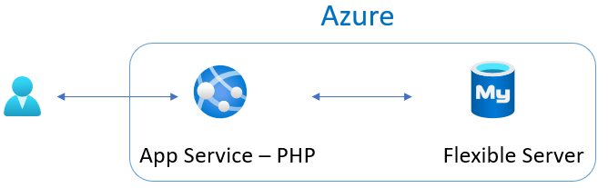

This image shows a sample architecture involving a PHP App Service instance and a Flexible Server instance.

### Site map

The web application is simple, but covers the fundamentals.

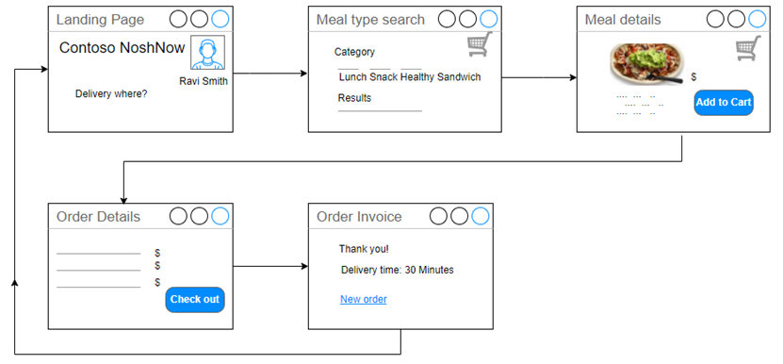

This image shows the sample app site map.

### Running the sample lab

You will find the steps to run the lab in the artifacts repo here: [Sample application tutorial](https://github.com/Azure/azure-PostgreSQL/tree/master/DeveloperGuide/step-1-sample-apps)

## Deployment evolution options

Let us discuss the journey overview. The journey will start with a classic deployment to a typical web and database server on a physical or virtualized host operating system. Next, explore the evolution of the potential deployment options from a simple web app deployed to App Service through a complex progression ending with the application running as containers in Azure Kubernetes Service (AKS) with Azure Database for PostgreSQL Flexible Server hosting the database.

The following scenarios will be discussed and demonstrated as part of this Azure PostgreSQL developer’s guide. All of the following deployments will utilize the same application and database backend and what is needed to modify the application to support the targets. Topics will be discussed in the following simple to complex architecture order.

### Deployment option TOC

1. Classic deployment
2. Azure VM Deployment
3. Simple App Service deployment with Azure Database for PostgreSQL Flexible Server
4. [App Service with In-App PostgreSQL]
5. Continuous Integration (CI) and Continuous Delivery (CD)
6. Containerizing layers with Docker
7. Azure Container Instances (ACI)
8. App Service Containers
9. Azure Kubernetes Service (AKS)
10. AKS with PostgreSQL Flexible Server

## Classic deployment

In a classic deployment, development and operations staff will typically set up a web server (such as Internet Information Services (IIS), Apache, or NGINX) on physical or virtualized **on-premises** hardware.

Some web servers are relatively easier to set up than others. The complexity depends on what the target operating system is and what features the application and database are using, for example, SSL/TLS.

In addition to the web server, it is also necessary to install and configure the physical PostgreSQL database server. This includes creating the schema and the application users that will be used to access the target database(s).

As part of our sample application and supporting Azure Landing zone created by the ARM templates, most of this gets set up automatically. Once the software is installed and configured, it is up to the developer to deploy the application and database on the system. Classical deployments tend to be manual such that the files are copied to the target production web server and then deploy the database schema and supported data via PostgreSQL tools or the pgAdmin tool.

The biggest advantage of a classic on-premises deployment is the infrastructure team will have full control of the environment. The biggest weakness is they must also maintain every aspect of the environment as well.

## Azure VM deployment

An Azure VM Deployment is very similar to a classical deployment but rather than deploying to physical hardware, deployment is to virtualized hardware in the Azure cloud. The operating system and software will be the same as in a classic deployment, but to open the system to external apps and users, the virtual networking must be modified to allow database access to the web server. This is known as the IaaS (infrastructure as a service) approach.

The advantages of using Azure to host virtual machines include the ability to enable backup and restore services, disk encryption, and scaling options that require no upfront costs and provide flexibility in configuration options with just a few clicks of the mouse. This is in contrast to the relatively complex and extra work needed to enable these types of services on-premises.

## Simple App Service deployment with Azure Database for PostgreSQL Flexible Server

If supporting the operating system and the various other software is not a preferred approach, the next evolutionary path is to remove the operating system and web server from the list of setup and configuration steps. This can be accomplished by utilizing the Platform as a Service (PaaS) offerings of Azure App Service and Azure Database for PostgreSQL Flexible Server.

However, modernizing an application and migrating them to these aforementioned services may introduce some relatively small application changes.

## Continuous Integration (CI) and Continuous Delivery (CD)

Doing manual deployments every time a change is made can be a very time-consuming endeavor. Utilizing an automated deployment approach can save a lot of time and effort. Azure DevOps and Github Actions can be used to automatically deploy code and databases each time a new commit occurs in the codebase.

Whether using Azure DevOps or Github, there will be some setup work to support the deployments. This typically includes creating credentials that can connect to the target environment and deploy the release artifacts.

## Containerizing layers with Docker

By building the application and database with a specific target environment in mind, it will need to be assumed that the operations team will have deployed and configured that same environment to support the application and data workload. If they missed any items, the application will either not load or may error during runtime.

Containers solve the potential issue of misconfiguration of the target environment. By containerizing the application and data, the application will run exactly as intended. Containers can also more easily be scaled using tools such as Kubernetes.

Containerizing an application and data layer can be relatively complex, but once the build environment is set up and working, it is possible to push container updates very quickly to multi-region load-balanced environments.

## Azure Container Instances (ACI)

After application and data layers are migrated to containers, a hosting target must be selected to run the containers. A simple way to deploy a container is to use Azure Container Instances (ACI).

Azure Container Instances can deploy one container at a time or multiple containers to keep the application, API, and data contained in the same resource.

## App Service Containers

Developers can extend the benefits of App Service, like scalability, elasticity, and simple CI/CD integration, to their containerized apps using App Service for Containers. This offering supports individual containers and multi-container apps through Docker Compose files. Containers give teams added flexibility beyond the platforms supported directly by App Service.

## Azure Kubernetes Service (AKS)

ACI and App Service Container hosting are effective ways to run containers, but they do not provide many enterprise features: deployment across nodes that live in multiple regions, load balancing, automatic restarts, redeployment, and more.

Moving to Azure Kubernetes Service (AKS) will enable the application to inherit all the enterprise features provided by AKS. Moreover, Kubernetes apps that persist data in PostgreSQL Flexible Server unlock numerous benefits:

* In supported regions, co-locating Flexible Server and AKS nodes in the same availability zone minimizes latency.

## AKS with PostgreSQL Flexible Server

Running the database layer in a container is better than running it in a VM, but not as great as removing all the operating system and software management components.

## Start the hands-on-tutorial developer journey

### Development environment setup

The first step to exploring the evolution of PostgreSQL Application development is to get the environment set up and configure the infrastructure.

We provided two ARM templates that can be deployed that will set up the environment. The template is a JavaScript Object Notation (JSON) file that defines the infrastructure and configuration for your project. In the template, you specify the resources to deploy and the properties for those resources.

One is a **basic deployment** of services that are exposed to the internet and the other is a more secure environment that utilizes private endpoints and VNet integrations. It also includes items like Azure Firewall and other security-related configurations.

The basic template is the cheaper way to go and should work without any configuration. The **secure template** will have much higher costs and will require special configuration and changes to get the samples to work properly.

#### How to deploy a local ARM template

Below are two methods of deploying an ARM template:

**Azure Portal**

* Login into the Azure Portal and choose a valid Subscription.
* Search for ‘Deploy a custom template’.

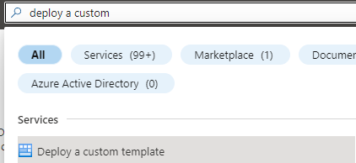

This image shows how to enter the Deploy a custom template wizard in the Azure portal.

* Select ‘Build your own template in the editor’.

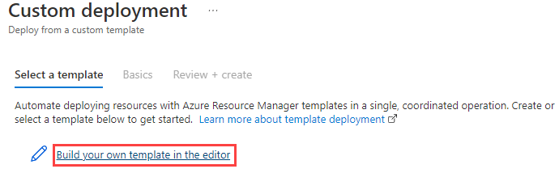

This image shows the Build your own template in the editor button.

* Load the ARM template file from your local drive.

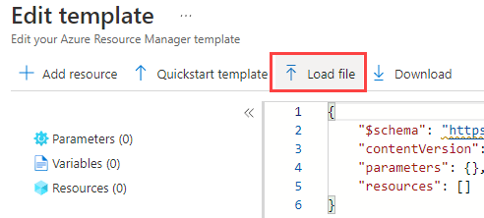

This image shows how to load the ARM template from the local drive.

* Navigate to the **template.json** file.
* Save the template.

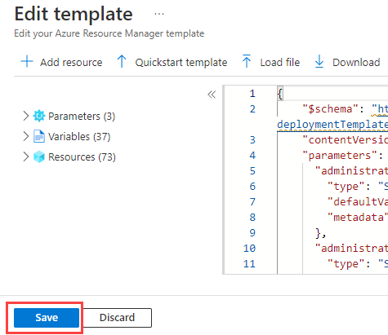

This image shows how to save the ARM template in the editor.

* Enter the template parameters.
* Select the **Review + create** button.
* Check for validation errors. For example, you may have exceeded your quota for that subscription and region.

Another option for deploying infrastructure using a template is to use Azure CLI or PowerShell. Here is a tutorial guide:

[Tutorial: Deploy a local ARM template](https://docs.microsoft.com/azure/azure-resource-manager/templates/deployment-tutorial-local-template?tabs=azure-cli)

#### Step 1 - Build the development environment - deploy one of the templates below

This is an optional step if you have your development environment already set up. You will need to install the basic Azure development packages.

* [Basic Template](https://github.com/Azure/azure-PostgreSQL/tree/master/DeveloperGuide/step-0-create-development-vm/basic-template/template.json)
* [Secure Template](https://github.com/Azure/azure-PostgreSQL/tree/master/DeveloperGuide/step-0-create-development-vm/secure-template/template-secure.json)

#### Step 2 - Explore the development environment

Once the template has been deployed, several resources will be deployed to support the developer journey. Not all of these will be used but are provided in case other paths would like to be explored.

As part of the deployment, a **pgsqldevSUFFIX-paw1** virtual machine has been deployed that will be used to perform all the activities. Login to this virtual machine by doing the following:

* Open Azure Portal
* Browse to your resource group
* Select the **pgsqldevSUFFIX-paw1** virtual machine
* Select **Connect->RDP**
* Select **Download RDP file**
* Open the downloaded file, select **Connect**
* For the username, type **wsuser**
* For the password, type **Solliance123**

Once in the virtual machine, notice that all the necessary development tools have already been installed. Additionally, the supporting GitHub repository has been downloaded that includes all the artifacts needed to start the developer journey. These files can be found on the **pgsqldevSUFFIX-paw1** machine in the C:\labfiles\microsoft-postgresql-developer-guide folder.

#### Step 3 - Start your journey

To reiterate, it is recommended to follow the developer journey from start to finish in the following order:

##### Deployment option tutorial lab links

Click the links to complete each journey before going to the next.

1. [Classic deployment](https://github.com/Azure/azure-PostgreSQL/tree/master/DeveloperGuide/step-2-developer-journey-steps/01-ClassicDeploy)
2. [Azure VM Deployment](https://github.com/Azure/azure-PostgreSQL/tree/master/DeveloperGuide/step-2-developer-journey-steps/02-01-CloudDeploy-Vm)
3. [Simple App Service Deployment with Azure Database for PostgreSQL Flexible Server](https://github.com/Azure/azure-PostgreSQL/tree/master/DeveloperGuide/step-2-developer-journey-steps/02-02-CloudDeploy-AppSvc)
4. [Continuous Integration / Continuous Delivery](https://github.com/Azure/azure-PostgreSQL/tree/master/DeveloperGuide/step-2-developer-journey-steps/02-03-CloudDeploy-CICD)
5. [Containerizing layers with Docker](https://github.com/Azure/azure-PostgreSQL/tree/master/DeveloperGuide/step-2-developer-journey-steps/03-00-Docker)
6. [Azure Container Instances (ACI)](https://github.com/Azure/azure-PostgreSQL/tree/master/DeveloperGuide/step-2-developer-journey-steps/03-01-CloudDeploy-ACI)
7. [App Service Containers](https://github.com/Azure/azure-PostgreSQL/tree/master/DeveloperGuide/step-2-developer-journey-steps/03-02-CloudDeploy-AppService-Container)
8. [Azure Kubernetes Service (AKS)](https://github.com/Azure/azure-PostgreSQL/tree/master/DeveloperGuide/step-2-developer-journey-steps/04-AKS)
9. [AKS with PostgreSQL Flexible Server](https://github.com/Azure/azure-PostgreSQL/tree/master/DeveloperGuide/step-2-developer-journey-steps/05-CloudDeploy-PostgreSQLFlex)

##### Compute and orchestration tutorial lab links

Additionally, some applications are more than just a web application with a database backend. Microsoft Azure provides several compute engines with varying degrees of features and administrative abilities.

It is recommended that each of the above scenarios is executed in the order shown so that a full picture of the steps involved in the development evolution is understood. This will also ensure the necessary pre-requisite Azure services and resources are available for the reader to progress to the more complex deployment examples.

* [Azure Functions](https://docs.microsoft.com/azure/azure-functions/functions-overview)
  + [Dotnet](https://github.com/Azure/azure-PostgreSQL/tree/master/DeveloperGuide/step-2-developer-journey-steps/06-01-FunctionApp-DotNet)
  + [Python](https://github.com/Azure/azure-PostgreSQL/tree/master/DeveloperGuide/step-2-developer-journey-steps/06-02-FunctionApp-Python)
  + [AKS](https://github.com/Azure/azure-PostgreSQL/tree/master/DeveloperGuide/step-2-developer-journey-steps/06-03-FunctionApp-AKS)
  + [Secured with MSI](https://github.com/Azure/azure-PostgreSQL/tree/master/DeveloperGuide/step-2-developer-journey-steps/06-04-FunctionApp-MSI)
* [Logic Apps](https://github.com/Azure/azure-PostgreSQL/tree/master/DeveloperGuide/step-2-developer-journey-steps/06-05-LogicApp)
* [Azure Data Factory](https://github.com/Azure/azure-PostgreSQL/tree/master/DeveloperGuide/step-2-developer-journey-steps/07-01-AzureDataFactory)
* [Azure Synapse Analytics](https://github.com/Azure/azure-PostgreSQL/tree/master/DeveloperGuide/step-2-developer-journey-steps/07-02-AzureSynapseAnalytics)
* [Azure Batch](https://github.com/Azure/azure-PostgreSQL/tree/master/DeveloperGuide/step-2-developer-journey-steps/07-03-AzureBatch)

### Sample Application evolution

The Sample Application is written as a two-tier application. This architecture is great for a proof of concept or an application that has limited performance needs. Scaling this type of application is difficult and costly. Developers should consider separating their application’s business logic and data concerns into a [microservice](https://azure.microsoft.com/solutions/microservice-applications/#solution-architectures) layer. For more information on design patterns, review: [Design patterns for microservices](https://docs.microsoft.com/azure/architecture/microservices/design/patterns).

After reviewing the need for microservice architecture and the typical design patterns, you can see how the Sample Application architecture changed when it utilizes a Java REST microservice architecture.

 [Deploying a Laravel app backed by a Java REST API to AKS](https://github.com/Azure/azure-PostgreSQL/tree/master/DeveloperGuide/step-1-sample-apps/sample-php-app-rest).

## Application continuous integration and deployment

Manually deploying an application is not efficient and changes to the environment need to be tested. Microsoft recommends automating build and deployment processes to minimize application errors and the time to release new features. This practice is often termed CI/CD. Below are the common terms and definitions:

* **Continuous Integration (CI):** CI tools automatically build, test, and merge code that developers push to version control systems. CI pipelines run code analysis tools to enforce style guidelines, unit tests, integration tests, and more. By constantly merging developers’ contributions to a shared branch, CI tools improve developer efficiency.
* **Continuous Delivery (CD):** Continuous delivery tools package applications in a format that operations teams can deploy to production. This typically involves pushing a container image to a container registry.
* **Continuous Deployment (CD):** Continuous deployment automates the production deployment process; it does not require an operations team to intervene. Continuous deployment processes extend continuous delivery.

Implementing build and deployment automation means that development teams can rapidly serve small features and fixes in production, rather than waiting for one large, error-prone manual deployment.

### CI/CD tools

Below are some common CI/CD tool options.

#### Jenkins

There are a plethora of CI/CD tools available for local Git repositories, such as Jenkins. Jenkins is an open-source project that supports over 1,500 extensions and offers advanced features, such as parallel test execution.

#### Local Git

Azure App Service supports automated deployments from local Git repositories: developers simply need to push their code to an App Service remote repository. Consult the [Running the sample application](https://github.com/Azure/azure-PostgreSQL/blob/master/DeveloperGuide/step-1-sample-apps/README.md) for a step-by-step App Service deployment from a local Git repository.

#### App Service Deployment Slots

App Service instances in the Standard tier or higher support *deployment slots*, which are separate instances of an app accessible on different hostnames. Developers can validate app updates in a staging slot before swapping the updates into the production slot. After swapping an app from a staging slot to the production slot, the staging slot holds the old production app, allowing teams to quickly roll back unsuccessful changes. Swapping a slot has no downtime.

#### App Service Deployment Center

The Deployment Center provides a summary of the deployment methods for an App Service instance. It also allows developers to quickly create CI/CD pipelines for code stored in version control systems. App Service executes pipelines on multiple targets, including GitHub Actions, Azure Pipelines, and built-in Kudu.

#### GitHub Actions

GitHub Actions runs automated pipelines after an event occurs, such as when a developer pushes to a repository branch or opens a PR. As GitHub Actions integrates with GitHub repositories, pipelines can respond to other repository events, such as when a new issue is opened.

A GitHub repository can have multiple *workflows* (pipelines) written in [YAML.](yaml.org) At their most basic level, workflows consist of *actions* that perform some basic task, such as initializing a build tool. Teams can run GitHub Actions on GitHub runners or self-hosted runners for greater flexibility.

#### Azure DevOps

Azure DevOps includes multiple tools to improve team collaboration and automate building, testing, and deploying apps.

* [Azure Boards:](https://docs.microsoft.com/azure/devops/boards/get-started/what-is-azure-boards?view=azure-devops) Azure Boards helps teams plan and track work items. It supports multiple [processes.](https://docs.microsoft.com/azure/devops/boards/work-items/guidance/choose-process?view=azure-devops&tabs=basic-process)
* [Azure Pipelines:](https://docs.microsoft.com/azure/devops/pipelines/get-started/what-is-azure-pipelines?view=azure-devops) Azure Pipelines is Microsoft’s CI/CD pipeline platform. It supports deployment to PaaS services, virtual machines, and container registries in Azure, other cloud platforms, and on-premises. Azure Pipelines integrates with common version control systems, like GitHub, GitLab, and Azure Repos.
* [Azure Test Plans:](https://docs.microsoft.com/azure/devops/test/overview?view=azure-devops) Azure Test Plans allows development teams to create manual tests, for feedback from developers and stakeholders, and automated tests, which are necessary for any CI/CD pipeline.
* [Azure Repos:](https://docs.microsoft.com/azure/devops/repos/get-started/what-is-repos?view=azure-devops) Azure Repos provides Microsoft-hosted public and private Git repositories.
* [Azure Artifacts:](https://docs.microsoft.com/azure/devops/artifacts/start-using-azure-artifacts?view=azure-devops) Azure Artifacts allows organizations to share packages, such as NuGet and npm packages, internally and publicly. Azure Artifacts integrates with Azure Pipelines.

Organizations can quickly start exploring Azure DevOps by creating a free organization. Azure DevOps’ suite of project management, CI/CD, and testing tools empowers organizations to deploy more frequently, more quickly, and with fewer failures.

### Infrastructure as Code (IaC)

Infrastructure as Code is a declarative approach to infrastructure management. Imperative approaches, like Azure PowerShell, are also supported, though declarative techniques are preferred for their flexibility. IaC integrates well with CI/CD pipelines, as it ensures that all application environments are consistent: IaC artifacts, such as ARM templates and Bicep files, are stored in version control systems. When development teams make environment changes, they edit IaC environment definitions, and pipelines automatically alter the cloud environment to fit the new requirements, irrespective of the existing state of the cloud environment (*idempotence*).

Both [Azure Pipelines](https://docs.microsoft.com/azure/azure-resource-manager/templates/add-template-to-azure-pipelines) and [GitHub Actions](https://docs.microsoft.com/azure/azure-resource-manager/templates/deploy-github-actions) support automated ARM template deployments. Moreover, through the [Azure Service Operator](https://azure.github.io/azure-service-operator/), development teams can provision Azure resources from Kubernetes, integrating infrastructure management into existing Kubernetes release pipelines. [Here](https://techcommunity.microsoft.com/t5/azure-database-for-PostgreSQL-blog/using-azure-service-operator-to-provision-azure-db-for-PostgreSQL/ba-p/3056231) is a Microsoft sample provisioning Flexible Server from Kubernetes.

## 04 / Summary

This module was designed to bring all the elements of the modernization and cloud adoption journey together via a progressive set of examples and learning paths. After completing all of the samples in this module, a developer will have an understanding of where an application sits in the modernization process and how to take it to the next level via containers and container hosting environments.

Although this guide did not go into detail about how to host applications across multiple cloud providers, this would be the next logical step in the evolution of PostgreSQL applications and databases. Several Microsoft partners and vendors (such as Hashicorp), provide tools and services that help facilitate this final step.

As the world of microservices continues to change and evolve through more innovative technologies (such as blockchain, other patterns and steps may emerge in the future that will change the evolutionary course of your architecture(s).

By using containers, developers can be assured the code will run consistently for specific target environments.However, when multiple containers are involved or are moved from one environment to another (such as AKS to Azure Service Fabric or some other container cloud provider), resources may not run well or at all. The management plane may not be configured properly to support the containers. Following the approaches defined in this section will help developers understand the tools available and what they should be looking for when designing microservices.

### Checklist

* Understand the basic Azure fundamental services.
* Understand the phases in the developer evolution journey.
* Be able to evaluate where your application architecture fits in the journey.
* Be cognizant of the changes that are needed for applications to move to the next state.
* Utilize modern development and deployment methodologies.

## Vectors

Dimension: The dimension of a vector is the number of elements that it contains. In the example above, vector1 and vector2 are both two-dimensional since they each have two elements. You can only visualize vectors with three dimensions or less, but generally, vectors can have any number of dimensions. In fact, as you’ll see later, vectors that encode words and text tend to have hundreds or thousands of dimensions.

Magnitude: The magnitude of a vector is a non-negative number that represents the vector’s size or length. You can also refer to the magnitude of a vector as the norm, and you can denote it with ||v|| or |v|. There are many different definitions of magnitude or norm, but the most common is the Euclidean norm or 2-norm. You’ll learn how to compute this later.

Unit vector: A unit vector is a vector with a magnitude of one. In the example above, vector1 and vector2 are unit vectors.

Direction: The direction of a vector specifies the line along which the vector points. You can represent direction using angles, unit vectors, or coordinates in different coordinate systems.

Dot product (scalar product): The dot product of two vectors, u and v, is a number given by u ⋅ v = ||u|| ||v|| cos(θ), where θ is the angle between the two vectors. Another way to compute the dot product is to do an element-wise multiplication of u and v and sum the results. The dot product is one of the most important and widely used vector operations because it measures the similarity between two vectors. You’ll see more of this later on.

Orthogonal vectors: Vectors are orthogonal if their dot product is zero, meaning that they’re at a 90 degree angle to each other. You can think of orthogonal vectors as being completely unrelated to each other.

Dense vector: A vector is considered dense if most of its elements are non-zero. Later on, you’ll see that words and text are most usefully represented with dense vectors because each dimension encodes meaningful information.

## Vector Similarity

Euclidean distance – The straight-line distance between points. L1 (Manhattan) distance – The sum of the differences of all of the vector components. L1 distance measures how many orthogonal city blocks you need to traverse from point A to point B. L-infinity (chessboard) distance – The number of moves a King would make on an n-dimensional chessboard. It’s different than Euclidean distance on the diagonals—a diagonal step on a 2-dimensional chessboard is 1.41 Euclidean units away, but 2 L-infinity units away. Inner product – The product of the magnitudes of two vectors and the cosine of the angle between them. Usually used for natural language processing (NLP) vector similarity. Cosine similarity – The cosine of the angle between two vectors in a vector space. Hamming distance – For binary-coded vectors, the number of bits that differ between the two vectors.

## Embeddings

### Text

### Voice

### Image

# References - DELETE

https://realpython.com/chromadb-vector-database/

## Standard Patterns

### RAG

### CoT

### ReAct

### Prompt Engineering

## Large Languange Models (LLMs)

## Small Language Models (SLMs)

## Responsible AI

TODO ## Prompt Engineering

TODO

### What is a prompt

### What is prompt engineering

### Anatomy of a prompt

### Zero-shot

### Few-shot

# Generative AI

# Chat Applications

# Image Generation

# Low Code Applciations

# External Applications with function calling

# Azure Database for PostgreSQL AI

## pgvector

TODO

## Azure extension

TODO

## embedding performance

TODO

## Other vector databases

TODO # 05 / Monitoring

Once the application and database are deployed, the next phase is to manage the new cloud-based data workload and supporting resources. Microsoft proactively performs the necessary monitoring and actions to ensure the databases are highly available and performed at the expecting level.

## Overview

Proper monitoring management helps with the following:

* Understanding the resource utilization
* Workload connection metric analysis
* Failure analysis and remediation
* Environment performance analysis and scaling adjustments
* Historical performance review

Azure can to monitor all of these types of operational activities using tools such as [Azure Monitor](https://docs.microsoft.com/azure/azure-monitor/overview), [Log Analytics](https://docs.microsoft.com/azure/azure-monitor/platform/design-logs-deployment), and [Azure Sentinel](https://docs.microsoft.com/azure/sentinel/overview). In addition to the Azure-based tools, external security information and event management (SIEM) systems can be configured to consume these logs as well.

Alerts should be created to warn administrators of outages, operational performance problems, or suspicious activities. If a particular alert event has a well-defined remediation path, alerts can automatically fire [Azure runbooks](https://docs.microsoft.com/azure/automation/automation-quickstart-create-runbook) to address and resolve the event.

This chapter will be focused on these monitoring concepts:

* Azure Monitor overview and strategy
* Application monitoring
* Database monitoring
* Alerts and strategies

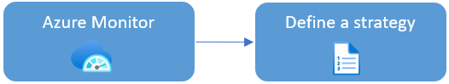

This image explains the Azure Monitor workflow.

### Azure Monitor overview

Azure Monitor is the Azure native platform service that provides a centralized area for monitoring your Azure resources. It monitors all layers of the Azure stack, starting with tenant services, such as Microsoft Entra, subscription-level events, and Azure Service Health.

At the lower levels, it monitors infrastructure resources, such as VMs, storage, and network resources. Administrators and developers employ Azure Monitor to consolidate metrics about the performance and reliability of their various cloud layers, including Azure Database for PostgreSQL Flexible Server instances. Management tools, such as Microsoft Defender for Cloud and Azure Automation, also push log data to Azure Monitor. The service aggregates and stores this telemetry in a log data store optimized for cost and performance.

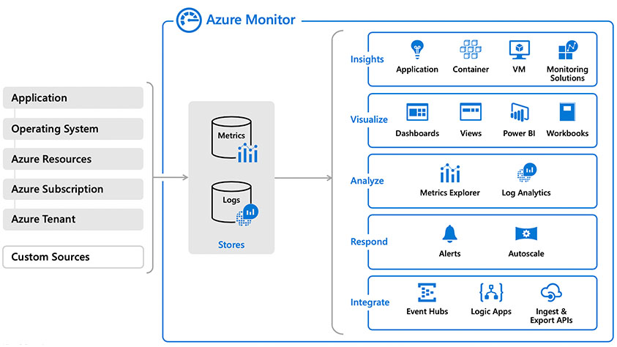

This image clarifies how Azure Monitor integrates with various Azure data sources and management tools.

For more information on what can be monitored, read: [What is monitored by Azure Monitor?](https://docs.microsoft.com/azure/azure-monitor/monitor-reference)

## Define your monitoring strategy

Administrators should [plan their monitoring strategy](https://docs.microsoft.com/azure/azure-monitor/best-practices-plan) and resource configuration for the best results. Some data collection and features are free, while others have associated costs. Focus on maximizing your applications’ performance and reliability. Identify the data and logs that indicate the highest potential signs of failure to optimize costs. See [Azure Monitor Pricing](https://azure.microsoft.com/pricing/details/monitor/) for more information on planning monitoring costs.

## Azure Monitor options

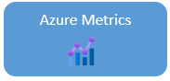

This image shows the Azure Monitor Metrics icon.

Azure Monitor Metrics is a feature of Azure Monitor that collects numeric data from monitored resources into a time-series database. Metrics in Azure Monitor are lightweight and capable of supporting near real-time scenarios, so they are helpful for alerting and detecting issues. You can analyze them interactively by using Metrics Explorer, be proactively notified with an alert when a value crosses a threshold, or visualize them in a workbook or dashboard.

[Azure Monitor Metrics overview](https://docs.microsoft.com/azure/azure-monitor/essentials/data-platform-metrics)

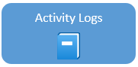

This image shows the Activity Logs icon.

The Activity log is a [platform log](https://docs.microsoft.com/azure/azure-monitor/essentials/platform-logs-overview) in Azure that provides insight into subscription-level events. The Activity log includes information like when a resource is modified or when a virtual machine was started.

Event examples:

* Start or stop a VM.
* Start or stop an App Service.

[Azure Activity log](https://docs.microsoft.com/azure/azure-monitor/essentials/activity-log)

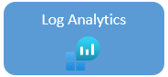

This image shows the Azure Log Analytics icon.

Log Analytics is a tool in the Azure portal used to edit and run log queries with data in Azure Monitor Logs. You can use Log Analytics queries to retrieve records that match particular criteria. Use the query results to identify trends, analyze patterns, and provide insights. Users can create charts to visualize important data in the portal.

Query examples:

* HTTP URL requests in the last hour.
* HTTP status codes in the two days.
* Call duration and result code.

[Overview of Log Analytics in Azure Monitor](https://docs.microsoft.com/azure/azure-monitor/logs/log-analytics-overview)

[Log Analytics tutorial](https://docs.microsoft.com/azure/azure-monitor/logs/log-analytics-tutorial)



This image shows the Azure Monitor Workbooks icon.

Workbooks provide a flexible canvas for data analysis and the creation of rich visual reports within the Azure portal. They allow you to tap into multiple Azure data sources and combine them into unified interactive experiences. Visualize data in one interactive report.

[Azure Monitor Workbooks](https://docs.microsoft.com/azure/azure-monitor/visualize/workbooks-overview)



This image shows the Azure Resource Health icon.

Azure Resource Health helps you diagnose and get support for service problems that affect your Azure resources. It reports on the current and past health of your resources. Resource Health can help you diagnose the root event causes.

Multiple Azure infrastructure components can trigger Platform events. The events include both scheduled actions (planned maintenance) and unexpected incidents (unplanned host reboot or degraded hosted hardware that is predicted to fail after a specified time window).

Resource Health provides additional details about the event and the recovery process. **It also enables you to contact Microsoft Support, even if you don’t have an active support agreement.**

Resource issue examples:

* Unplanned events, for example an unexpected host reboot
* Planned events, like scheduled host OS updates
* Events triggered by user actions, for example a user rebooting a virtual machine

[Resource Health overview](https://docs.microsoft.com/azure/service-health/resource-health-overview)

## Application monitoring

It is important to monitor the uptime, performance, and understand usage patterns once an application has been deployed. [Application Insights](https://docs.microsoft.com/azure/azure-monitor/app/app-insights-overview) is a feature that provides extensible application performance management (APM) and monitoring for web-based applications.

Application insights monitoring is very flexible in that it supports a wide variety of platforms, including .NET, Node.js, Java, and Python as well as apps hosted on-premises or on any public cloud. Just about any application can take advantage of this powerful monitoring tool.

Using Application Insights:

* Install a small instrumentation package (SDK) in your app
* Or enable Application Insights by using the Application Insights agent in Azure.

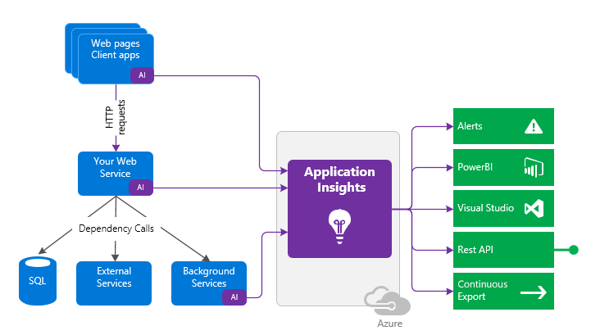

The instrumentation code directs telemetry data to an Application Insights resource by using a unique instrumentation key and URL.

Example steps to configure WordPress monitoring:

* Install Application Insights plugin from WordPress Plugins.
* Create Application Insights.
* Copy the Instrumentation Key from created Application Insights.
* Then go to **Settings** and Application Insights inside WordPress, and add the key there.
* Access the website and look for details.

 **Tip**: [Connection Strings](https://docs.microsoft.com/azure/azure-monitor/app/sdk-connection-string?tabs=net) are recommended over instrumentation keys.

### Azure Metrics Explorer

[Azure Metrics Explorer](https://docs.microsoft.com/azure/azure-monitor/essentials/metrics-getting-started) makes it easy to capture performance counters for resources quickly without adding instrumentation to your application code. As the following diagram shows, you simply select the resource and metric and then apply your filters:



The Azure Metrics workflow is displayed.

For example, to capture performance counters for a PHP App Service resource, simply follow these steps.

* Determine your scope. Navigate to the App Service in the Azure Portal.
* In the **Monitoring** section, select the **Metrics** item.
* Select your time range.
* 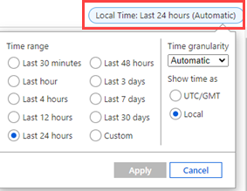
* The picture shows the time frame options for metric filtering.
* Select your **Metric** from the dropdown.
* 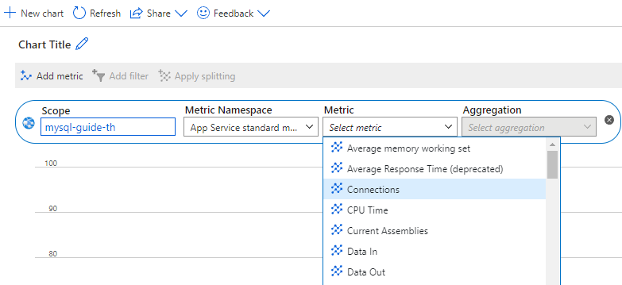
* The picture shows the Metric category filter options.
* Select your chart choice for the chosen metric.
* 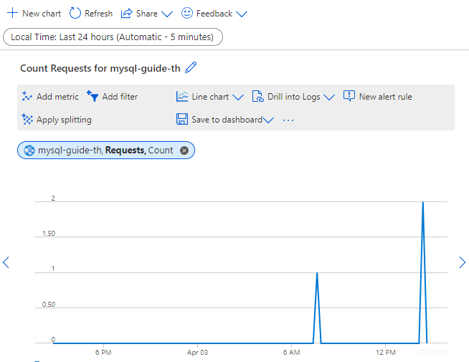
* The Azure Metric request count example is displayed.
* Create a rule by selecting **New alert rule**.
* 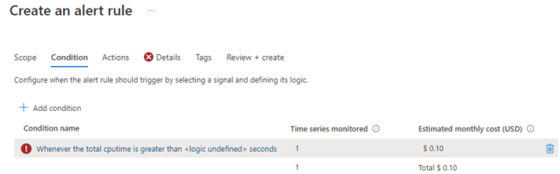
* The Azure Metrics new alert rule is displayed.

### Application Insights cost management

Application Insights comes with a free allowance that tends to be relatively large enough to cover the development and publishing of an app for a small number of users. As a best practice, setting a limit can prevent more data than necessary from being processed and keep costs low.

Larger volumes of telemetry are charged by the gigabyte and should be monitored closely to ensure your finance department does not get a larger than expected Azure invoice. [Manage usage and costs for Application Insights](https://docs.microsoft.com/azure/azure-monitor/app/pricing)

## Monitoring database operations

Azure can be configured to monitor the Flexible server database as well.

 **Watch:** [Monitoring [7 of 16] | Azure Database for PostgreSQL Flexible Server - Beginners Series](https://www.youtube.com/watch?v=yQOnRNgly0M&list=PLlrxD0HtieHghqeFLMwaGxfxPbndt52Ap&index=7)

### Azure Database for PostgreSQL Flexible Server overview

The Azure Portal resource overview excellent overview of the PostgreSQL metrics. This high-level dashboard provides insight into the typical database monitoring counters, like CPU, IO, Query Count, etc.

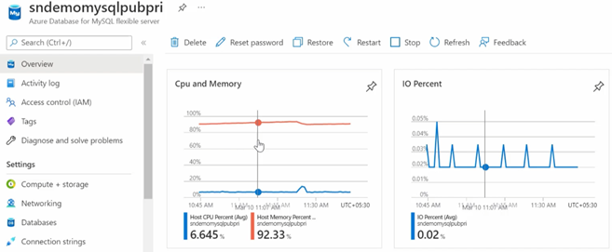

This image shows PostgreSQL metrics in the Azure portal.

### Metrics

For more specific metrics, navigate to the **Monitoring** section. Select **Metrics**. More custom granular metrics can be configured and displayed.

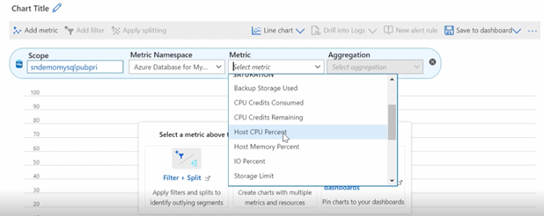

This image shows Metrics on the Monitoring tab in the Azure portal.

 [Monitor Azure Database for PostgreSQL Flexible Servers with built-in metrics](https://learn.microsoft.com/azure/postgresql/flexible-server/flexible-server/concepts-monitoring)

### Diagnostic settings

Diagnostic settings allow you to route platform logs and metrics continuously to other storage and ingestion endpoints.

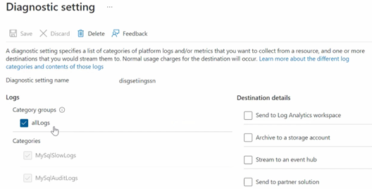

This image shows how to graph metrics in the Azure portal Monitoring tab.

 [Set up diagnostics](https://learn.microsoft.com/azure/postgresql/flexible-server/flexible-server/tutorial-configure-audit#set-up-diagnostics)

### Log Analytics

Once you configure your Diagnostic Settings, you can navigate to the Log Analytics workspace. You can perform specific filtered queries on interesting categories. Are you looking for slow queries?

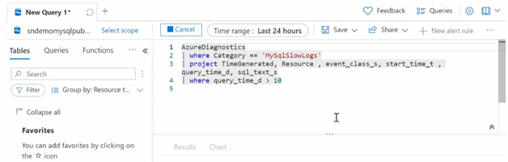

This image shows a KQL query.

Now, you can review the results from your query. There is a wealth of information about the category.

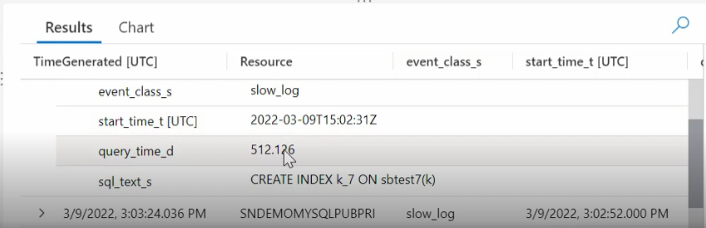

This image shows KQL query results.

PostgreSQL audit log information is also available.

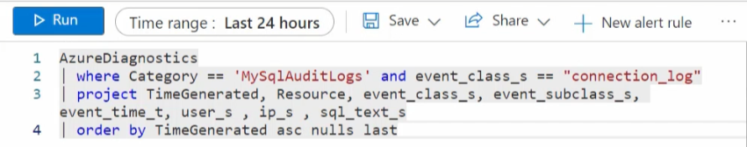

This image shows a KQL query that polls the PostgreSQL audit log.

 [View query insights by using Log Analytics](https://learn.microsoft.com/azure/postgresql/flexible-server/flexible-server/tutorial-query-performance-insights#view-query-insights-by-using-log-analytics)

### Workbooks

As mentioned previously, Workbooks is a simple canvas to visualize data from different sources, like Log Analytics workspace. It is possible to view performance and storage metrics all in a single pane.

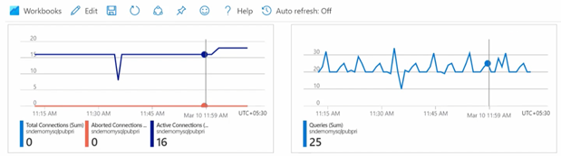

This image shows Azure Monitor Workbooks visualizations.

CPU, IOPS, and other common monitoring metrics are available. You can also access Query Performance Insight.

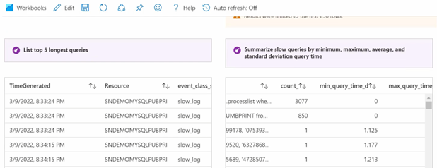

This image shows QPI in the Azure portal.

In addition to the fundamental server monitoring aspects, Azure provides tools to monitor application query performance. Correcting or improving queries can lead to significant increases in the query throughput. Use the [Query Performance Insight tool](https://learn.microsoft.com/azure/postgresql/flexible-server/flexible-server/tutorial-query-performance-insights) to:

* Analyze the longest-running queries and determine if it is possible to cache those items.
* If they are deterministic within a set period, modify the queries to increase their performance.

In addition to the query performance insight tool, Wait statistics provides a view of the wait events that occur during the execution of a specific query.

 **Warning**: Wait statistics are meant for troubleshooting query performance issues. It is recommended to be turned on only for troubleshooting purposes.

Finally, the slow_query_log can be set to show slow queries in the PostgreSQL log files (default is OFF). The long_query_time server parameter can be used to log long-running queries (default long query time is 10 sec).

 [Monitor Azure Database for PostgreSQL Flexible Server by using Azure Monitor workbooks](https://learn.microsoft.com/azure/postgresql/flexible-server/flexible-server/concepts-workbooks)

### Resource health

It is essential to know if the PostgreSQL service has experienced a downtime and the related details. Resource health can assist with this information. If you need additional assistance, a helpful contact support link available.

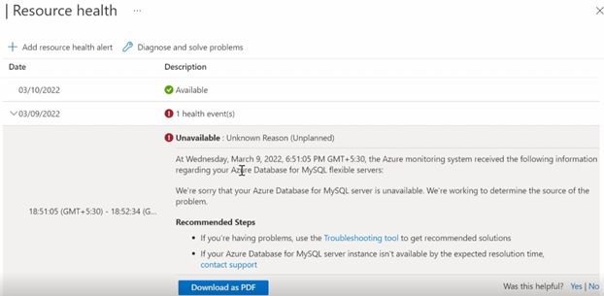

This image shows Azure Resource Health.

### Activity logs

This area captures the administrative events captured over a period of time.

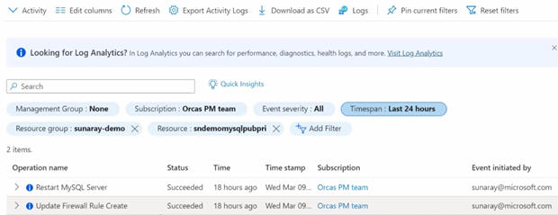

This image shows administrative events in the Azure Activity Log.

The event details can be viewed as well. These details can be extremely helpful when troubleshooting.

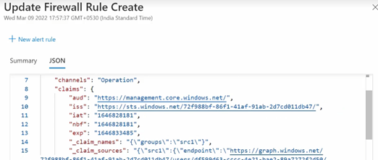

This image shows the details of an Activity Log event.

### Creating alerts

You can create alerts in a couple of ways. Navigate to the **Alerts** menu item in the portal and create it manually.



This image shows how to create resource alerts in the Azure portal.

You can also create alerts from the Metrics section.

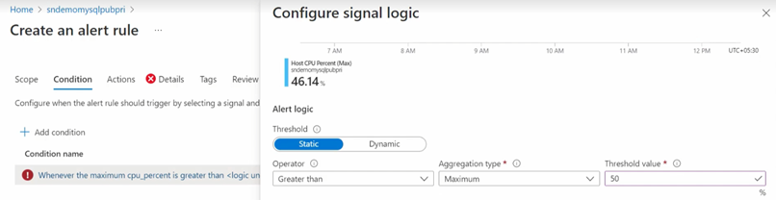

This image shows how to create resource alerts from the Metrics section in the Azure portal.

Once the alert has been configured, you can create an action group to send a notification to the operations team.

 [Set up alerts on metrics for Azure Database for PostgreSQL Flexible Server-Flexible Server](https://learn.microsoft.com/azure/postgresql/flexible-server/flexible-server/how-to-alert-on-metric)

### Server Logs

Server logs from Azure Database for PostgreSQL Flexible Server can also be extracted through the Azure platform *resource logs*, which track data plane events. Azure can route these logs to Log Analytics workspaces for manipulation and visualization through KQL.

In addition to Log Analytics, the data can also be routed to Event Hubs for third-party integrations and Azure storage for long-term backup.

### PostgreSQL audit logs

PostgreSQL has a robust built-in audit log feature. This [audit log feature is disabled](https://learn.microsoft.com/azure/postgresql/flexible-server/flexible-server/concepts-audit-logs) in Azure Database for PostgreSQL Flexible Server by default. Server level logging can be enabled by changing the audit_log_enabled server parameter. Once enabled, logs can be accessed through [Azure Monitor](https://docs.microsoft.com/azure/azure-monitor/overview) and [Log Analytics](https://docs.microsoft.com/azure/azure-monitor/platform/design-logs-deployment) by turning on [diagnostic logging](https://learn.microsoft.com/azure/postgresql/flexible-server/flexible-server/tutorial-configure-audit#set-up-diagnostics).

In addition to metrics, it is also possible to enable PostgreSQL logs to be ingested into Azure Monitor. While metrics are better suited for real-time decision-making, logs are also useful for deriving insights. One source of logs generated by Flexible Server is PostgreSQL *audit logs*, which indicate connections, DDL and DML operations, and more. Many businesses utilize audit logs to meet compliance requirements, but they can impact performance.

 **Warning**: Excessive audit logging can degrade server performance, so be mindful of the events and users configured for logging.

### Enabling audit logs

Audit logging is controlled by the audit_log_enabled server parameter in Flexible Server. Azure provides granularity over the events logged (audit_log_events). User fields include the database users subject to logging (audit_log_include_users), and an explicit list of the database users exempt from logging (audit_log_exclude_users).

For more details about the logging server parameters, including the type of events that can be logged, consult [the documentation.](https://learn.microsoft.com/azure/postgresql/flexible-server/flexible-server/concepts-audit-logs)

## Alerting guidelines

Once monitoring data is configured to flow into Azure Monitor or Log Analytics, the next step would to be to create alerts when issue data is generated. The operations team will want to know as quickly as possible when a pending outage or system issue is developing. Understanding the symptoms is critical. *“You can’t fix what you don’t know is broken.”*

Alert creation and remediation will take fine-tuning to ensure that alert fatigue does not set in. Focus less on integrating monitoring with IT Service Management (ITSM) systems for Incident Management, and seize on opportunities to let cloud automation replace more expensive service management processes, thereby eliminating time spent on easily automatically resolvable alerts and incidents.

**Consider the following principles for determining whether a symptom is an appropriate candidate for alerting:**

* Does it matter? Is the issue symptomatic of a real problem or issue influencing the overall health of the application? For example, does it matter whether the CPU utilization is high on the resource? Or that a particular SQL query running on a SQL database instance on that resource is consuming high CPU utilization over a sustained period? If the CPU utilization condition is a real issue, alerts should be fired when it occurs. Although an alert will fire, the team will still need to determine what is causing the alert condition in the first place. Alerting and notifying on the SQL query process utilization issue is both relevant and actionable.
* Is it urgent? Is the issue real, and does it need urgent attention? If so, the responsible team should be immediately notified.
* Are your customers affected? Are users of the service or application affected as a result of the issue?
* Are other dependent systems affected? Are there alerts from dependencies that are interrelated and that can possibly be correlated to avoid notifying different teams all working on the same problem?

Test and validate the assumptions in a nonproduction environment, and then deploy them into production. Monitoring configurations are derived from known failure modes, test results of simulated failures, and experiences from different members of the team.

Consider automating the remediation steps in Azure.

 [Successful alerting strategy](https://docs.microsoft.com/azure/cloud-adoption-framework/manage/monitor/response#successful-alerting-strategy)

### Azure alerting concepts

#### Metric alerts

Metric alerts assess metric time-series according to defined conditions and take action. They consist of the following parts:

* **Alert rules** define the alert conditions. They require the following information:
  + The metric to monitor (e.g. aborted_connections)
  + An aggregation for the selected metric (e.g. total)
  + A threshold for the aggregated value (e.g. 10 connections)
  + A time window for the aggregation (e.g. 30 minutes)
  + A polling frequency to determine if the previous conditions are met (e.g. 5 minutes)
* **Action groups** define notification actions, such as emailing or texting an administrator, and other actions to take, like calling a webhook or [Azure Automation Runbooks](https://docs.microsoft.com/azure/automation/automation-runbook-types)
* **Alert processing rules** is a *preview* feature that filters alerts as they are generated to modify the actions taken in response to that alert (i.e. by disabling action groups)

Refer to [Microsoft’s tutorial](https://learn.microsoft.com/azure/postgresql/flexible-server/flexible-server/how-to-alert-on-metric) explaining the configuration of a metric alert for a Flexible Server instance.

### Best Practices with Alerting Metrics

Here are some scenarios of how aggregating metrics over time generates insights. Read the [Microsoft blog](https://azure.microsoft.com/blog/best-practices-for-alerting-on-metrics-with-azure-database-for-PostgreSQL-monitoring/) for more examples.

* If there were **10** or more failed connections (total of aborted_connections in Flexible Server) in the last **30** minutes, then send an email alert
  + This may indicate incorrect credentials or an SSL issue in the application
* If IOPS is **90%** or more of capacity (average of io_consumption_percent in Flexible Server) for at least **1** hour, then call a webhook
  + Excessive IO usage affects the performance of transactional workloads, so [scale storage to increase IOPS capacity or provision additional IOPS](https://learn.microsoft.com/azure/postgresql/flexible-server/flexible-server/concepts-compute-storage)
  + See the linked CLI examples for automatic scaling based on metrics

### Webhooks

Webhook action groups send POST requests to configured webhook endpoints. Action groups can use the [common alert schema](https://docs.microsoft.com/azure/azure-monitor/alerts/alerts-common-schema) for webhook calls, or custom JSON payloads. This feature allows Azure Monitor to [integrate with incident management systems like PagerDuty](https://www.pagerduty.com/docs/guides/azure-integration-guide/), [call Logic Apps](https://docs.microsoft.com/azure/connectors/connectors-native-webhook), and [execute Azure Automation runbooks](https://docs.microsoft.com/azure/automation/automation-webhooks).

### Metrics resources

#### Azure CLI

Azure CLI provides the az monitor series of commands to manipulate action groups (az monitor action-group), alert rules and metrics (az monitor metrics), and more.

* [Azure CLI reference commands for Azure Monitor](https://docs.microsoft.com/cli/azure/azure-cli-reference-for-monitor)
* [Monitor and scale an Azure Database for PostgreSQL Flexible Server using Azure CLI](https://learn.microsoft.com/azure/postgresql/flexible-server/flexible-server/scripts/sample-cli-monitor-and-scale)

#### Azure Portal

While the Azure Portal does not provide automation capabilities like the CLI or the REST API, it does support configurable dashboards and provides a strong introduction to monitoring metrics in PostgreSQL.

* [Set up alerts on metrics for Azure Database for PostgreSQL Flexible Server-Flexible Server](https://learn.microsoft.com/azure/postgresql/flexible-server/flexible-server/how-to-alert-on-metric)
* [Tutorial: Analyze metrics for an Azure resource](https://docs.microsoft.com/azure/azure-monitor/essentials/tutorial-metrics)

#### Azure Monitor REST API

The REST API allows applications to access metric values for integration with other monitoring systems like external SIEM systems. It also allows applications to manipulate alert rules externally.

To interact with the REST API, applications first need to obtain an authentication token from Microsoft Entra and then use that token in API requests.

* [REST API Walkthrough](https://docs.microsoft.com/azure/azure-monitor/essentials/rest-api-walkthrough)
* [Azure Monitor REST API Reference](https://docs.microsoft.com/rest/api/monitor/)

### Azure Service Health

[Azure Service Health](https://azure.microsoft.com/features/service-health/) notifies administrators about Azure service incidents and planned maintenance so actions can be taken to mitigate downtime. Configure customizable cloud alerts and use personalized dashboards to analyze health issues, monitor the impact on cloud resources, get guidance and support, and share details and updates.

## 05 / Summary

Monitoring the performance of your environment is a vital final step after deployment. This section described how Azure Monitor and Log Analytics are essential tools to assist in monitoring your applications.

Both the control and data plane should be considered in your monitoring activities. Platform administrators and database administrators should be notified of issues before or when they start to happen.

With cloud-based systems, being proactive is a better strategy then being reactive.

### Checklist

* Define a monitoring strategy to provide useful insights without deteriorating application performance and incurring excessive costs. For example, storing slow query logs on Flexible Server instances without proper management consumes storage space, affects database performance.
* Configure your Azure resources to emit strategic logs (like PostgreSQL Flexible Server slow query logs) and route them to Azure destinations, like Log Analytics workspaces.
* Develop KQL queries to record database performance, query performance, and DDL/DML activity.
* If necessary, configure alert rules for metrics and logs. Azure can automatically respond to fired alerts through Azure Automation runbooks.
* Visualize data in Workbooks.

## Recommended content

* [Best practices for alerting on metrics with Azure Database for PostgreSQL Flexible Server monitoring](https://azure.microsoft.com/blog/best-practices-for-alerting-on-metrics-with-azure-database-for-PostgreSQL-monitoring/)
* [Configure audit logs (Azure portal)](https://learn.microsoft.com/azure/postgresql/flexible-server/flexible-server/tutorial-configure-audit)
* [Azure Monitor best practices](https://docs.microsoft.com/azure/azure-monitor/best-practices)
* [Cloud monitoring guide: Collect the right data](https://docs.microsoft.com/azure/cloud-adoption-framework/manage/monitor/data-collection)
* [Configure and access audit logs in the Azure CLI](https://learn.microsoft.com/azure/postgresql/flexible-server/howto-configure-audit-logs-cli)
* [Write your first query with Kusto Query Language (Microsoft Learn)](https://docs.microsoft.com/learn/modules/write-first-query-kusto-query-language/)
* [Azure Monitor Logs Overview](https://docs.microsoft.com/azure/azure-monitor/logs/data-platform-logs)
* [Application Monitoring for Azure App Service Overview](https://docs.microsoft.com/azure/azure-monitor/app/azure-web-apps)
* [Configure and access audit logs for Azure Database for PostgreSQL Flexible Server in the Azure Portal](https://learn.microsoft.com/azure/postgresql/flexible-server/howto-configure-audit-logs-portal)
* [Kusto Query Language (KQL)](https://docs.microsoft.com/azure/data-explorer/kusto/query/)
* [SQL Kusto cheat sheet](https://docs.microsoft.com/azure/data-explorer/kusto/query/sqlcheatsheet)
* [Get started with log queries in Azure Monitor](https://docs.microsoft.com/azure/azure-monitor/log-query/get-started-queries)
* [Monitor Azure Database for PostgreSQL Flexible Server using Percona Monitoring and Management (PMM)](https://techcommunity.microsoft.com/t5/azure-database-for-PostgreSQL-blog/monitor-azure-database-for-PostgreSQL-using-percona-monito%20ring-and/ba-p/2568545)

# 06 / Networking and Security

The Azure Database for PostgreSQL Flexible Server network configuration can adversely affect security, application performance (latency), and compliance. This section explains the fundamentals of Azure Database for PostgreSQL Flexible Server networking concepts.

Azure Database for PostgreSQL Flexible Server provides several mechanisms to secure the networking layers by limiting access to only authorized users, applications, and devices.

 **Watch:** [Networking and Security [6 of 16] | Azure Database for PostgreSQL Flexible Server - Beginners Series](https://www.youtube.com/watch?v=LSNV5BW-g-U&list=PLlrxD0HtieHghqeFLMwaGxfxPbndt52Ap&index=6)

## Public vs. Private Access

As with any cloud-based resources, it can be exposed to the Internet or be locked down to only be accessible by Azure connections resources. However, it does not have to be just Azure-based resources. VPNs and Express route circuits can be used to provide access to Azure resources from on-premises environments. The following section describes how to configure Azure Database for PostgreSQL Flexible Server instances for network connectivity.

### Public Access

By default, Azure Database for PostgreSQL Flexible Server allows access to internet-based clients, including other Azure services. If this is an undesirable state, firewall access control lists (ACLs) can limit access to hosts that fall within the allowed trusted IP address ranges.

The first line of defense for protecting a PostgreSQL instance access is to implement [firewall rules](https://learn.microsoft.com/azure/postgresql/flexible-server/concepts-firewall-rules). IP addresses can be limited to only valid locations when accessing the instance via internal or external IPs. If a PostgreSQL instance’s purpose is to serve internal applications, then [restrict public access](https://learn.microsoft.com/azure/postgresql/flexible-server/howto-deny-public-network-access).

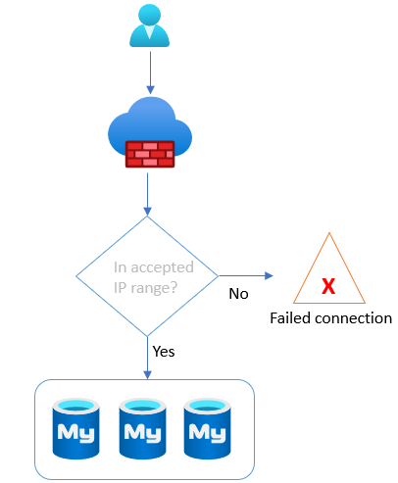

This image shows how PostgreSQL Flexible Server instances evaluate firewall rules.

Firewall rules are set at the server level, meaning that they govern network access to all databases on the server instance. While it is best practice to create rules that allow specific IP addresses or ranges to access the instance, developers can also enable network access from all Azure resources. This feature is useful for Azure services without fixed public IP addresses, such as [Azure Functions](https://docs.microsoft.com/azure/azure-functions/functions-overview) that use public networks to access the server and databases.

 **Note:** Restricting access to Azure public IP addresses still provides network access to the instance to public IPs owned by other Azure customers.

* Flexible Server
  + [Manage firewall rules for Azure Database for PostgreSQL Flexible Server - Flexible Server using the Azure portal](https://learn.microsoft.com/azure/postgresql/flexible-server/flexible-server/how-to-manage-firewall-portal)
  + [Manage firewall rules for Azure Database for PostgreSQL Flexible Server - Flexible Server using Azure CLI](https://learn.microsoft.com/azure/postgresql/flexible-server/flexible-server/how-to-manage-firewall-cli)
  + [ARM Reference for Firewall Rules](https://docs.microsoft.com/azure/templates/microsoft.dbforPostgreSQL/flexibleservers/firewallrules?tabs=json)
* Single Server
  + [Create and manage Azure Database for PostgreSQL Flexible Server firewall rules by using the Azure portal](https://learn.microsoft.com/azure/postgresql/flexible-server/howto-manage-firewall-using-portal)
  + [Create and manage Azure Database for PostgreSQL Flexible Server firewall rules by using the Azure CLI](https://learn.microsoft.com/azure/postgresql/flexible-server/howto-manage-firewall-using-cli)
  + [ARM Reference for Firewall Rules](https://docs.microsoft.com/azure/templates/microsoft.dbforPostgreSQL/servers/firewallrules?tabs=json)

### Private Access

As mentioned, Azure Database for PostgreSQL Flexible Server supports public connectivity by default. However, most organizations will utilize private connectivity to limit access to Azure virtual networks and resources.

**Note:** There are many other [basic Azure Networking considerations](https://learn.microsoft.com/azure/postgresql/flexible-server/concepts-data-access-and-security-vnet) that must be taken into account that are not the focus of this guide.

## Virtual Network Hierarchy

An Azure virtual network is similar to a on-premises network. It provides network isolation for workloads. Each virtual network has a private IP allocation block. Choosing an allocation block is an important consideration, especially if the environment requires multiple virtual networks to be joined.

 **Warning:** The allocation blocks of the virtual networks cannot overlap. It is best practice to choose allocation blocks from [RFC 1918.](https://datatracker.ietf.org/doc/html/rfc1918)

**Note**: When deploying a resource such as a VM into a virtual network, the virtual network must be located in the same region and Azure subscription as the Azure resource. Review the [Introduction to Azure](../02_IntroToPostgreSQL/02_02_Introduction_to_Azure.md) document for more information about regions and subscriptions.

Each virtual network is further segmented into subnets. Subnets improve virtual network organization and security, just as they do on-premises.

When moving an application to Azure along with the PostgreSQL workload, there will likely multiple virtual networks set up in a hub and spoke pattern that will require [Virtual Network Peering](https://docs.microsoft.com/azure/virtual-network/virtual-network-peering-overview) to be configured. Virtual networks are joined through *peering*. The peered virtual networks can reside in the same or different Azure regions.

Lastly, it is possible to access resources in a virtual network from on-premises. Some organizations opt to use VPN connections through [Azure VPN Gateway](https://docs.microsoft.com/azure/vpn-gateway/vpn-gateway-about-vpngateways), which sends encrypted traffic over the Internet. Others opt for [Azure ExpressRoute](https://docs.microsoft.com/azure/expressroute/expressroute-introduction), which establishes a private connection to Azure through a service provider.

For more information on Virtual Networks, reference the following:

* [Introduction to Azure Virtual Networks](https://docs.microsoft.com/learn/modules/introduction-to-azure-virtual-networks/)
* Creating virtual networks
  + [Portal](https://docs.microsoft.com/azure/virtual-network/quick-create-portal)
  + [PowerShell](https://docs.microsoft.com/azure/virtual-network/quick-create-powershell)
  + [CLI](https://docs.microsoft.com/azure/virtual-network/quick-create-cli)
  + [ARM Template](https://docs.microsoft.com/azure/virtual-network/quick-create-template)

### Flexible Server

Flexible Server supports deployment into a virtual network for secure access. When enabling virtual network integration, the target virtual network subnet must be *delegated*, meaning that it can only contain Flexible Server instances. Because Flexible Server is deployed in a subnet, it will receive a private IP address. To resolve the DNS names of Azure Database for PostgreSQL Flexible Server instances, the virtual networks are integrated with a private DNS zone to support domain name resolution for the Flexible Server instances.

 **Note:** If the Flexible Server client, such as a VM, is located in a peered virtual network, then the private DNS zone created for the Flexible Server must also be integrated with the peered virtual network.

 **Note:** Private DNS zone names must end with PostgreSQL.database.azure.com. If you are connecting to the Azure Database for PostgreSQL Flexible Server - Flexible sever with SSL and are using an option to perform full verification (sslmode=VERIFY_IDENTITY) with certificate subject name, use .postgres.database.azure.com in your connection string.

 [Private DNS zone overview](https://docs.microsoft.com/azure/dns/private-dns-overview)

For more information on configuring Private Access for Flexible Server, reference the following:

* [Azure Portal](https://learn.microsoft.com/azure/postgresql/flexible-server/flexible-server/how-to-manage-virtual-network-portal)
* [Azure CLI](https://learn.microsoft.com/azure/postgresql/flexible-server/flexible-server/how-to-manage-virtual-network-cli)

## Networking best practices for Flexible Server

* If deploying an application in an Azure region that supports *Availability Zones*, deploy the application and the Flexible Server instance in the same zone to minimize latency.

For a review of availability zones, consult the Introduction to Azure Database for PostgreSQL Flexible Server document.

* Organize the components of the application into multiple virtual networks, such as in a [hub and spoke configuration.](https://docs.microsoft.com/azure/architecture/reference-architectures/hybrid-networking/hub-spoke?tabs=cli) Employ virtual network peering or VPN Gateways to join the application’s virtual networks.
* Configure data protection at rest and in motion (see the [Security and Compliance document](03_PostgreSQL_Security_Compliance.md)).
* [General Azure Networking Best Practices](https://docs.microsoft.com/azure/cloud-adoption-framework/migrate/azure-best-practices/migrate-best-practices-networking)
  + Determine IP addressing and subnetting.
  + Determine DNS setup and whether forwarders are needed.
  + Employ tools like network security groups to secure traffic within and between subnets.

## Security

Moving to cloud-based services does not mean the entire Internet will have access to it at all times. Azure provides best-in-class security that ensures data workloads are continually protected from bad actors and rogue programs. Additionally, Azure provides several certifications that ensure your resources are compliant with local and industry regulations, an important factor for many organizations today.

Organizations must take proactive security measures to protect their workloads in today’s geopolitical environment. Azure simplifies many of these complex tasks and requirements through the various security and compliance resources provided out of the box. This section will focus on many of these tools.

### Encryption

Azure Database for PostgreSQL Flexible Server offers various encryption features, including encryption for data, backups, and temporary files created during query execution.

Data stored in the Azure Database for PostgreSQL Flexible Server instances are encrypted at rest by default. Any automated backups are also encrypted to prevent potential leakage of data to unauthorized parties. This encryption is typically performed with a key generated when the Azure Database for PostgreSQL Flexible Server instance is created.

In addition to be encrypted at rest, data can be encrypted during transit using SSL/TLS. SSL/TLS is enabled by default. As previously discussed, it may be necessary to [modify the applications](https://learn.microsoft.com/azure/postgresql/flexible-server/howto-configure-ssl) to support this change and configure the appropriate TLS validation settings. It is possible to allow insecure connections for legacy applications or enforce a minimum TLS version for connections, **but this should be used sparingly and in highly network-protected environments**. Flexible Server’s TLS enforcement status can be set through the require_secure_transport PostgreSQL server parameter. Consult the guides below.

* [Flexible Server](https://learn.microsoft.com/azure/postgresql/flexible-server/flexible-server/how-to-connect-tls-ssl)

### Microsoft Sentinel

Many of the items discussed thus far operate in their sphere of influence and are not designed to work directly with each other. Every secure feature provided by Microsoft Azure and corresponding applications, like Microsoft Entra, contains a piece of the security puzzle.

Disparate components require a holistic solution to provide a complete picture of the security posture and the automated event remediation options.

[Microsoft Sentinel](https://docs.microsoft.com/azure/sentinel/overview) is the security tool that provides the needed connectors to bring all your security log data into one place and then provide a view into how an attack may have started.

Microsoft Sentinel works with Azure Log Analytics and other Microsoft security services to provide a log storage, query, and alerting solution. Through machine learning, artificial intelligence, and user behavior analytics (UEBA), Microsoft Sentinel provides a higher understanding of potential issues or incidents that may not have seen with a disconnected environment.

### Microsoft Purview

Data privacy has evolved into a organizational priority over the past few years. Determining where sensitive information lives across your data estate is a requirement in today’s privacy-centered society.

[Microsoft Purview](https://docs.microsoft.com/azure/purview/overview) can scan your data estate, including your Azure Database for PostgreSQL Flexible Server instances, to find personally identifiable information or other sensitive information types. This data can then be analyzed, classified and lineage defined across your cloud-based resources.

### Security baselines

In addition to all the topics discussed above, the Azure Database for PostgreSQL Flexible Server [security baseline](https://learn.microsoft.com/azure/postgresql/flexible-server/security-baseline) is a basic set of potential tasks that can be implemented on your Azure Database for PostgreSQL Flexible Server instances to further solidify your security posture.

## 06 / Summary

Protecting the data and control plane is just another piece to the puzzle of having a robust, secure and performant application environment.

Deciding what risks the organization can accept will typically help guide what security features discussed in this section should be enabled and paid for.

If the data is vital, important and business critical, everything possible should be done to ensure its protected and secure.

This section discussed many tools Microsoft Azure provided to give an organization peace of mind that the cloud-based workload will be just as secure as if running it on-premises.

## Security checklist

* Utilize the most robust possible authentication mechanisms such as Microsoft Entra.
* Enable Advanced Threat Protection and Microsoft Defender for Cloud.
* Enable all auditing features.
* Enable encryption at every layer that supports it.
* Consider a Bring-Your-Own-Key (BYOK) strategy, where supported.
* Implement firewall rules.
* Utilize private endpoints for workloads that do not travel over the Internet.
* Integrate Microsoft Sentinel for advanced SIEM and SOAR.
* Utilize private endpoints and virtual network integration where possible.

# 07 / Testing

Testing is a crucial part of the application development lifecycle. Architects, developers, and administrators should continually assess and evaluate their applications for *availability* (minimal downtime) and *resiliency* (recovery from failure). Microsoft recommends performing tests regularly and highly suggests automating them to minimize any errors in the process or setup. Tests can be run in the application build or deployment process.

This chapter discusses the various types of tests you can run against Azure Database for PostgreSQL Flexible Server application and database. Running tests ensures the optimal performance of your application and database deployments.

## Approaches

Let’s discuss the types of approaches and tools.

### Functional testing

Functional testing ensures that an app functions as documented in the user and business requirements. Testers do not know how software systems function; they ensure systems perform the business functions specified in the documentation. Functional tests validate things like data limits (field lengths and validation) and that specific actions are taken in response to various triggers. The tests usually involve some type of application user interface. It is usually the most complete type of testing for UI applications.

#### Function testing tools

[Selenium](https://www.selenium.dev/) automates functional tests for web apps. Developers can create web application test scripts in several supported languages, like Ruby, Java, Python, and C#. Once scripts are developed, the Selenium WebDriver executes the scripts using browser-specific APIs. Teams can operate parallel Selenium tests on different devices using [Selenium Grid](https://www.selenium.dev/documentation/grid/).

To get started with Selenium, developers can install the [Selenium IDE](https://www.selenium.dev/selenium-ide/) to generate testing scripts from browser interactions. The Selenium IDE is not intended for production tests. Still, it can speed up the development of your test script development tasks.

Teams can include [Selenium tests in Azure DevOps.](https://techcommunity.microsoft.com/t5/testingspot-blog/continuous-testing-with-selenium-and-azure-devops/ba-p/3143366). The screenshot below demonstrates a Selenium test running in a DevOps Pipeline.

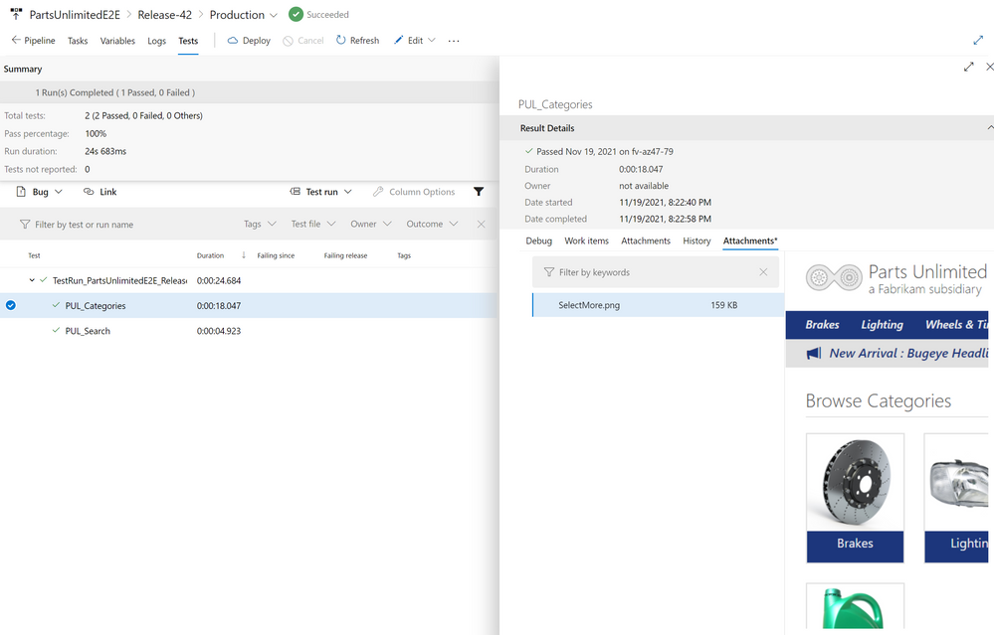

This image demonstrates screenshots from a Selenium test in Azure DevOps.

### Resiliency and version testing

Testers can only execute so many test cases within a time period. Users tend to test application functionality not imagined by the development or test teams. Allowing real users to test the application while limiting deployment downtime and version risk can be difficult. One strategy to test for resiliency is the blue-green method. The latest version of an application operates in a second production environment. Developers test the most recent version in the second production environment by adding some production users to the new version. If the new version functions adequately, the second environment begins handling more production user requests. Developers can roll back the application by serving requests from the older environment if an unexpected error occurs.

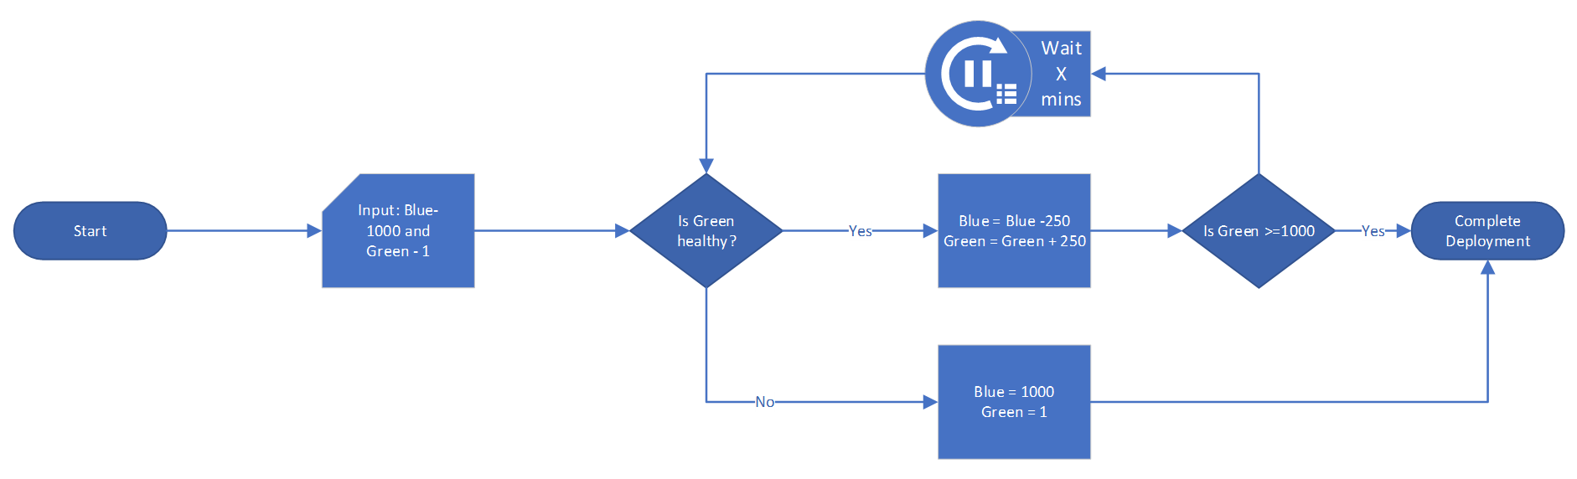

This image shows how to implement a Blue/Green test using Azure Traffic Manager.

 **Tip**: Newer versions of an application often require database updates. It is recommended to update the database to support the new and previous versions of the software before deploying application updates to the second environment.

Azure has the capability to support this type of testing via Deployment Center, Azure Traffic Manager, and other tools.

The following links provide resources on Blue-green deployment options:

* [Deployment Center example](https://docs.microsoft.com/azure/app-service/deploy-github-actions?tabs=applevel)
* [Azure Traffic Manager example](https://azure.microsoft.com/blog/blue-green-deployments-using-azure-traffic-manager/)
* [Application Gateway example](https://techcommunity.microsoft.com/t5/apps-on-azure-blog/upgrading-aks-version-with-blue-green-deployment-i/ba-p/2527145)

### Performance testing

#### Load testing

Load testing determines an application’s performance as load increases. Load testing tools typically simulate users or requests, and they help companies meet their user and business SLAs. Proper load testing requires knowledge of the load a production system normally experiences and potential Azure service limits (e.g. [Event Hub throughput by tier](https://docs.microsoft.com/azure/event-hubs/event-hubs-quotas#basic-vs-standard-vs-premium-vs-dedicated-tiers)).

#### Stress testing

Stress testing determines the maximum load a system can handle before failure. A proper stress testing approach would be to perform stress testing at different Azure service tiers and determine appropriate thresholds when scaling within those tiers. This will give administrators an idea of how to build alerts for monitoring if the application starts to approach these known limits. Knowing your acceptable low and high stress range levels is necessary to minimize costs (by selecting the appropriate tier and scaling) and thereby provide a positive user experience.

#### Performance testing tools

### Apache JMeter

[Apache JMeter](https://jmeter.apache.org/) is an open source tool to test that systems function and perform well under load. It can test web applications, REST APIs, databases, and more. JMeter provides a GUI and a CLI, and it can export test results in a variety of formats, including HTML and JSON.

The image below demonstrates one approach to operating JMeter at scale using Azure Container Instances. The jmeter-load-test pipeline manages the test infrastructure and provides the test definition to the **JMeter Controller**.

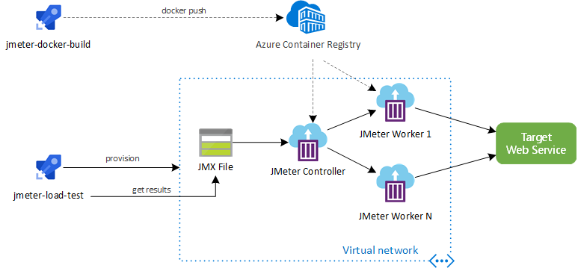

This image demonstrates how to perform a load test at scale using CI/CD, JMeter, and ACI.

It is also possible to run JMeter load tests using [Azure Load Testing Preview.](https://docs.microsoft.com/azure/load-testing/quickstart-create-and-run-load-test)

### K6

[Grafana K6](https://k6.io/) is a load testing tool hosted locally or in the cloud. Developers script tests using ES6 JavaScript. Supporting over 20 integrations, including [Azure DevOps Pipelines](https://techcommunity.microsoft.com/t5/azure-devops/load-testing-with-azure-devops-and-k6/m-p/2489134), K6 is a popular choice for many teams.

## Testing data capture tools

### Azure Monitor

Azure Monitor allows developers to collect, analyze, and act on telemetry. *Application Insights*, a subset of Azure Monitor, tracks application performance, usage patterns, and issues. It integrates with common development tools, like Visual Studio. Similarly, *Container insights* measures the performance of container workloads running on Kubernetes clusters. These powerful tools are backed by Azure Log Analytics workspaces and the Azure Monitor metrics store.

The image below demonstrates container logs from a containerized deployment of the ContosoNoshNow sample app running in AKS. These logs are analyzed in the cluster’s Log Analytics workspace.

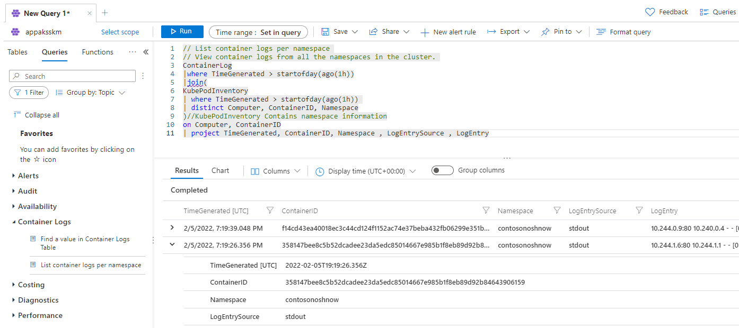

This image demonstrates container logs in the AKS cluster’s Log Analytics workspace.

The image below demonstrates the cluster’s maximum CPU usage over a half-hour period. It utilizes metrics provided by AKS, though more granular metrics from Container insights can also be used.

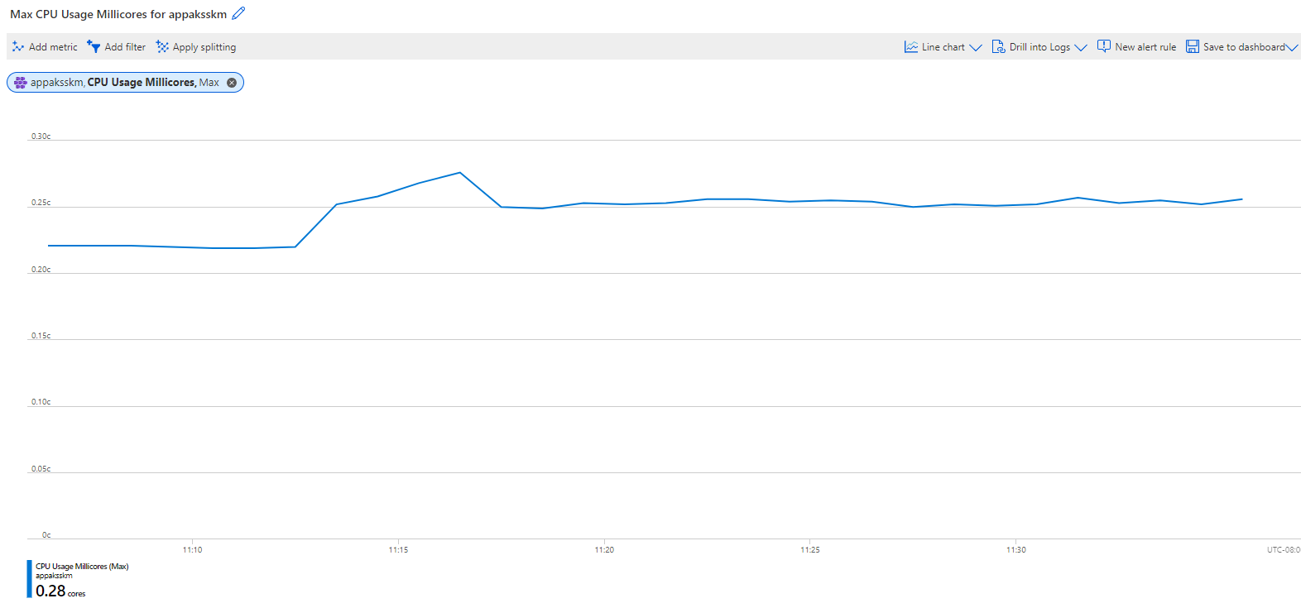

This image demonstrates the maximum CPU usage of the AKS cluster’s nodes, a feature provided by metrics from AKS.

#### Resources

* [Supported languages for Azure App Insights](https://docs.microsoft.com/azure/azure-monitor/app/platforms)
* Comparison of *metrics* and *logs* in Azure Monitor
  + [Azure Monitor Metrics overview](https://docs.microsoft.com/azure/azure-monitor/essentials/data-platform-metrics)
  + [Azure Monitor Logs overview](https://docs.microsoft.com/azure/azure-monitor/logs/data-platform-logs)
* [Monitoring Azure Kubernetes Service (AKS) with Azure Monitor](https://docs.microsoft.com/azure/aks/monitor-aks#scope-of-the-scenario)

### Grafana and Prometheus

Prometheus is a powerful tool for developers to capture metrics, store them in a time-series database on disk, and analyze them through a custom query language. However, due to the storage of metrics on disk, Prometheus is not ideal for long-term retention.

Grafana is a visualization tool to create customizable dashboards from time-series databases. These visualizations supplement the raw metrics exposed by services such as Prometheus.

The image below demonstrates two charts in Grafana demonstrating the CPU usage of a Laravel pod in the Contoso Nosh Now AKS deployment. The requests and limits values were supplied in the Kubernetes deployment file.

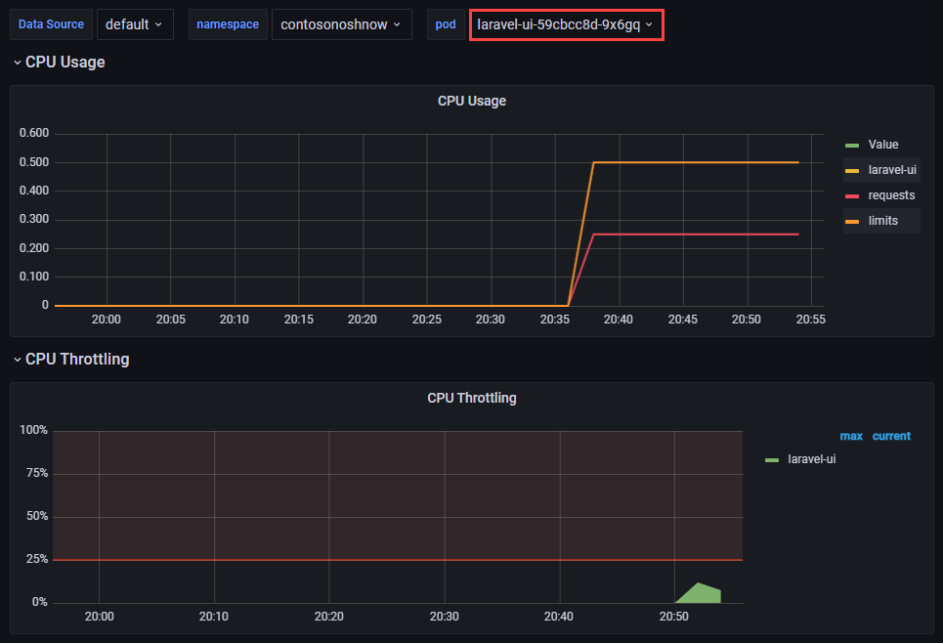

This image demonstrates a dashboard in Grafana showing CPU usage for a pod.

### Recommended content

The following resources are helpful for exploring various approaches to using the previously mentioned tools and concepts.

* [Using Azure Kubernetes Service with Grafana and Prometheus](https://techcommunity.microsoft.com/t5/apps-on-azure-blog/using-azure-kubernetes-service-with-grafana-and-prometheus/ba-p/3020459)
* [Prometheus Overview](https://prometheus.io/docs/introduction/overview)
* [What is Grafana OSS](https://grafana.com/docs/grafana/latest/introduction/oss-details/)
* [Store Prometheus Metrics with Thanos, Azure Storage and Azure Kubernetes Service (AKS)](https://techcommunity.microsoft.com/t5/apps-on-azure-blog/store-prometheus-metrics-with-thanos-azure-storage-and-azure/ba-p/3067849)
* [What are Azure Pipelines?](https://docs.microsoft.com/azure/devops/pipelines/get-started/what-is-azure-pipelines?view=azure-devops#:~:text=Azure%20Pipelines%20automatically%20builds%20and,ship%20it%20to%20any%20target)
* [What is Azure Load Testing?](https://docs.microsoft.com/azure/load-testing/overview-what-is-azure-load-testing?wt.mc_id=loadtesting_acompara4_webpage_cnl)

## 07 / Summary

Testing your applications after they have been deployed to an existing or a new environment is a vital step in the development cycle. It could prevent unwanted downtime or lost of application functionality.

### Checklist

* Perform functional testing on applications and databases.
* Perform performance testing on applications and databases.
* Utilize industry standard tools and benchmarks to ensure accurate and comparable results.
* Integrate reporting tools such as Azure Monitor, Grafana or Prometheus into your testing suites.

# 08 / Performance and Optimization

After organizations migrate their PostgreSQL workloads to Azure, they unlock turnkey performance monitoring solutions, scalability, and the benefits of Azure’s global footprint. Operation teams must establish performance baselines before fine-tuning their PostgreSQL instances to ensure that changes, especially those that require application downtime, are worth doing. If you can, **simulate your workload in a test environment** and make adjustments in test before implementing changes in a production environment.

Before jumping into specific and time consuming performance enhancements/investigation, there are some general tips that can improve performance in your environment that this section will explore.

## General performance tips

The following are some basic tips for how to increase or ensure the performance of your Azure Database for PostgreSQL Flexible Server applications and database workloads:

* Ensure the input/output operations per second (IOPS) are sufficient for the application needs. Keep the IO latency low.
* Create and tune the table indexes. Avoid full table scans.
* Performance regular database maintenance.
* Make sure the application/clients (e.g. App Service) are physically located as close as possible to the database. Reduce network latency.
* Use accelerated networking for the application server if you use a Azure virtual machine, Azure Kubernetes, or App Services.
* Use connection pooling when possible. Avoid creating new connections for each application request. ProxySQL for built-in connection pooling and load balancing. Balance your workload to multiple read replicas as demand requires without any changes in application code.
* Set timeouts when creating transactions.
* Set up a [read replica](https://dev.PostgreSQL.com/doc/refman/5.7/en/replication-features.html) for read-only queries and analytics.
* Consider using query caching solution like Heimdall Data Proxy. Limit connections based on per user and per database. Protect the database from being overwhelmed by a single application or feature.
* Temporarily scale your Azure Database for PostgreSQL Flexible Server resources for taxing tasks. Once your task is complete, scale it down.

See [Best practices for optimal performance of your Azure Database for PostgreSQL Flexible Server](https://learn.microsoft.com/azure/postgresql/flexible-server/concept-performance-best-practices)

## Monitoring hardware and query performance

As previously discussed in the monitoring section of this guide, monitoring metrics such as the cpu_percent or memory_percent can be important when deciding to upgrade the database tier. Consistently high values for extended periods of time could indicate a tier upgrade is necessary.

If CPU and memory do not seem to be the issue, administrators can explore database-based options such as indexing and query modifications for poor-performing queries.

To find poor-performing queries, run the following:

AzureDiagnostics  
| where ResourceProvider == "MICROSOFT.DBFORPostgreSQL"  
| where Category == 'PostgreSQLSlowLogs'  
| project TimeGenerated, LogicalServerName_s, event_class_s, start_time_t , query_time_d, sql_text_s  
| top 5 by query_time_d desc

## Upgrading the tier

*Know your workload!* The Azure portal and the CLI can be used to scale between the Burstable, General Purpose, and Memory Optimized tiers. Tier scaling requires restarting the Flexible Server instance, causing 60-120 seconds of downtime. If your application does not require a significant compute, use the Burstable SKU. When your application requires more performance during certain times, Azure Database for PostgreSQL Flexible Server can increase performance automatically and reduce when you do not need it. Organizations can save operational costs.

## Scaling the server

Within the tier, it is possible to scale cores and memory to the minimum and maximum [limits](https://learn.microsoft.com/azure/postgresql/flexible-server/concepts-pricing-tiers) allowed in that tier. If monitoring shows a continual maxing out of CPU or memory, scale up to meet demand.

You can also adjust the IOPS for better transactions per second (TPS) performance. You can use an [Azure CLI script](https://learn.microsoft.com/azure/postgresql/flexible-server/flexible-server/scripts/sample-cli-monitor-and-scale) to monitor relevant metrics and scale the server.

## Azure Database for PostgreSQL Flexible Server memory recommendations

An Azure Database for PostgreSQL Flexible Server performance best practice is to allocate enough RAM so that your working set resides almost completely in memory. Check if the memory percentage used is reaching the limits.

Do not be surprised. Set up alerts on thresholds to ensure that notifications can be sent to administrators before servers reach limits. Based on the defined limits, check if scaling the database SKU to a higher compute size or to a better pricing tier increases performance enough to meet the workload requirements.

For information on monitoring a DB instance’s metrics, see [PostgreSQL DB Metrics](https://learn.microsoft.com/azure/postgresql/flexible-server/concepts-monitoring#metrics).

## Moving regions

It is possible to move a geo-redundant Flexible Server instance to a [paired Azure region](https://docs.microsoft.com/azure/availability-zones/cross-region-replication-azure) through geo-restore. Geo-restore creates a new Flexible Server instance in the paired Azure region based on the current state of the database.

 **Note:** Point-in-time restore is not supported.

Geo-restore can be used to recover from a service outage in the primary region. However, the Flexible Server instance created in the paired region can only be configured with locally redundant storage, as its paired region (the old primary region) is down.

To minimize downtime, Flexible Server configuration settings can be kept intact.

## Server parameters

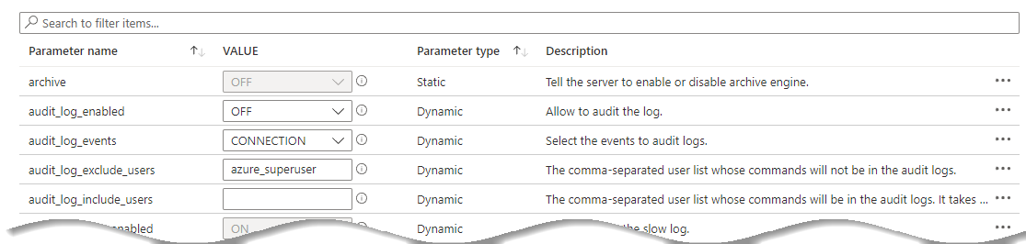

This image shows PostgreSQL server parameters in the Azure portal.

As part of the migration, the on-premises [server parameters](https://learn.microsoft.com/azure/postgresql/flexible-server/flexible-server/concepts-server-parameters) were likely modified to support a fast egress. Also, modifications were made to the Azure Database for PostgreSQL Flexible Server parameters to support a fast ingress. The Azure server parameters should be set back to their original on-premises workload-optimized values after the migration.

However, be sure to review and make server parameter changes that are appropriate for the workload and the environment. Some values that were great for an on-premises environment may not be optimal for a cloud-based environment. When migrating the current on-premises parameters to Azure, verify that they can be set.

Some Azure Database for PostgreSQL Flexible Server parameters cannot be modified. Verify the strategy before making environment assumptions.

## Upgrade Azure Database for PostgreSQL Flexible Server versions

Sometimes, just upgrading versions may be the solution to an issue. Flexible Server supports PostgreSQL versions 5.7 and 8.0. Migrating from on-premises PostgreSQL 5.x to PostgreSQL Flexible Server 5.7 or 8.0 delivers major performance improvements. Consult the [Microsoft documentation](https://learn.microsoft.com/azure/postgresql/flexible-server/migrate/PostgreSQL-on-premises-azure-db/08-data-migration) for more information regarding PostgreSQL Azure migrations, including major version changes.

## Customizing the container runtime

When using containers for your PostgreSQL and PHP application, the platform choice has a huge impact on your performance limits. In most cases, creating a custom PHP container can improve performance up to 6x over the out-of-the-box official PHP containers. It is important to determine if the effort of building a custom image will be worth the performance gain from the work. Also, keep in mind recent versions of PHP tend to perform better than older versions.

Custom environments can be tested against standard workloads by running various benchmarks using the [PHPBench tool](https://github.com/phpbench/phpbench).

 [Container insights overview](https://docs.microsoft.com/azure/azure-monitor/containers/container-insights-overview)

## Running PostgreSQL Benchmarks

There are several tools that can be used to benchmark PostgreSQL environments. Here are a few that can be used to determine how well an instance is performing:

* [DBT2 Benchmark](https://downloads.PostgreSQL.com/source/dbt2-0.37.50.16.tar.gz) - DBT2 is an open source benchmark that mimics an OLTP application for a company owning large amounts of warehouses. It contains transactions to handle New Orders, Order Entry, Order Status, Payment and Stock handling
* [SysBench Benchmark Tool](https://downloads.PostgreSQL.com/source/sysbench-0.4.12.16.tar.gz) - Sysbench is a popular open source benchmark to test open source DBMSs.

More Common sets of tests typically utilize TPC benchmarks such as [TPC-H](https://www.tpc.org/tpch/) but there are many more [types of tests](https://www.tpc.org/information/benchmarks5.asp) that can be run against the PostgreSQL environment to test against specific workloads and patterns.

## Instrumenting vital server resources

The [PostgreSQL Performance Schema](https://learn.microsoft.com/azure/postgresql/flexible-server/howto-troubleshoot-sys-schema) **sys_schema** provides a way to inspect internal server execution events at runtime. The PostgreSQL performance_schema provides instrumentation for many vital server resources such as memory allocation, stored programs, metadata locking, etc. However, the performance_schema contains more than 80 tables and getting the necessary information often requires joining tables within the performance_schema, and tables from the information_schema. Building on both performance_schema and information_schema, the sys_schema provides a powerful collection of user-friendly views in a read-only database and is fully enabled in Azure Database for PostgreSQL Flexible Server version 5.7.

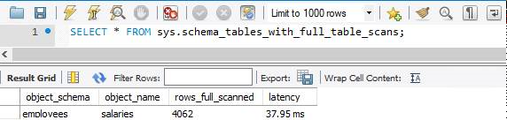

This image shows how to use tables in the sys schema to optimize PostgreSQL queries.

 **Warning**: The Performance Schema avoids using mutexes to collect or produce data, so there are no guarantees of consistency and results can sometimes be incorrect. Event values in performance_schema tables are non-deterministic and unrepeatable.

## Server Parameters

PostgreSQL server parameters allow database architects and developers to optimize the PostgreSQL engine for their specific application workloads. One of the advantages of Flexible Server is the large number of server parameters exposed by the service. Some important exposed parameters are listed below, but storage and compute tiers affect the possible parameter values. Consult the [Microsoft documentation](https://learn.microsoft.com/azure/postgresql/flexible-server/flexible-server/concepts-server-parameters) for more information.

Some parameters that cannot be configured at the server level can be configured at the connection level. Moreover, *dynamic* parameters can be changed without restarting the server, while modifying *static* parameters warrants a restart.

* [log_bin_trust_function_creators](https://dev.PostgreSQL.com/doc/refman/8.0/en/replication-options-binary-log.html#sysvar_log_bin_trust_function_creators) is enabled by default and indicates whether users can create triggers
* [innodb_buffer_pool_size](https://dev.PostgreSQL.com/doc/refman/8.0/en/innodb-parameters.html#sysvar_innodb_buffer_pool_size) indicates the size of the buffer pool, a cache for tables and indexes
* For this parameter, consult the [Microsoft documentation](https://learn.microsoft.com/azure/postgresql/flexible-server/flexible-server/concepts-server-parameters), as the database compute tier affects the parameter value range
* [innodb_file_per_table](https://dev.PostgreSQL.com/doc/refman/8.0/en/innodb-parameters.html#sysvar_innodb_file_per_table) affects where table and index data are stored

### Tools to Set Server Parameters

Standard Azure management tools, like the Azure portal, Azure CLI, and Azure PowerShell, allow for configuring server parameters.

* [Use Azure portal to configure server parameters](https://learn.microsoft.com/azure/postgresql/flexible-server/flexible-server/how-to-configure-server-parameters-portal)
* [User Azure CLI to configure server parameters](https://learn.microsoft.com/azure/postgresql/flexible-server/flexible-server/how-to-configure-server-parameters-cli)

### Server Parameters best practices

The server parameters below may provide performance improvements for an application workload; however, before modifying these values in production, verify that they yield performance improvements without compromising application stability.

* Enable thread pooling by setting thread_handling to pool-of-threads. Thread pooling improves concurrency by serving connections through a pool of worker threads, instead of creating a new thread to serve each connection. Enabling thread pooling improves performance for transactional workloads, as connections are short-lived
  + The degree of concurrency is set through the thread_pool_size parameter
  + Only supported in PostgreSQL 8.0
* 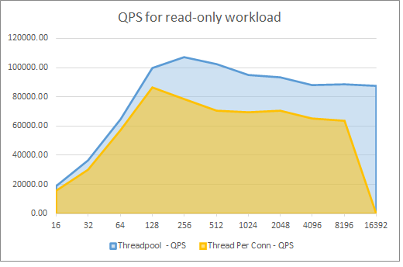
* This graph demonstrates the performance benefits of thread pooling for a Flexible Server instance.
* The graph above reflects the performance improvements of thread pooling for a 16 vCore, 64 GiB memory Flexible Server instance. The x-axis represents the number of connections, and the y-axis represents the number of queries served per second (QPS). Read the associated [Microsoft TechCommunity post](https://techcommunity.microsoft.com/t5/azure-database-for-PostgreSQL-blog/achieve-up-to-a-50-performance-boost-in-azure-database-for-PostgreSQL/ba-p/2909691) for more details
* Enable InnoDB buffer pool warmup by setting innodb_buffer_pool_dump_at_shutdown to ON: InnoDB buffer pool warmup loads data files from disk after a restart and before receiving queries on that data. This change improves the latency of the first queries executed against the database after a restart, but it does increase the server’s start-up time
  + Microsoft only recommends this change for database instances with more than 335 GB of provisioned storage
  + Learn more from the [Microsoft documentation](https://learn.microsoft.com/azure/postgresql/flexible-server/concept-performance-best-practices)

## Caching

Utilizing resources such as CPU, memory, disk (read/write access) and network can factor into how long an application request takes to process. Being able to remove deterministic actions (ex: the same function/API call does not change) within a certain set of time is an important pattern to implement in your various application layers. Caching reduces the latency and contention that is associated with handling large volumes of concurrent requests in the original data store.

Caching is a common technique that aims to improve the performance and scalability of a system. It does this by temporarily copying frequently accessed data to fast storage that’s located close to the application.

 [Caching guidance](https://docs.microsoft.com/azure/architecture/best-practices/caching)

### Disk cache

When memory is not readily available or some items are just too big to stream over a network connection due to latency issues, it may be appropriate to copy data to disk. It is important to test whether a repeated operation takes more time to access from disk than it does to do the operation.

This caching option is a common pattern for when applications have users scattered all over the world. By distributing the same files and content to locations that are closest to those users, the users will see improved latency and perceived application performance.

### Memory cache

Access to data in memory is much faster compared to retrieving data from disk. It is an effective means for storing modest amounts of static data, since the size of a cache is typically constrained by the amount of memory available on the machine hosting the process.

#### Local memory

If an application has access to local memory, it can utilize that memory to cache its data and access it more quickly than going to disk or over the network. However, if the memory available to the application is less than ideal (potentially driven by operating system or hardware limits), another caching option must be chosen. If the application requires exceptionally low access rates, it will be necessary to send the data to a memory server.

#### Redis Cache

A common piece of software that helps with caching is called [Redis cache](https://redis.io/). As with all pieces of software, it can be run on-premises, in a virtual machine in the cloud (IaaS), or even as a platform-as-a-service offering (PaaS).

Redis cache works by putting data into memory via key/value pairs. The application will typically serialize the data and then hand it off to Redis for quick retrieval later. The Redis cache should be located close to the application. Query results should be retrieved and forwarded quickly.

[Azure Cache for Redis](https://docs.microsoft.com/azure/azure-cache-for-redis/cache-overview) is a platform as a service Microsoft Azure-hosted Redis environment that provides several levels of service such as [Enterprise, Premium, Standard, and Basic tiers](https://azure.microsoft.com/pricing/details/cache/).

## Azure Content Delivery Network

An Azure Content Delivery Network (CDN) utilizes distributed point-of-presence (POP) servers to serve cached static web content and optimize the delivery of dynamic content to users. As shown in the diagram below, users request static content from their nearest POP, which will serve content from its cache. If the local POP servers do not have the desired asset, they will request the site (origin) web server and cache it for the time-to-live (TTL) period.

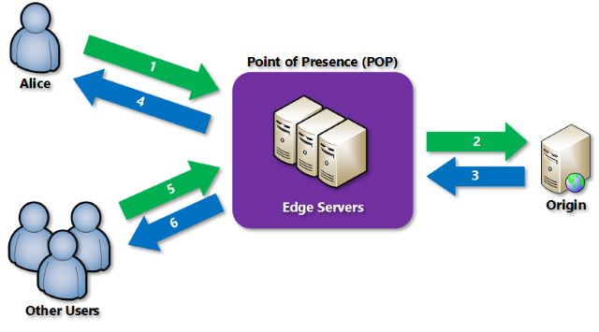

This image demonstrates how Azure CDN POPs optimize content delivery.

Azure CDN also supports dynamic site acceleration, optimizing the network path from clients to the server through POP sites, pre-fetches images and scripts, and more.

### Using Azure CDN in Web Apps

Azure App Service natively supports integrating with Azure CDN. Refer to the digital marketing sample in the 12 / PostgreSQL architectures section for a practical example involving Azure CDN and a content management system. For non-App Service workloads, Azure CDN is compatible with any public web server.

## 08 / Summary

After developers benchmark their PostgreSQL Flexible Server workloads, they can tune server parameters, scale compute tiers, and optimize their application containers to improve performance. Through Azure Monitor and KQL queries, teams monitor the performance of their workloads.

Caching is a very common way to increase the performance of applications. Through disk or memory-based cache, a developer and architect should always be on the lookout for deterministic areas that can be cached. Azure CDN provides caching via POP servers to users of global-scale web apps.

Lastly, an important balance should be struck between performance of the cache and costs.

### Checklist

* Monitor for slow queries.
* Periodically review the Performance Insight dashboard.
* Utilize monitoring to drive tier upgrades and scale decisions.
* Consider moving regions if the users’ or application’s needs change.
* Adjust server parameters for the running workload.
* Utilize caching techniques to increase performance.
* Get data closer to users by implementing content delivery networks.

# 09 / Troubleshooting

As applications are running and executing in cloud environments, it is always a possibility that something unexpected can occur. This chapter covers a few common issues and the troubleshooting steps for each issue.

## Common PostgreSQL issues

Debugging operational support issues can be time consuming. Configuring the right monitoring and alerting can help provide useful error messages and clues to the potential problem area(s).

### Connectivity issues

Both server misconfiguration issues and network access issues can prevent clients from connecting to an Azure Database for PostgreSQL Flexible Server instance. For some helpful connectivity suggestions, reference the [Troubleshoot connection issues to Azure Database for PostgreSQL Flexible Server](https://learn.microsoft.com/azure/postgresql/flexible-server/howto-troubleshoot-common-connection-issues) and [Handle transient errors and connect efficiently to Azure Database for PostgreSQL Flexible Server](https://learn.microsoft.com/azure/postgresql/flexible-server/concepts-connectivity) articles.

#### Misconfiguration

* [Error 1184](https://dev.PostgreSQL.com/doc/PostgreSQL-errors/8.0/en/server-error-reference.html#error_er_new_aborting_connection): This error occurs after a user authenticates with the database instance, but before they execute SQL statements. The init_connect server parameter includes statements that execute before sessions are initiated. Consequently, erroneous SQL statements in init_connect prevent clients from connecting.
  + **Resolution**: Reset the value of init_connect using the Azure portal or SQL.
* Administrators use the database admin user specified during server creation to create new databases and add new users. If the admin user credentials were not recorded, administrators can easily reset the admin password using the Azure portal.
  + Logging in with the administrator account can help debug other access issues, like confirming if a given user exists.

#### Network access issues

* By default, Flexible Server only supports encrypted connections through the TLS 1.2 protocol; clients using TLS 1.0 or 1.1 will be unable to connect unless explicitly enabled. If it is not possible to change the TLS protocol used by an application, then [change the Flexible Server instance’s supported TLS versions.](https://learn.microsoft.com/azure/postgresql/flexible-server/flexible-server/how-to-connect-tls-ssl)
* If connecting to Flexible Server via public access, ensure that firewall ACLs permit access from the client.
* Ensure that corporate firewalls do not block outbound connections to port 5432.
* Use a fully qualified domain name instead of an IP address in connection strings. This type of configuration is especially important with Azure Database for PostgreSQL Flexible Server Single Server instances, which use gateways to route incoming requests to database servers. It is possible to use the gateway public IP address in your applications.
*  **Warning:** However, as Microsoft plans to [retire older gateways](https://learn.microsoft.com/azure/postgresql/flexible-server/concepts-connectivity-architecture#azure-database-for-PostgreSQL-gateway-ip-addresses), you are responsible for updating the gateway IP address in your applications. It is less error-prone to work with the FQDN.
* Use [Azure Network Watcher](https://docs.microsoft.com/azure/network-watcher/network-watcher-monitoring-overview) to debug traffic flows in virtual networks.
*  **Note:** It does not support PaaS services, but it is still a helpful tool for IaaS configurations
  + Network Watcher works well with other networking utilities, like the Unix traceroute tool

### Resource issues

If the application experiences transient connectivity issues, perhaps the resources of the Azure Database for PostgreSQL Flexible Server instance are constrained. Monitor resource usage and determine whether the instance needs to be scaled up.

### Unsupported PostgreSQL features

Operating in a cloud environment means that certain features that function on-premises are incompatible with Azure Database for PostgreSQL Flexible Server instances. While Flexible Server has better feature parity with on-premises PostgreSQL than Single Server, it is important to be aware of any limitations.

* Azure Database for PostgreSQL Flexible Server does not support the PostgreSQL SUPER privilege and the DBA role. This may affect how some applications operate.
  + [Error 1419](https://dev.PostgreSQL.com/doc/PostgreSQL-errors/8.0/en/server-error-reference.html#error_er_binlog_create_routine_need_super): By default, PostgreSQL instances with binary logging enabled for replication require function creators to have the SUPER privilege to avoid privilege escalation attacks.
    - **Resolution**: The Azure suggested setting is to set the log_bin_trust_function_creators parameter to 1. Azure insulates against threats that exploit the binary log.
  + [Error 1227](https://dev.PostgreSQL.com/doc/PostgreSQL-errors/8.0/en/server-error-reference.html#error_er_specific_access_denied_error): This error occurs when creating stored procedures or views with DEFINER statements.
    - **Resolution**: If you encounter this error while migrating schema objects from an on-premises PostgreSQL instance, remove the DEFINER statements manually from the database dump.
* Direct file system access is not available to clients. This means that SELECT ... INTO OUTFILE commands are unsupported.
* Only the InnoDB and MEMORY storage engines are supported. This may affect older data warehousing and web applications based on the non-transactional MyISAM engine. Consult the [PostgreSQL documentation](https://dev.PostgreSQL.com/doc/refman/8.0/en/converting-tables-to-innodb.html) to learn how to convert your MyISAM tables to InnoDB and make them run optimally.

### Platform issues

* On occasion, Azure experiences outages. Use [Azure Service Health](https://azure.microsoft.com/features/service-health/) to determine if an Azure outage impacts PostgreSQL workloads in your region or datacenter.
* Azure’s periodic updates can impact the availability of applications. Flexible Server allows administrators [to set custom maintenance schedules.](https://learn.microsoft.com/azure/postgresql/flexible-server/flexible-server/concepts-maintenance)
* Implement retry logic in your applications to mitigate transient connectivity issues:
  + To provide resiliency against more severe failures, like Azure service outages, implement the [circuit breaker pattern](https://docs.microsoft.com/azure/architecture/patterns/circuit-breaker) to avoid wasting application resources on operations that are likely to fail

## Troubleshoot app issues in Azure App Service

* **Enable web logging.** Azure provides built-in diagnostics to assist with [debugging an App Service app](https://docs.microsoft.com/azure/app-service/troubleshoot-diagnostic-logs).
* Network requests taking a long time? [Troubleshoot slow app performance issues in Azure App Service](https://docs.microsoft.com/azure/app-service/troubleshoot-performance-degradation)
* In Azure App Service, certain settings are available to the deployment or runtime environment as environment variables. Some of these settings can be customized when configuring the app settings. [Environment variables and app settings in Azure App Service](https://docs.microsoft.com/azure/app-service/reference-app-settings?tabs=kudu%2Cdotnet)
* [Azure App Service on Linux FAQ](https://docs.microsoft.com/azure/app-service/faq-app-service-linux)

## App debugging

Following software development best practices makes your code simpler to develop, test, debug, and deploy. Here are some strategies to resolve application issues.

* Use logging utilities wisely to help troubleshoot failures without impairing app performance. Structured logging utilities, like PHP’s native logging functions or third-party tools, such as [KLogger](https://github.com/katzgrau/KLogger), can write logs to the console, to files, or to central repositories. Monitoring tools can parse these logs and alert anomalies.
* In development environments, remote debugging tools like [XDebug](https://xdebug.org/docs/) may be useful. You can set breakpoints and step through code execution. [Apps running on Azure App Service PHP and Container instances can take advantage of XDebug.](https://azureossd.github.io/2020/05/05/debugging-php-application-on-azure-app-service-linux/)
  + Users of Visual Studio Code can install XDebug’s [PHP Debug extension](https://marketplace.visualstudio.com/items?itemName=xdebug.php-debug).
* To debug slow PHP applications, consider using Application Performance Monitoring solutions like [Azure Application Insights](https://docs.microsoft.com/azure/azure-monitor/app/app-insights-overview), which integrates with Azure Monitor. Here are a few common culprits for low-performing PHP apps.
  + Executing database queries against tables that are indexed inefficiently
  + Configuring web servers poorly, such as by choosing a suboptimal number of worker processes to serve user requests
  + Disabling [opcode caching](https://www.php.net/manual/en/intro.opcache.php), requiring PHP to compile code files to opcodes every request
* Write tests to ensure that applications function as intended when code is modified. Review the 07 / Testing document for more information about different testing strategies. Tests should be included in automated release processes.
* Generally, all cloud applications should include connection [retry logic](https://docs.microsoft.com/azure/architecture/patterns/retry), which typically responds to transient issues by initiating subsequent connections after a delay.

### Additional support

* In the Azure portal, navigate to the **Diagnose and solve problems** tab of your Azure Database for PostgreSQL Flexible Server instance for suggestions regarding common connectivity, performance, and availability issues.
* 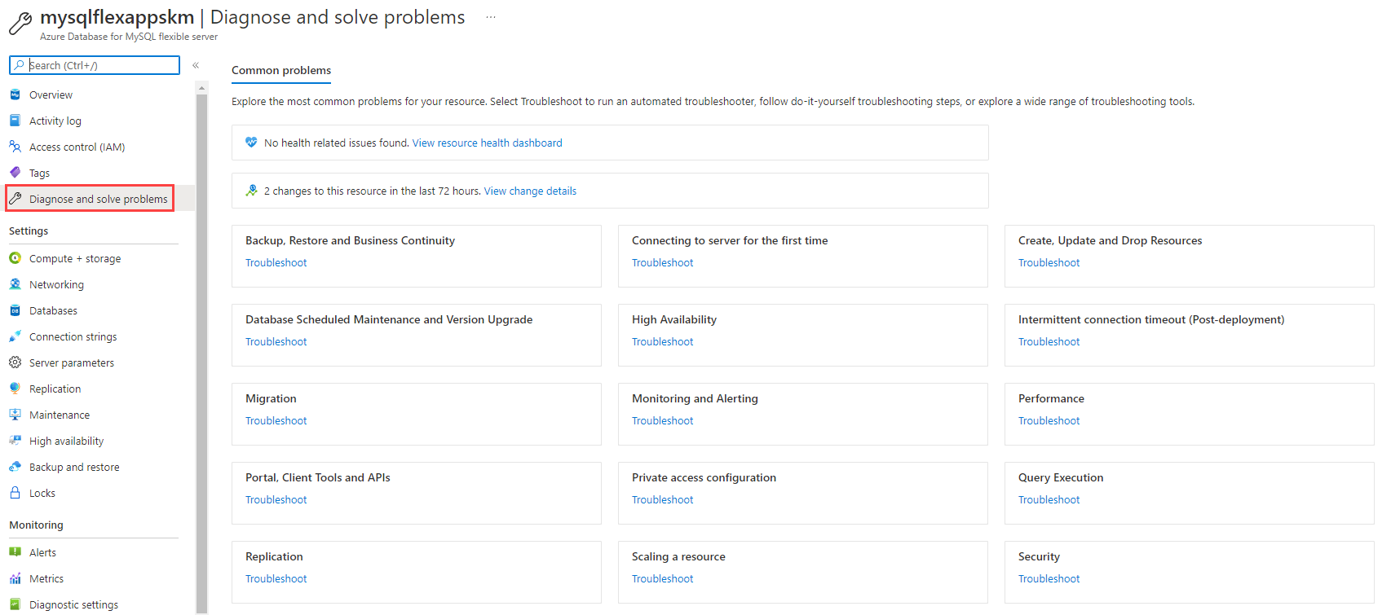
* This image demonstrates the Diagnose and solve problems tab of a Flexible Server instance in the Azure portal.
* This experience integrates with Azure Resource Health to demonstrate how Azure outages affect your provisioned resources.
* 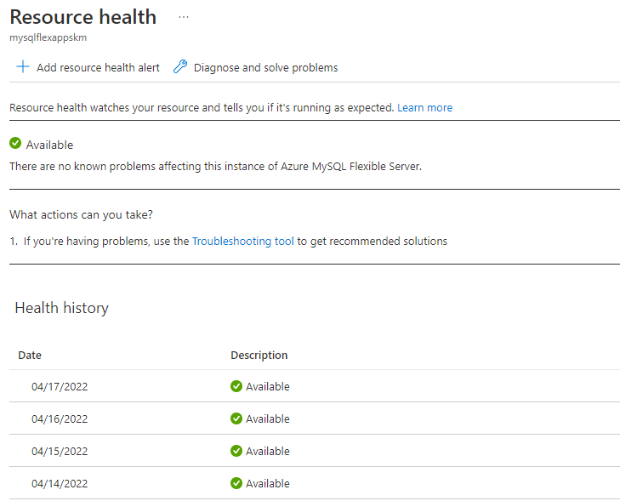
* This image demonstrates how Azure Resource Health correlates Azure service outages with the customer’s provisioned resources.
* If none of the above resolve the issue with the PostgreSQL instance, [send a support request from the Azure portal.](https://portal.azure.com/#blade/Microsoft_Azure_Support/HelpAndSupportBlade/overview)

### Opening a support ticket

If you need assistance with an Azure Database for PostgreSQL Flexible Server issue, [open an Azure support ticket](https://portal.azure.com/#blade/Microsoft_Azure_Support/HelpAndSupportBlade/overview) with Microsoft. Be sure to select the correct product and provide as much information as possible, so the proper resources is assigned to your ticket.

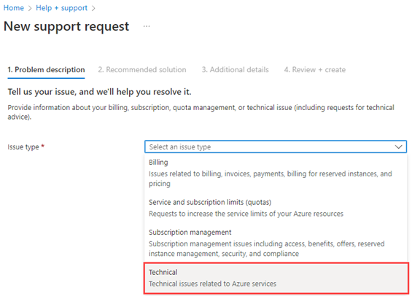

This image shows how to open a detailed support ticket for Microsoft from the Azure portal.

### Recommended content

* [Troubleshoot connection issues to Azure Database for PostgreSQL Flexible Server](https://learn.microsoft.com/azure/postgresql/flexible-server/howto-troubleshoot-common-connection-issues)
* [Handle transient errors and connect efficiently to Azure Database for PostgreSQL Flexible Server](https://learn.microsoft.com/azure/postgresql/flexible-server/concepts-connectivity)
* [Troubleshoot errors commonly encountered during or post migration to Azure Database for PostgreSQL Flexible Server](https://learn.microsoft.com/azure/postgresql/flexible-server/howto-troubleshoot-common-errors)
* [Troubleshoot data encryption in Azure Database for PostgreSQL Flexible Server](https://learn.microsoft.com/azure/postgresql/flexible-server/howto-data-encryption-troubleshoot)
* [Azure Community Support](https://azure.microsoft.com/support/community/) Ask questions, get answers, and connect with Microsoft engineers and Azure community experts

## 09 / Summary

This section helped pinpoint some of the most common issues a team may run into when hosting your PostgreSQL based applications in the cloud. These included items from connectivity, deployment, and performance.

### Checklist

* Understand the OSI model and how it can help troubleshoot issues.
* Start at the bottom of the OSI model and work your way up.
* Network connectivity issues can exist anywhere between client and server.
* Be sure a clear plan of attack has been developed for resolving issues.
* Utilize logging to assist in troubleshooting activities.

# 10 / Business Continuity and Disaster Recovery

Businesses implement *business continuity* (BC) and *disaster recovery* (DR) strategies to minimize disruptions. While *business continuity* emphasizes preserving business operations through policies, *disaster recovery* explains how IT teams will restore access to data and services.

## High availability

Flexible Server implements high availability by provisioning another VM to serve as a standby. It is possible to provision this secondary Flexible Server VM in another availability zone, as shown below. This HA option is only supported for Azure regions with availability zones. While this option does provide redundancy against zonal failure, there is more latency between the zones that affects replication.

 **Watch:** [High Availability [9 of 16] | Azure Database for PostgreSQL Flexible Server - Beginners Series](https://www.youtube.com/watch?v=5hp8KlNNPpA&list=PLlrxD0HtieHghqeFLMwaGxfxPbndt52Ap&index=9)

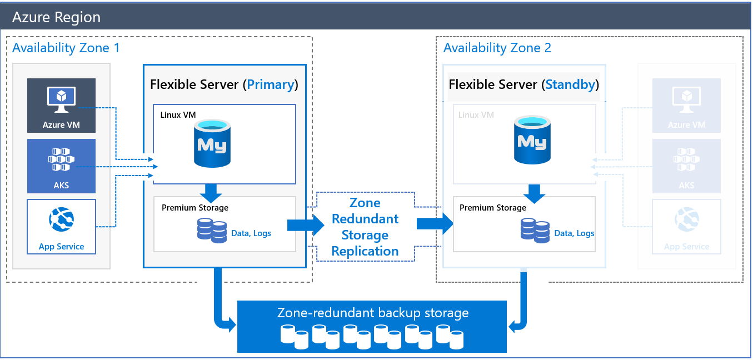

This image demonstrates Zone-Redundant HA for PostgreSQL Flexible Server.

Azure provides HA within a single zone to compensate for the latency challenges. In this configuration, both the primary node and the standby node are in the same zone. All Azure regions support this configuration. Of course, it does not insulate against zonal failure.

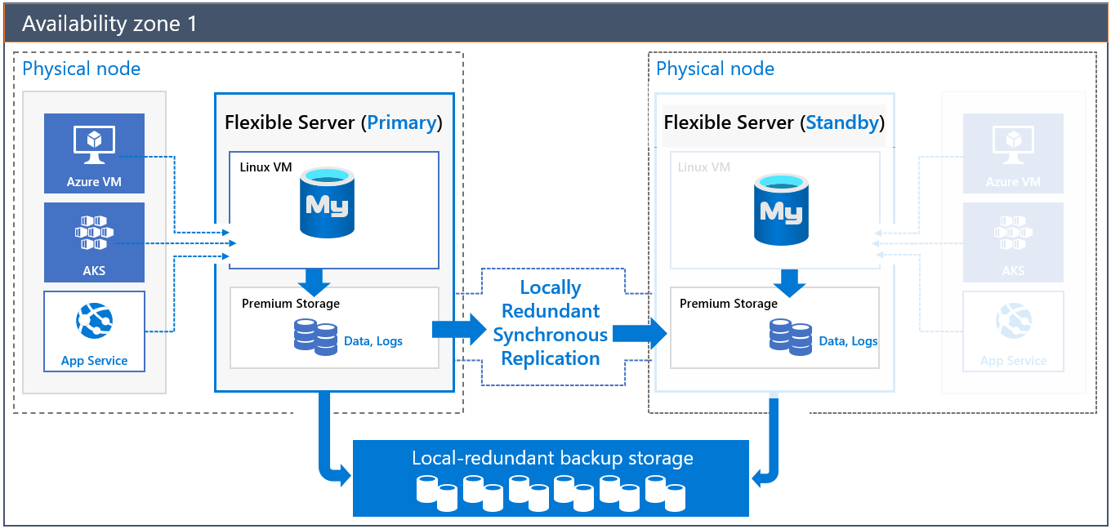

This image demonstrates HA for PostgreSQL Flexible Server in a single zone.

Both of these HA solutions have transparent failover. In a failover event, the standby server becomes the primary server, and DNS records point to the new primary. If the old primary comes back online, it becomes the secondary.

 **Note:** Replication is not synchronous to avoid the performance penalty of synchronous replication. A transaction committed to the primary node is not necessarily committed to the secondary node; the secondary node is brought up to the latest committed transaction during failover.

To learn more about HA with PostgreSQL Flexible Server, consult the [documentation.](https://learn.microsoft.com/azure/postgresql/flexible-server/flexible-server/concepts-high-availability)

### Implementing cross-region high availability

Flexible Server does not currently support cross-region high availability. However, it is possible to achieve this using PostgreSQL native replication instead of replicating log files at the Azure storage level. The image below demonstrates two Flexible Server instances deployed in two virtual networks in two Azure regions.

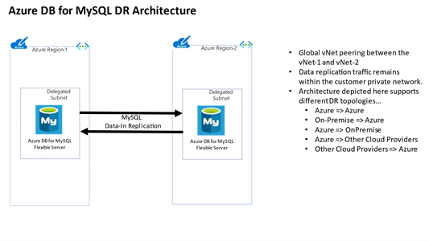

This image demonstrates a possible cross-region HA scenario using two virtual networks.

The virtual networks are peered to provide network connectivity for PostgreSQL native replication. As the image indicates, developers can employ PostgreSQL native replication for scenarios like replicating from an on-premises primary to an Azure secondary.

One disadvantage of this architecture is that it is customer-managed.

## Replication

Replication in Flexible Server allows applications to scale by providing **read-only** replicas to serve queries while dedicating write operations to the main Flexible Server instance.

 **Watch:** [Replication [10 of 16] | Azure Database for PostgreSQL Flexible Server - Beginners Series](https://www.youtube.com/watch?v=K-MScJu4Jqw&list=PLlrxD0HtieHghqeFLMwaGxfxPbndt52Ap&index=10)

Replication from the main instance to the read replicas is asynchronous. Consequently, there is a lag between the source instance and the replicas. Microsoft estimates that this lag typically ranges between a few seconds to a few minutes.

 **Warning:** Replication is not a high availability strategy. Consult the BCDR document for more details. Replication is designed to improve application performance, so **it does not support automatic failover or bringing replicas up to the latest committed transaction during failover**.

Replication is only supported in the General Purpose and Memory Optimized tiers of Flexible Server. Also, it is possible to promote a read replica to being a read-write instance. However, that severs the replication link between the main instance and the former replica, as the former replica cannot return to being a replica.

## Read replicas

[Read replicas](https://learn.microsoft.com/azure/postgresql/flexible-server/concepts-read-replicas) can be used to increase the PostgreSQL read throughput, improve performance for regional users, and implement disaster recovery. There is a cost. When creating one or more read replicas, be aware that additional charges will apply for the same compute and storage as the primary server.

## Deleted servers

 **Warning:** If an administrator or bad actor deletes the server in the Azure Portal or via automated methods, all backups and read replicas will also be deleted. [Resource locks](https://docs.microsoft.com/azure/azure-resource-manager/management/lock-resources) must be created on the Azure Database for PostgreSQL Flexible Server resource group to add an extra layer of deletion prevention to the instances.

## Regional failure

In case of a rare regional failure event, geo-redundant backups or a read replica can be used to get the data workloads running again. It is best to have both geo-replication and a read replica available for the best protection against unexpected regional failures.

 **Note:** Changing the database server region also means the endpoint will change and application configurations will need to be updated accordingly.

### Use fully qualified domain names in connection strings

* Use a fully qualified domain name instead of an IP address in connection strings. If network changes are made causing IP addresses to change, your application should be operational. Administrators should not have to locate and change dependent application configuration, especially during a recovery event.

## Load Balancers

If the application is made up of many different instances around the world, it may not be feasible to update all of the clients. A load balancer may assist in this challenge. Load balancing focuses on distributing load (incoming network traffic) across a group of backend resources or servers. Utilize an [Azure Load Balancer](https://docs.microsoft.com/azure/load-balancer/load-balancer-overview) or [Application Gateway](https://docs.microsoft.com/azure/application-gateway/overview) to implement a seamless failover functionality. Although helpful and time-saving, these tools are not required for regional failover capability.

### Use cases

#### Load balancer

Often, developers use load balancers, like ProxySQL, to direct read operations to read replicas automatically. ProxySQL can [run on an Azure VM](https://techcommunity.microsoft.com/t5/azure-database-for-PostgreSQL-blog/load-balance-read-replicas-using-proxysql-in-azure-database-for/ba-p/880042) or [Azure Kubernetes Service.](https://techcommunity.microsoft.com/t5/azure-database-for-PostgreSQL-blog/deploy-proxysql-as-a-service-on-kubernetes-using-azure-database/ba-p/1105959)

 **Tip:** Moreover, analytical systems often benefit from read replicas. BI tools can connect to read replicas, while data is written to the main instance and replicated to the read replicas asynchronously.

#### Read replicas

Using read replicas also helps with microservice architecture implementations. The image below demonstrates how APIs that require read-only access data can connect to read replicas. APIs that modify data can use the primary database instance.

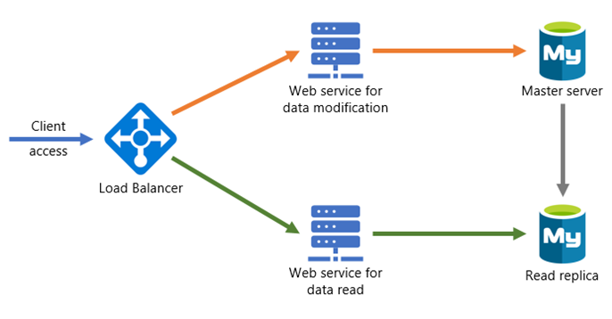

This image demonstrates a possible microservices architecture with PostgreSQL read replicas.

## Flexible Server resources

* [Azure Portal](https://learn.microsoft.com/azure/postgresql/flexible-server/flexible-server/how-to-read-replicas-portal)
* [Azure CLI](https://learn.microsoft.com/azure/postgresql/flexible-server/flexible-server/how-to-read-replicas-cli)

## Backup and restore

As with any mission-critical system, having a backup and restore as well as a disaster recovery (BCDR) strategy is an important part of the overall system design.

 **Watch:** [Backup and Restore [8 of 16] | Azure Database for PostgreSQL Flexible Server - Beginners Series](https://www.youtube.com/watch?v=B7qGSX8IeSY&list=PLlrxD0HtieHghqeFLMwaGxfxPbndt52Ap&index=8)

If an unforeseen event occurs, administrators should have the ability to restore data to a point in time called the Recovery Point Objective (RPO) and in a reasonable amount of time called the Recovery Time Objective (RTO).

### Backup

Azure Database for PostgreSQL Flexible Server takes automatic backups of data and transaction log files. These backups can be stored in locally-redundant storage (replicated multiple times in a datacenter); zone-redundant storage (multiple copies are stored in two separate availability zones in a region); and geo-redundant storage (multiple copies are stored in two separate Azure regions).

Azure Database for PostgreSQL Flexible Server supports automatic backups for 7 days by default. It may be appropriate to modify this to the current maximum of 35 days. It is important to be aware that if the value is changed to 35 days, there will be charges for any extra backup storage over 1x of the storage allocated. Data file backups are taken once daily, while transaction log backups are taken every five minutes.

Find additional storage pricing details for Flexible Server [here.](https://azure.microsoft.com/pricing/details/PostgreSQL/flexible-server/)

There are several current limitations to the database backup feature as described in the [Backup and restore in Azure Database for PostgreSQL Flexible Server](https://learn.microsoft.com/azure/postgresql/flexible-server/concepts-backup) docs article. It is important to understand them when deciding what additional strategies should be implemented.

Some items to be aware of include:

* No direct access to the backups
* Tiers that allow up to 4TB have a full backup once per week, differential twice a day, and logs every five minutes
* Tiers that allow up to 16TB have snapshot-based backups

 **Note:** [Some regions](https://learn.microsoft.com/azure/postgresql/flexible-server/concepts-pricing-tiers#storage) do not yet support storage up to 16TB.

### Restore

Redundancy (local or geo) must be configured during server creation. However, a geo-restore can be performed and allows the modification of these options during the restore process. Performing a restore operation will temporarily stop connectivity, and any applications will be down during the restore process.

During a database restore, any supporting items outside of the database will also need to be restored. Review the migration process. See [Perform post-restore tasks](https://learn.microsoft.com/azure/postgresql/flexible-server/concepts-backup#perform-post-restore-tasks) for more information.

Lastly, note that performing a restore from a backup provisions a new Flexible Server instance. Most of the new server’s configuration is inherited from the old server, though it depends on the type of restore performed.

Learn more about backup and restore in Flexible Server from the [Microsoft documentation.](https://learn.microsoft.com/azure/postgresql/flexible-server/flexible-server/concepts-backup-restore)

### Flexible Server resources

* [Point-in-time restore with Azure Portal](https://learn.microsoft.com/azure/postgresql/flexible-server/flexible-server/how-to-restore-server-portal)
* [Point-in-time restore with CLI](https://learn.microsoft.com/azure/postgresql/flexible-server/flexible-server/how-to-restore-server-cli)
* [Azure CLI samples for Azure Database for PostgreSQL Flexible Server - Flexible Server](https://learn.microsoft.com/azure/postgresql/flexible-server/flexible-server/sample-scripts-azure-cli)

## Service maintenance

Like any Azure service, Flexible Server receives patches and functionality upgrades from Microsoft. To ensure that planned maintenance does not blindside administrators, Azure provides them control over when patching occurs.

With Flexible Server, administrators can specify a custom **Day of week** and **Start time** for maintenance, or they can let the platform choose a day of week and time. If the maintenance schedule is chosen by the platform, maintenance will always occur between 11 PM and 7 AM in the region’s time zone.

See [this](https://azure.microsoft.com/global-infrastructure/data-residency/#select-geography) list from Microsoft to determine the physical location of Azure regions and thus the regional time zone.

Azure always rolls out updates to servers with platform-managed schedules before instances with custom schedules. Platform-managed schedules allow developers to evaluate Flexible Server feature improvements in non-production environments. Moreover, maintenance events are relatively infrequent; there are typically 30 days of gap unless a critical security fix must be applied.

As a general rule, only set a maintenance schedule for production instances.

### Notifications

In most cases, irrespective of whether using a platform-managed or custom maintenance schedule, Azure will notify administrators five days before a maintenance event. The exception is critical security fixes.

Use Azure Service Health to view upcoming infrastructure updates and set notifications. Refer to the links at the end of the document.

### Differences for Single Server

Single Server uses a gateway to access database instances, unlike Flexible Server. These gateways have public IP addresses that are retired and replaced, which may impede access from on-premises. Azure notifies customers about gateway retirements three months before. Learn more [here.](https://learn.microsoft.com/azure/postgresql/flexible-server/concepts-connectivity-architecture)

Single Server does not support custom schedules for maintenance. Azure notifies administrators 72 hours before the maintenance event.

### Configure maintenance scheduling and alerting

* [Manage scheduled maintenance settings using the Azure Portal (Flexible Server)](https://learn.microsoft.com/azure/postgresql/flexible-server/flexible-server/how-to-maintenance-portal)
* [View service health notifications in the Azure Portal](https://docs.microsoft.com/azure/service-health/service-notifications)
* [Configure resource health alerts using Azure Portal](https://docs.microsoft.com/azure/service-health/resource-health-alert-monitor-guide)

## Azure Database for PostgreSQL Flexible Server upgrade process

Since Azure Database for PostgreSQL Flexible Server is a PaaS offering, administrators are not responsible for the management of the updates on the operating system or the PostgreSQL software. Also, administrators need to plan for database version upgrades. Cloud providers are continuously upgrading and improving their supported offerings. Older versions eventually fall into the unsupported status.

 [Retired PostgreSQL engine versions not supported in Azure Database for PostgreSQL Flexible Server](https://learn.microsoft.com/azure/postgresql/flexible-server/concepts-version-policy#retired-PostgreSQL-engine-versions-not-supported-in-azure-database-for-PostgreSQL)

 **Warning:** It is important to be aware the upgrade process can be random. During deployment, the PostgreSQL server workloads will stop be processed on the server. Plan for these downtimes by rerouting the workloads to a read replica in the event the particular instance goes into maintenance mode.

 **Note:** This style of failover architecture may require changes to the applications data layer to support this type of failover scenario. If the read replica is maintained as a read replica and is not promoted, the application will only be able to read data and it may fail when any operation attempts to write information to the database.

The [planned maintenance notification](https://learn.microsoft.com/azure/postgresql/flexible-server/concepts-monitoring#planned-maintenance-notification) feature will inform resource owners up to 72 hours in advance of installation of an update or critical security patch. Database administrators may need to notify application users of planned and unplanned maintenance.

 **Note:** Azure Database for PostgreSQL Flexible Server maintenance notifications are incredibly important. The database maintenance can take the database and connected applications down for a short period of time.

## 10 / Summary

A solid BCDR plan is critical for every organization. The operation team should leverage strategies covered in this chapter to ensure business continuity. Downtime events are not only disaster events, but also include normal scheduled maintenance. This chapter pointed out that platform as a service instances such as Azure Database for PostgreSQL Flexible Server still have some downtime that must be taken into consideration. Older versions of PostgreSQL will trigger end-of-life (EOL) support. A plan should be developed to ensure that the possibility of upgrades will not take applications offline. Consider using read only replicas that will maintain the application availability during these downtimes. To support these types of architectures, the applications may need to be able to gracefully support the failover to read-only nodes when users attempt to perform write based activities.

### Checklist

* Perform backups regularly, ensure the backup frequency meets requirements.
* Setup read replicas for read intensive workloads and regional failover.
* Use resource locks to prevent accidental deletions.
* Create resource locks on resource groups.
* Implement a load balancing strategy for applications for quick failover.
* Be aware that service outages will occur and plan appropriately.
* Develop a scheduled maintenance plan and setup maintenance notifications.
* Develop a database version upgrade plan.

# 11 / Best practices

## Best practices for PostgreSQL Flexible Server apps

Organizations developing cloud apps backed by Azure Database for PostgreSQL Flexible Server should consider implementing the following best practices. Note, that this list is not comprehensive.

Readers should review additional guide chapters for a more comprehensive understanding.

* [05 / Monitoring]
* 06 / Networking and Security
* 07 / Testing
* 08 / Performance and Optimization
* 10 / Business Continuity and Disaster Recovery

Consult the [Azure Well-Architected Framework](https://docs.microsoft.com/azure/architecture/framework/) for more information regarding the core principles of efficient cloud workloads. You can assess your existing Azure workloads for Well-Architected Framework compliance with the [Azure Well-Architected Review utility.](https://docs.microsoft.com/assessments/?id=azure-architecture-review&mode=pre-assessment)

### 1. Co-locate resources

Locating Azure services in the same region minimizes network traffic costs and network latency. Flexible Server supports co-location in the same region and co-location in the same Availability Zone for [regions that support Availability Zones.](https://docs.microsoft.com/azure/availability-zones/az-region) PostgreSQL Flexible Server couples well with zonal services, like Virtual Machines.

### 2. Implement connection pooling

Developers can significantly improve application performance by reducing the number of times that connections are established and increasing the duration of those connections through connection pooling. Microsoft recommends the ProxySQL connection pooling solution, hosted on application servers or container orchestrators, like Azure Kubernetes Service (AKS).

* [ProxySQL on a VM](https://techcommunity.microsoft.com/t5/azure-database-for-PostgreSQL-blog/setting-up-proxysql-as-a-connection-pool-for-azure-database-for/ba-p/2589350)
* [ProxySQL on AKS](https://techcommunity.microsoft.com/t5/azure-database-for-PostgreSQL-blog/deploy-proxysql-as-a-service-on-kubernetes-using-azure-database/ba-p/1105959)

### 3. Monitor and size containers adequately

To ensure that containerized applications function optimally, verify that application containers are allocated sufficient resources. It may be necessary to adjust application parameters for container environments, like Java heap size parameters.

Developers can identify container resource issues using monitoring utilities, like [Container insights,](https://docs.microsoft.com/azure/azure-monitor/containers/container-insights-overview) which supports Azure Kubernetes Service, Azure Container Instances, on-premises Kubernetes clusters, and more.

* Identify AKS containers that are running on the node and their average processor and memory utilization. This knowledge can help you identify resource bottlenecks.
* Identify processor and memory utilization of container groups and their containers hosted in Azure Container Instances.
* Review the resource utilization of workloads running on the host that are unrelated to the standard processes that support the pod.

### 4. Implement network isolation and SSL connectivity

PostgreSQL Flexible Server natively supports connectivity through Azure Virtual Networks, meaning that the database endpoint does not face the public Internet, and database traffic remains within Azure. Consider the 06 / Networking and Security document for more information regarding public and private access.

Microsoft also recommends securing data in motion through SSL for applications that support SSL connectivity. Legacy applications should only use lower SSL versions or disable SSL connectivity in secure network environments.

### 5. Retry on transient faults

Given that cloud environments are more likely to encounter transient faults, like network connectivity interruptions or service timeouts, applications must implement logic to deal with them, typically by retrying requests after a delay.

Applications must first determine if a fault is transient or more persistent. Typically, API responses indicate the nature of the issue, sometimes even specifying a retry interval. If the fault is transient, applications must retry requests without consuming excessive resources. Common retry strategies including sending requests at regular intervals, exponential intervals, or random intervals. If a given number of retry requests fail, applications consider the operation failed.

Azure SDKs typically provide native support for retrying service requests. Consult the documentation’s [list of per-service retry recommendations.](https://docs.microsoft.com/azure/architecture/best-practices/retry-service-specific)

For some ORMs that are commonly used with PostgreSQL databases, like PHP’s **PDO PostgreSQL**, it may be necessary to write custom retry code that retries database connections if particular PostgreSQL error codes are thrown.

### 6. Size database compute resources adequately

Teams must be diligent with sizing their Flexible Server instances to be cost-effective while maintaining sufficient application performance. There are [three different tiers of Flexible Server instances](https://learn.microsoft.com/azure/postgresql/flexible-server/flexible-server/concepts-compute-storage), each with different intended use cases and memory configurations.

* **Burstable**:
  + Up to **2 GiB** memory per vCore
  + Intended for workloads that do not use the CPU continuously
  + Cost-effective for smaller web applications and development workloads
* **General Purpose**:
  + **4 GiB** per vCore
  + Intended for applications that require more throughput
* **Memory Optimized**:
  + **8 GiB** per vCore
  + Intended for high-throughput transactional and analytical workloads, like real-time data processing

Flexible Server instances can be resized after creation. Azure stops database VM instances and needs up to 120 seconds to scale compute resources.

Use Azure Monitor Metrics to determine if you need to scale your Flexible Server instance. Monitor metrics like **Host CPU percent**, **Active Connections**, **IO percent**, and **Host Memory Percent** to make your scaling decisions. To test database performance under realistic application load, consider utilities like [sysbench.](https://techcommunity.microsoft.com/t5/azure-database-for-PostgreSQL-blog/benchmarking-azure-database-for-PostgreSQL-flexible-server-using/ba-p/3108799)

## 11 / Summary

The preceding best practices are a collection of the most common items that architects and developers may employ to improve the performance, security and availability of their Azure Database for PostgreSQL Flexible Server applications. Be sure to review if you have followed all the recommended best practices and if you discover they have not been followed, try to implement them as soon as possible to esnure the integrity of your applications and satisfaction of your users.

# 12 / PostgreSQL architectures

By progressing through this guide, there have been various ways presented to build and deploy applications using many different services in Azure. Although we covered many topics, there are many other creative and different ways to build and deploy PostgreSQL-based services.

The [Azure Architecture center](https://docs.microsoft.com/azure/architecture/) provides many different examples of how to create different architectures. Although some of them utilize other database persistence technologies, these could easily be substituted with Azure Database for PostgreSQL Flexible Server - Flexible Server.

## Sample architectures

The following are a few examples of architectures using different patterns and focused on various industries from the Azure Architecture Center.

### Digital marketing using Azure Database for PostgreSQL Flexible Server

* [Digital marketing using Azure Database for PostgreSQL Flexible Server:](https://docs.microsoft.com/azure/architecture/solution-ideas/articles/digital-marketing-using-azure-database-for-PostgreSQL) In this architecture, corporations serve digital marketing campaigns through content management systems, like WordPress or Drupal, running on Azure App Service. These CMS offerings access user data in Azure Database for PostgreSQL Flexible Server. Azure Cache for Redis caches data and sessions, while Azure Application Insights monitors the CMS app for issues and performance.

### Finance management apps using Azure Database for PostgreSQL Flexible Server

* [Finance management apps using Azure Database for PostgreSQL Flexible Server:](https://docs.microsoft.com/azure/architecture/solution-ideas/articles/finance-management-apps-using-azure-database-for-PostgreSQL) This architecture demonstrates a three-tier app, coupled with advanced analytics served by Power BI. Tier-3 clients, like mobile applications, access tier-2 APIs, which reference tier-1 Azure Database for PostgreSQL Flexible Server. To offer additional value, [Power BI](https://docs.microsoft.com/power-bi/fundamentals/power-bi-overview) accesses Azure Database for PostgreSQL Flexible Server (possibly read replicas) through its PostgreSQL connector.

### Intelligent apps using Azure Database for PostgreSQL Flexible Server

* [Intelligent apps using Azure Database for PostgreSQL Flexible Server:](https://docs.microsoft.com/azure/architecture/solution-ideas/articles/intelligent-apps-using-azure-database-for-PostgreSQL) This solution demonstrates an innovative app that utilizes serverless computing (Azure Function Apps), machine learning (Azure Machine Learning Studio & Cognitive Services APIs), Azure Database for PostgreSQL Flexible Server, and Power BI.

### Gaming using Azure Database for PostgreSQL Flexible Server

* [Gaming using Azure Database for PostgreSQL Flexible Server:](https://docs.microsoft.com/azure/architecture/solution-ideas/articles/gaming-using-azure-database-for-PostgreSQL) This architecture demonstrates how to develop apps that must process API requests at scale, such as gaming backends.
* The architecture utilizes:
  + Azure Traffic Manager to geographically distribute traffic.
  + Azure API Management to provide rate limiting.
  + Azure App Service to host gaming APIs and Azure Database for PostgreSQL Flexible Server. Firms can perform analysis on gaming data in Azure Database for PostgreSQL Flexible Server using Azure HDInsight.
  + Power BI to visualize the data.

### Retail and e-commerce using Azure PostgreSQL

* [Retail and e-commerce using Azure PostgreSQL:](https://docs.microsoft.com/azure/architecture/solution-ideas/articles/retail-and-ecommerce-using-azure-database-for-PostgreSQL) This application architecture focuses on processing transactions quickly and creating tailored customer experiences. It consists of Azure App Service, Azure Database for PostgreSQL Flexible Server (for storing product and session information), and Azure Search (for full-text search capability).

### Scalable web and mobile applications using Azure Database for PostgreSQL Flexible Server

* [Scalable web and mobile applications using Azure Database for PostgreSQL Flexible Server:](https://docs.microsoft.com/azure/architecture/solution-ideas/articles/scalable-web-and-mobile-applications-using-azure-database-for-PostgreSQL) This generic architecture utilizes the scaling capabilities (vertical and horizontal) of Azure App Service and PostgreSQL Flexible Server.

## 12 / Summary

Many customers have built scalable resilient architectures using Azure Database for PostgreSQL Flexible Server. Developers can build basic two-tier and three-tier architectures to more advanced container-based and event-driven PostgreSQL based architectures.

At the very core, an application will consume CPU, memory, disk and network. Finding the right target hosting platform while balancing costs is a vital skill. Developers should leverage the examples provided throughout this guide to accelerate their learning and adoption journey.

### Checklist

* Reference architectures can provide ideas on how to use a product. Start to learn from successful deployments.
* Utilize the knowledge others have to build your own applications.
* Implement common proven patterns in your architectures.

# 13 / Customer stories

Azure Database for PostgreSQL Flexible Server is used by customers world wide, and many have shared their stories on the [Microsoft Customer Stories portal](https://customers.microsoft.com/search?sq=%22Azure%20Database%20for%20PostgreSQL%22&ff=&p=2&so=story_publish_date%20desc).

## Case studies

The following are a set of case studies from the Microsoft Customer Stories page focused on the usage of Azure Database for PostgreSQL Flexible Server.

### Minecraft



This image shows the Minecraft logo.

Minecraft migrated from AWS Aurora to Azure Database for PostgreSQL Flexible Server for its Realms service to improve performance and reduce costs. Minecraft moved over 1 TB of data, distributed across 13 databases, serving over 6k requests per second during the migration. Minecraft utilized the Azure Database Migration Service six-month free offer to save costs.

Minecraft also migrated its frontend servers to Azure to take advantage of Azure’s global footprint. This migration also improved developer productivity through smaller code footprints and simpler deployments.

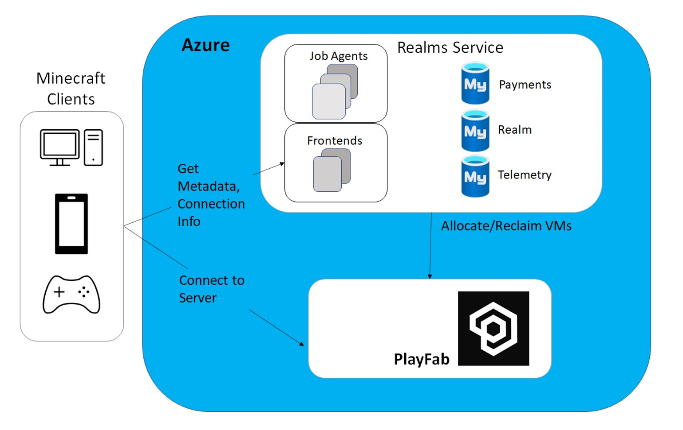

This image demonstrates the Minecraft Realms service running in Azure, accessing Azure Database for PostgreSQL Flexible Server.

### Automobile Retail

The retailer ran PostgreSQL database on Red Hat Enterprise Linux with a Java Spring Boot application on the backend and a Vue.js on the frontend. The environment did not have the capability to scale up and down as needed to cope with this fluctuation in the market, and 30% of its resources were underutilized. As a result, the retailer was overpaying and unnecessarily bleeding valuable capital.

The PostgreSQL database was modernized with Azure Database for PostgreSQL Flexible Server with a read replica to support the reporting needs of the business.

### Linked Brain



This image shows the LinkedBrain logo.

In November 2019, a Microsoft gaming industry representative visited [Linked Brain](https://customers.microsoft.com/story/1418505453083122843-linked-brain-en-japan) to explain Microsoft Azure services and FastTrack for Azure. Features fitted perfectly with Linked Brain’s goal of building game systems with PaaS, and the company decided to officially adopt Microsoft Azure.

We learned Flexible Server could scale up and down without stoppages, offer backup capabilities, and deliver I/O capacity proportionate to storage size, making it easy to boost performance as data accumulates. Azure also offers regional disaster recovery as a standard benefit—an option which requires another instance fee on Amazon RDS.”

### T-Systems



This image shows the T-Systems logo.

In the Internet of Things (IoT) age, organizations must share proprietary data quickly while maintaining control, security, and compliance. [T-Systems](https://customers.microsoft.com/story/724200-deutsche-telekom-telecommunications-azure), a Deutsche Telekom division, worked with expert partner Ultra Tendency to meet that need, using Microsoft Azure and Azure Database for PostgreSQL Flexible Server to help create the Telekom Data Intelligence Hub, a data marketplace for data sharing that includes built-in analytics tools.

“We were looking for managed database solutions,” says Robert Neumann, Chief Executive Officer at Ultra Tendency. “With Azure database services, we wouldn’t have to manage uptime, backup, and recovery scenarios, and we could make the platform faster and more reliable.”

The execution layer of Data Intelligence Hub runs entirely on Azure database services, using the Azure Database for PostgreSQL Flexible Server and Azure Database for PostgreSQL Flexible Server services to support data availability without having to maintain a database operations infrastructure.

### Children’s Mercy Hospital



This image shows the logo of Children’s Mercy Kansas City.

[Children’s Mercy Kansas City](https://customers.microsoft.com/story/860516-childrens-mercy-health-provider-azure), an award-winning hospital and research institute, manages one of the leading genome sequencing centers in the United States. To better support researchers, Children’s Mercy is working with Microsoft and Pacific Biosciences to create a scalable, sharable, cloud-based data hub for vital research into pediatric diseases, built on Microsoft Genomics and Azure. It’s already garnering praise from the genomics research community and has the potential to accelerate vital clinical care for children.

The hospital and research institute had an existing relationship with Microsoft, so when researchers saw sequencing data begin to push toward the CMRI datacenter’s storage limits, the organization chose to support its genomic data platform with Microsoft Genomics, Azure Database for PostgreSQL Flexible Server, and Azure infrastructure as a service (IaaS) resources.

### GeekWire



This image shows the GeekWire logo.

Based in Seattle, Washington, [GeekWire](https://customers.microsoft.com/story/geekwire) is a rapidly growing technology news site with a global readership. In addition to covering the latest innovation, GeekWire serves the Pacific Northwest tech community with events, a job board, startup resources, a weekly radio show, and more. As its popularity and site traffic increased, so did performance concerns. To gain better scalability and performance, GeekWire decided to migrate its WordPress site to the Microsoft Azure platform. By taking advantage of fully managed services like Azure Database for PostgreSQL Flexible Server, the company can scale on-demand while cutting costs 45 percent.

## Common PostgreSQL Apps

This section documents common PostgreSQL-based products and their third-party implementations that organizations operate on Azure.

### 3rd party Azure solutions / Azure Marketplace

The [Azure Marketplace](https://azuremarketplace.microsoft.com/marketplace/) provides thousands of certified apps on Azure tailored to meet customer needs. Many of these apps utilize Azure Database for PostgreSQL Flexible Server.

#### CMS like WordPress

The WordPress CMS, based on PHP and PostgreSQL, is the most popular CMS, powering millions of web-scale sites and offering a variety of extensions. There are multiple WordPress offerings in the Azure Marketplace, such as [one from WordPress](https://azuremarketplace.microsoft.com/marketplace/apps/WordPress.WordPress?tab=Overview), which utilizes App Service and VMs.

#### LMS like Moodle

The Moodle LMS supports thousands of educational institutions and organizations, numbering 213 million users as of June 2020. There are a plethora of Azure Marketplace Moodle offerings; [this offering](https://azuremarketplace.microsoft.com/marketplace/apps/bitnami.moodle-frontend-manageddb-multitier?tab=Overview) uses Azure Database for PostgreSQL Flexible Server for its persistence layer.

#### e-commerce like Magento

Magento is a powerful e-commerce and marketing platform suitable for small and large businesses. There are multiple implementations available on the Azure Marketplace, including [this offering](https://azuremarketplace.microsoft.com/marketplace/apps/bitnami.magento-chart?tab=Overview) that provides a Helm chart for a Kubernetes deployment.

## 13 / Summary

Similar to the reference architecture, case studies provide a view into how other organizations are building applications using PostgreSQL that could be appropriate and similar to how a developer may be thinking of building their own application. Although they may not go into as much depth as reference architectures, they certainly provide a means of generating ideas.

### Checklist

* Understand the most common uses of a product.
* Reference customers’ architecture.
* Justify and validate your use cases based on the use case studies.
* Attend conferences to learn how others are using the product(s).

# 14 / Zero to Hero

We have reached the end of the guide. You have the content and tutorials to assess your application and database evolution the target needs. Take a moment to determine the required steps to move your application architecture to the next evolutionary level. Architecture modernization and operational monitoring are an iterative processes and we hope you refer to this guide often.

## Determining the evolutionary waypoint

In module 4, we explored a series of progressions from classic development and deployment to current modern development and deployment methods. As a review, bre sure to reference this information to find your waypoint.

## Summary of tasks

* Have the right tools available.
* Determine how best to deploy the application.
* Utilize code repositories with CI/CD enabled.
* Ensure the target environment is configured to support the workload(s).
* Secure the application configurations.
* Secure the database configurations.
* Secure the virtual networks.
* Monitor the applications and database workloads for performance.
* Perform regular testing.
* Ensure up policies and procedures are setup and configured for auditing application and database workloads.
* Setup backup and restore based on RTO and RPO objectives.
* Be familiar with potential issues, how to troubleshoot, and remediate them.

## 14 / Final Summary

This guide was designed to provide insightful and rich sets of information on how to get started with developing applications with Azure Database for PostgreSQL Flexible Server. After reading through all the sections, a developer will have nurtured a foundation for how to get set up with the right tools and how to make decisions on target deployment models. This guide provided several sample architectures, deployment models and real-world customer references of using Azure Database for PostgreSQL Flexible Server that can be referenced in platform selection decisions.

As a final note, although there are several options for hosting PostgreSQL in Azure, the recommended and preferred method is to utilize Azure Database for PostgreSQL Flexible Server for its rich set of features and flexibility.

## Resources

### Call to Action

Thanks for downloading and reading this Azure Database for PostgreSQL Flexible Server developer guide. We encourage to to continue your learning by reviewing the following links to documentation pages and creating a free azure account to practice with.

* [Review homepage](https://aka.ms/PostgreSQL)
* [Documentation](http://aka.ms/PostgreSQLdocs)
* [Tutorial](https://learn.microsoft.com/azure/postgresql/flexible-server/flexible-server/how-to-deploy-on-azure-free-account)
* [Get started for free with an Azure free account!](https://azure.microft.com/free/PostgreSQL)
* [Azure Pricing Calculator, TCO Calculator](https://azure.microsoft.com/pricing)
* [Migrate your workloads to Azure DB for PostgreSQL](https://learn.microsoft.com/azure/postgresql/flexible-server/migrate)

### Stay tuned for latest updates and announcements

* [What’s new in Flexible Server?](https://learn.microsoft.com/azure/postgresql/flexible-server/flexible-server/whats-new)
* [Tech Community Blog](https://aka.ms/azure-db-PostgreSQL-blog)

### Follow Azure Database for PostgreSQL Flexible Server on social platforms

* [Twitter](https://twitter.com/AzureDBPostgreSQL)
* [LinkedIn](https://www.linkedin.com/company/azure-database-for-PostgreSQL/)
* Email the Azure Database for PostgreSQL Flexible Server team at AskAzureDBforPostgreSQL@service.microsoft.com

### Find a partner to assist in migrating

This guide introduced and covered several advanced development and deployment concepts that may be new to you or your organization. If at anypoint you need help there are many experts in the community with a proven migration and modernization track record.

Feel free to [search for a Microsoft Partner](https://www.microsoft.com/solution-providers/home) or [Microsoft MVP](https://mvp.microsoft.com/MvpSearch) to help with finding the most appropriate migration strategy.

Browse the technical forums and social groups for more detailed real-world information:

* [Microsoft Community Forum](https://docs.microsoft.com/answers/topics/azure-database-PostgreSQL.html)
* [StackOverflow for Azure PostgreSQL](https://stackoverflow.com/questions/tagged/azure-database-PostgreSQL)
* [Azure Facebook Group](https://www.facebook.com/groups/MsftAzure)
* [LinkedIn Azure Group](https://www.linkedin.com/groups/2733961/)
* [LinkedIn Azure Developers Group](https://www.linkedin.com/groups/1731317/)

# Appendix

TODO

# Getting Started

1. Clone the [whitepaper GitHub repository](https://github.com/solliancenet/microsoft-PostgreSQL-developer-guide.git) to the development machine.
2. Install the [PowerShell Azure module](https://docs.microsoft.com/powershell/azure/install-az-ps?view=azps-6.6.0) if not already installed.

* [PowerShell Core](https://github.com/PowerShell/PowerShell) is a cross-platform tool that is useful for managing Azure resources through the Az module.
* Try the -AllowClobber flag if the install does not succeed.

1. Utilize the Connect-AzAccount to interactively authenticate the Azure PowerShell environment with Azure.

## Create a Lab Resource Group

1. Use Azure PowerShell to create a new resource group. Substitute the rgName and location parameters with the name of the resource group and its location, respectively.

* $rgName = ""  
  $location = ""  
  New-AzResourceGroup -Name $rgName -Location $location

## Deploy the ARM Template

1. There are two ARM templates provided with the whitepaper.
   * The secure deployment uses private endpoints to securely access the PostgreSQL database instances through private IP addresses. It costs roughly … per month.
   * The standard deployment routes traffic to the PostgreSQL instances over the public internet. It costs roughly … per month.
2. If deploying the [secure ARM template](../Artifacts/template-secure.json) (template-secure.json), edit the associated [parameters file](../Artifacts/template-secure.parameters.json) (template-secure.parameters.json).
   * The prefix specifies a unique identifier for Azure resources
   * The administratorLogin specifies the login for the Azure resources (such as PostgreSQL and the VM)
   * The administratorLoginPassword specifies the password for the deployed Azure resources
   * The location set to an Azure environment closest to the users
3. If deploying the [insecure ARM template](../Artifacts/template.json) (template.json), edit the associated [parameters file](../Artifacts/template.parameters.json) (template.parameters.json).
   * The uniqueSuffix specifies a unique identifier for Azure resources
   * The administratorLogin specifies the login for the Azure resources (such as PostgreSQL and the VM)
   * The administratorLoginPassword specifies the password for the deployed Azure resources
   * The vmSize specifies the VM tier
   * The dnsPrefix specifies the DNS prefix for the load balancer public IP address

* NOTE: Because of some automation account mapping settings, these templates are designed to only be deployed to eastus2, eastus, southcentralus, westcentralus, westus2, westus, northcentralus

1. If deploying the secure ARM template, issue the following command from the repository root.

* cd "C:\labfiles\microsoft-postgres-docs-project"  
    
  New-AzResourceGroupDeployment -ResourceGroupName $rgName -TemplateFile .\artifacts\template-secure.json -TemplateParameterFile .\artifacts\template-secure.parameters.json
* Use template.json and template.parameters.json for the insecure ARM template deployment.

## Running the sample application

Instead of learning multiple sample applications, the guide focused on evolving deployment strategies. Readers should learn the sample application structure once and focus on how the application will need to be modified to fit the deployment model.

### Site map



This image shows the sample app site map.

### Sample Application Prerequisites

* Azure subscription
* Git
* pgAdmin

### Quick start: manual Azure set up instructions

As part of this guide, there are environment automation setup scripts provided that will build and configure much of the environment needed for the sample application. It is important to understand the basic Azure **concepts** before running the automated scripts. Walking through each step will help provide additional context and learning opportunities. The scripts will create an environment in a few minutes rather than requiring to walk through lengthy setup exercises.

 **Note:** The sample application was tested with PHP version 7.4 and 8.0. Deploying to an 8.x environment requires a slightly different configuration as the underlying web server has changed.

| PHP Version | Web Server |
| --- | --- |
| 7.4 | Apache |
| 8.0 | Nginx |

The Azure App Service uses this [Docker image](https://github.com/Azure-App-Service/nginx-fpm) for its 8.0 container builds.

 **Warning**: Outdated runtimes are periodically removed from the Web Apps Create and Configuration blades in the Portal. These runtimes are hidden from the Portal when they are deprecated by the maintaining organization or found to have significant vulnerabilities. These options are hidden to guide customers to the latest runtimes where they will be the most successful. Older Azure App Service Docker images can be found [here](https://github.com/Azure-App-Service/php).

### Sample application deployment steps

**Deploying to PHP 8.0**

The deployment strategy applied in this sample application focuses on updating project environment variables instead of global environment variable configuration.

1. Log into the Azure Portal.
2. Search for Marketplace.
3. While in the Marketplace, search for and create Azure Web App + Database resources in the Marketplace.
   * Select the Marketplace button.
   * 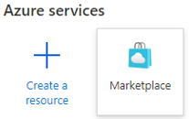
   * Displays the Marketplace button.
   * Enter Web App + Database in the search box.
   * Select the Microsoft Web App + Database search result.
   * 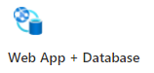
   * Web app + database search result.
4. Create a web application and database.

* 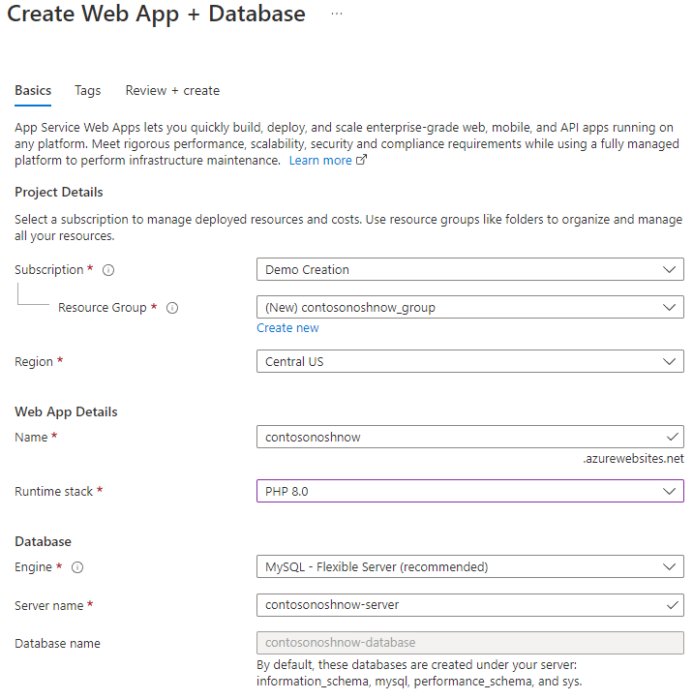
* Create web app database.
  + Choose the subscription.
  + Create a new resource group
  + Choose a region.
  + Create a unique web app name.
  + Select the runtime stack. The web app is only tested with PHP 8.0.
  + Create the resources.

1. After the resources have been deployed, locate the App Service in the Resource Group.
   * Select the **Deployment Center** and capture the configuration settings.
   * In the Settings tab, choose Local Git.

* 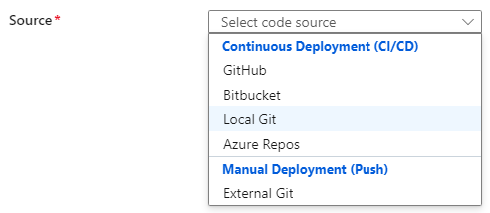
* App Service repository options.
  + Select **Save** at the top.
*  **Note:** Alternative Azure CLI command:
* az webapp deployment source config-local-git --name <app-name> --resource-group <group-name>
  + Capture the **Git Clone Uri**. Later exercises will be pushing the application files to the Azure App Service local storage from the development machine.
  + 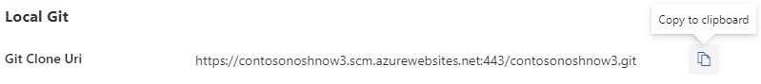
  + Local Git URL example
  + Capture the Application Scope user and password to be used later. Make sure to capture only the user name.
  + 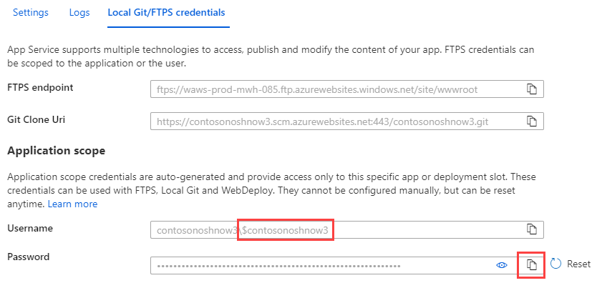
  + Application Scope user and password

1. Clone the sample **ContosoNoshNow** application to the local development machine from the Microsoft Git repository:

TODO: Get the MS repo.

* Open the command prompt or terminal on the development machine.
* Type the following commands individually to configure the remote repo connection. Review the output:
* git remote add azure <Azure App Service Git Clone URL>  
  git remote -v  
  git push azure master
* When pushing content to the Azure App Service, the systems will prompt for the Local Git credentials. Enter the Application Scope credentials.
* 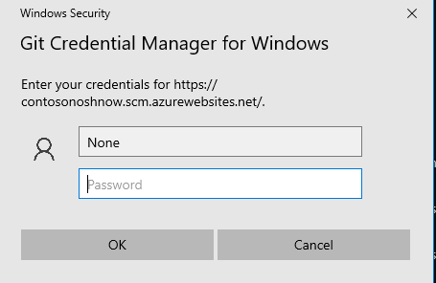
* Git Credential Manager
* If you make a mistake entering the credentials, you will have to open Credential Manager to update the credentials.
* The following output should display in the command window:
* 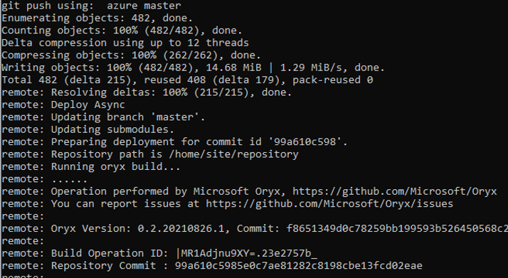
* Azure local git push example.

1. Return to the Azure Portal. Navigate to the App Service. Find the **Deployment Tools** section. Log into App Service SSH terminal.

* 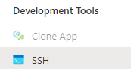
* This image shows how to access the App Service SSH prompt from the Azure portal.

1. Verify the sample application files have been copied into the wwwroot directory.

* cd /home/site/wwwroot  
  ls -la

1. Run the Composer update command in the wwwroot directory, which will import the packages and create the vendor folder, along with the autoload script (../vendor/autoload.php).

* cp /home/site/repository/.env.example.azure /home/site/wwwroot/.env  
  composer.phar update

1. Generate Laravel application key. This command will update the **.env** file.

* php artisan key:generate

1. Update the **APP_URL** parameter in the .env file with the Azure App Service URL and save the changes.

* nano /home/site/wwwroot/.env
* 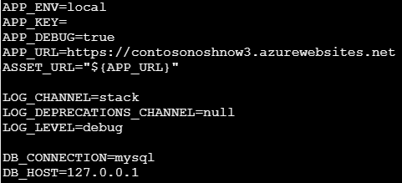
* Update APP_URL value

1. Copy the Nginx default to the home default. By default, App Service set WEBSITES_ENABLE_APP_SERVICE_STORAGE = true. Files stored in /home path are persisted in an Azure Storage file share, which can survive restart and shared across scale instances. So we need to save your own Nginx configure file under /home path.

* cp /etc/nginx/sites-enabled/default /home/default

1. Update the Nginx home default.

* nano /home/default
  + absolute_redirect off
  + root /home/site/wwwroot/public
  + try_files $uri $uri//index.php$ is_args$args;
* 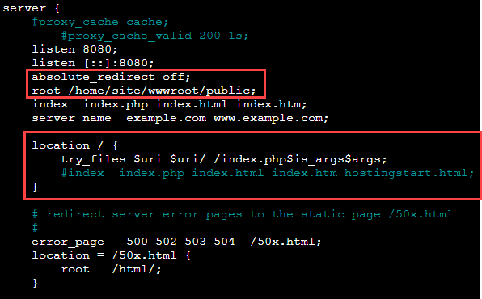
* This image shows the needed modifications to the /home/default file.

1. Restart the service.

* service nginx restart

1. Your configuration needs to survive an App Service restart. Update the App Service Startup Command.
   * Navigate to the **Settings** section.
   * Select **Configuration**.
   * Select the **General settings**.
   * Enter the following command in the **Startup Command**:

* cp /home/default /etc/nginx/sites-enabled/default; service nginx restart
* 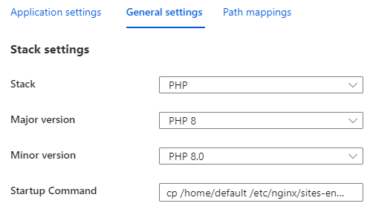
* This image shows how to configure the App Service startup command in the Azure portal.

1. Open a browser and view the application.

* 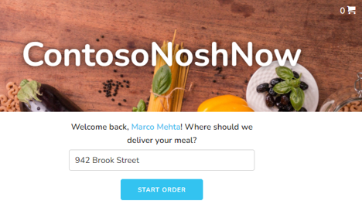
* ContosoNoshNow home page

 **Note:** Notice the message in red at the bottom of the web page. “Site is unable to pull from database. Using JSON data instead.”

## Connecting to the database

The application should now be available and show some sample data, however the web application is not reading or writing to the database. Let’s go through the steps to configure the database configuration information.

1. Capture the database connection information. Open the Azure CLI Cloud Shell and run this command.

* az webapp deployment list-publishing-profiles --resource-group <resource group name> --name <app service name>

1. Capture the following connection values:
   * Host/Server
   * User ID
   * Password

*  **Note:** For production environments, values will be retrieved from Azure Key Vault.

1. Using the Azure Portal, navigate to the Flexible Server in the resource group and create the contosonoshnow database.

* 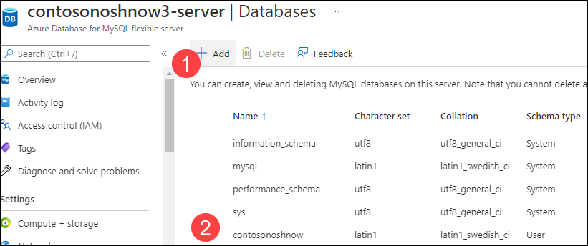
* This image shows how to create the contosonoshnow database in the new Flexible Server instance.
*  **Note:** It is possible to execute alternative commands in the App Service SSL terminal to create the database. See the alternative commands below.
* Alternative commands:
* PostgreSQL --host=<hostname>-server.postgres.database.azure.com --user=<user name> --password=<password> --ssl=true
* CREATE DATABASE contosonoshnow
* exit

1. With the database connection information in hand, open the App Service SSH console and configure the **.env** project file.

* nano /home/site/wwwroot/.env
* 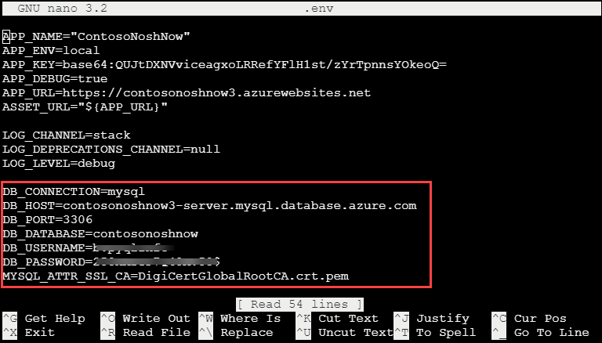
* Configure the database environment variables.
* Update the following environment variables:
  + DB_HOST
  + DB_DATABASE
  + DB_USERNAME
  + DB_PASSWORD

1. Run the php artisan migrate command to create the tables in the contosonoshnow database.

* php artisan migrate
* 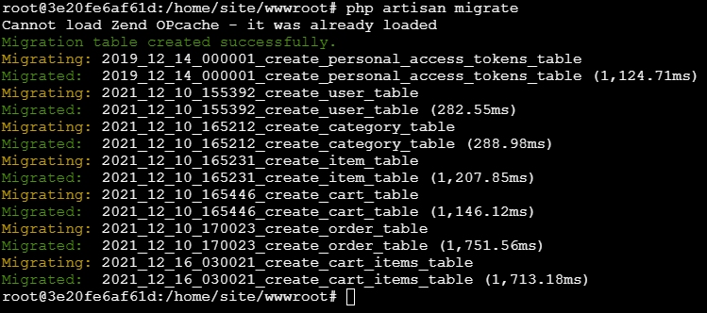
* This image shows how to create PHP migrations.

1. Run the php artisan db:seed command to seed the database with sample data values.

* php artisan db:seed
* 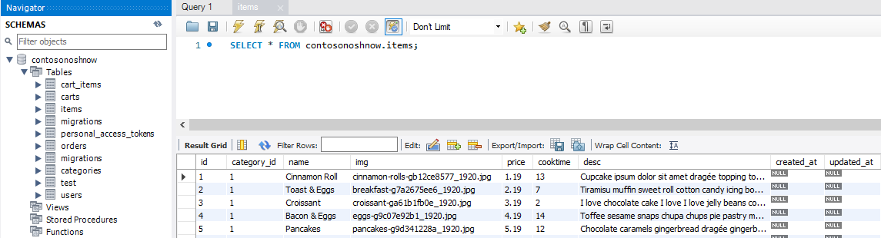
* Seeded database.
  + Using pgAdmin, verify the tables have the seed data.

1. Navigate back to the web app and enter a sample order.

* 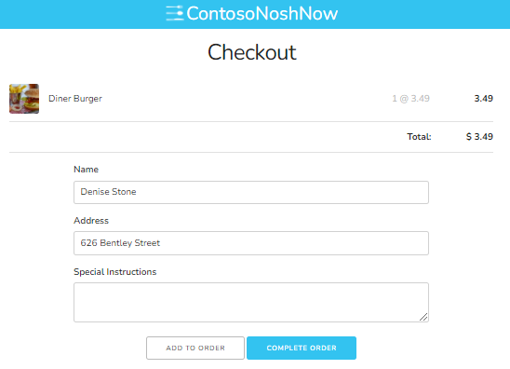
* This image shows how to create a sample order from the Laravel app.

1. Using pgAdmin, verify the order was saved to the Flexible Server database.

* 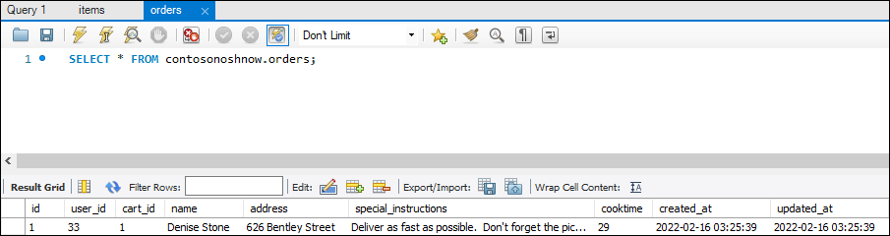
* This image shows the output of a SQL query that demonstrates the new order.

### What happens to my app during an Azure deployment?

All the officially supported deployment methods make changes to the files in the /home/site/wwwroot folder of the app. These files are used to run the application. The web framework of choice may use a subdirectory as the site root. For example, Laravel, uses the public/ subdirectory as the site root.

The environment variable could be set globally or at the project level. Setting the environment variables at the project level, when possible, allows for deployment independence and reduces the likelihood of dependency collision.

### Troubleshooting tips

* Select the App Service in the Azure Portal. In the **Monitoring** section, select **Log Stream**.
* [Troubleshoot connection issues to Azure Database for PostgreSQL Flexible Server](https://learn.microsoft.com/azure/postgresql/flexible-server/howto-troubleshoot-common-connection-issues)
* Running php -i at the Azure App Service SSH console will provide valuable configuration information.
* Azure App Service 8.0 php.ini location - cat /usr/local/etc/php/php.ini-production
* [Configure a PHP app for Azure App Service - Access diagnostic logs](https://docs.microsoft.com/azure/app-service/configure-language-php?pivots=platform-linux#access-diagnostic-logs)
* [Deploying a Laravel application to Nginx server.](https://laravel.com/docs/8.x/deployment#nginx)
* [Local Git deployment to Azure App Service](https://docs.microsoft.com/azure/app-service/deploy-local-git?tabs=cli)

## Recommended content

* [How PHP apps are detected and built.](https://github.com/microsoft/Oryx/blob/main/doc/runtimes/php.md)

## Deploying a Laravel app backed by a Java REST API to AKS

### Evolve the sample application

In the previous stages of this developer guide, an MVC app was deployed on an Azure VM, containerized, and then hosted on various PaaS services (e.g. Azure Container Instances, App Service, AKS). The second sample app provided with this developer guide delegates database access operations (Flexible Server queries) to a Java REST API. The Laravel app calls the REST API.

One of the advantages of this microservices architecture is that the Java API and the Laravel app can be scaled independently. Both deployments have high availability. Moreover, though this exercise does not demonstrate how to configure CI/CD for this app, but can apply the same techniques learned previously.

We recommend creating a new resource group for this exercise.

az group create -n [RESOURCE GROUP NAME] -l [AZURE REGION]

### Download the tools

To complete this document, install the following tools on the development machine:

* Azure CLI
* [Apache Maven:](https://maven.apache.org/) This tool manages the build processes for the Java API. Add the Maven executable to the system’s PATH variable for simpler usage.
* [Docker Desktop:](https://docs.docker.com/desktop/) Docker Desktop provides an intuitive management interface for the Docker service. This guide uses the Docker CLI to create Docker images.
* [kubectl:](https://kubernetes.io/docs/reference/kubectl/kubectl/) kubectl is a useful management tool for Kubernetes clusters. Install it from the Azure CLI through az aks install-cli.

### Provision the database

Navigate to .\java-api\Database from a PowerShell terminal instance. Then, execute the create-database.ps1 script, passing the parameters in the order shown below. The command will provision a new Flexible Server instance with the app database schema.

* Provide a unique Suffix to ensure that the Flexible Server instance’s name is unique
* Provide a strong Password for the database admin user (AppAdmin)
* Provide the name of the lab Resource Group
* Provide the desired Location for the Azure resources

.\create-database.ps1 'Suffix' 'Password' 'Resource Group' 'Location'

The Flexible Server instance will have 1 vCore, 2 GiB memory, 32 GiB storage, and it will allow all clients to access it. Note that this is not recommended for production scenarios; access can be limited to target Azure resources through the Azure portal or other management tools.

Consult the [Microsoft documentation](https://learn.microsoft.com/azure/postgresql/flexible-server/flexible-server/tutorial-deploy-springboot-on-aks-vnet) for information on how to configure private access for PostgreSQL Flexible Server from Azure Kubernetes Service. This example uses public access for simplicity.

### Create Docker images

#### API

Navigate to the .\java-api directory and enter the following command to create an optimized Docker image. Note that Maven does not need a Dockerfile to create this image, called noshnowapi:0.0.1-SNAPSHOT.

mvn spring-boot:build-image

#### Laravel

Navigate to the .\sample-php-app-rest directory. Create a file called .env. Set APP_KEY= as the first line in the file. Then, run php artisan key:generate to create an application key in the .env file.

APP_KEY=[ARTISAN APPLICATION KEY]

Now, in the same directory, enter the following command to create a Docker image to serve the PHP frontend app through Apache.

docker image build -t noshnowui:0.0.1 .

### Provision Azure Kubernetes Service

Navigate to .\java-api\Kubernetes from a PowerShell terminal instance. Then, execute the create-azure-resources.ps1 script, using the same parameters as the prior script. The command will provision Azure Container Registry and push the two Docker images; provision a new Azure Kubernetes Service cluster and provide it access to ACR; create the contosonoshnow namespace within the Kubernetes cluster.

.\create-azure-resources.ps1 'Suffix' 'Resource Group' 'Location'

Note that if the resources are deployed to an Azure region that supports Availability Zones, the script will co-locate the Flexible Server instance and the Kubernetes cluster.

### Deploy the API to Azure Kubernetes Service

#### Create the API Secret

Open the api.secrets.yml file in the Kubernetes directory. This file contains the base64-encoded password for the application user. Besides the administrative user, the database schema setup script created a less-privileged app user.

Run the command below from the Kubernetes directory to create the password secret:

kubectl apply -f api.secrets.yml

#### Create the API Service

api.service.yml defines a Service that directs all traffic received from within the cluster on port 8080 to the pods that serve the Java API. Note that the API service is only accessible from within the cluster.

kubectl apply -f api.service.yml

#### Create the API Deployment

api.deployment.yml defines a deployment with two pods, created from the Java API image pushed to ACR.

Open the file. Replace the two [SUFFIX] placeholders with the values used when provisioning the Azure resources. Then, execute the command below:

kubectl apply -f api.deployment.yml

Congratulations. The API to Azure Kubernetes Service is now deployed and exposed internally through a Service.

### Deploy the Laravel app to Azure Kubernetes Service

#### Create the Laravel app Service

Navigate to .\sample-php-app-rest\Kubernetes. Create a service to expose the Laravel app through a public IP address (in this case, through a Load Balancer provisioned in Azure).

kubectl apply -f web.service.yml

#### Create the Laravel app Deployment

The deployment specified in the web.deployment.yml file (in the same directory as the previous step) creates two pods from the Laravel app image pushed to ACR.

Again, replace the [SUFFIX] placeholder in the file. Then, create the deployment.

kubectl apply -f web.deployment.yml

### Browse to the app

Run kubectl get svc to get the public IP address of laravel-ui-service. Copy the EXTERNAL-IP value to a browser window.



This image demonstrates the IP address of the LoadBalancer service for the Laravel app.

If all functions correctly, the user details for a random user will be displayed.

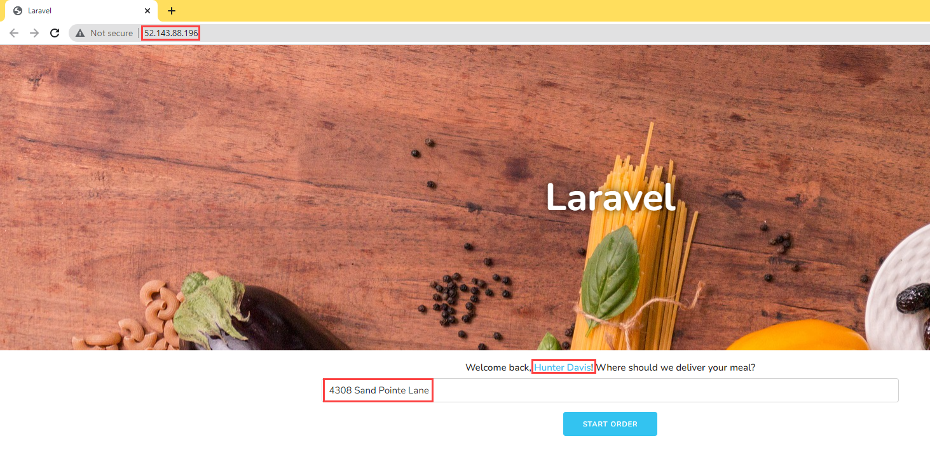

This image demonstrates that the Laravel app functions without a problem when deployed to AKS.

# Classic Deployment to PHP enabled IIS server

This is a simple app that runs PHP code to connect to a PostgreSQL database. These tasks will be performed on the **paw-1** virtual machine that was deployed via the ARM template.

## Database Deployment

1. On the **paw-1** virtual machine, open a Windows PowerShell window
2. Run the following commands to create the database (type yes when prompted). Note that the repo should be cloned to the c:\labfiles directory:

* cd C:\labfiles\microsoft-postgresql-developer-guide\artifacts\sample-php-app  
    
  composer update   
    
  copy .env.example.root .env  
    
  php artisan config:clear  
    
  php artisan migrate  
    
  php artisan db:seed  
    
  php artisan key:generate

1. Several tables should get created and will be populated with sample data:

* 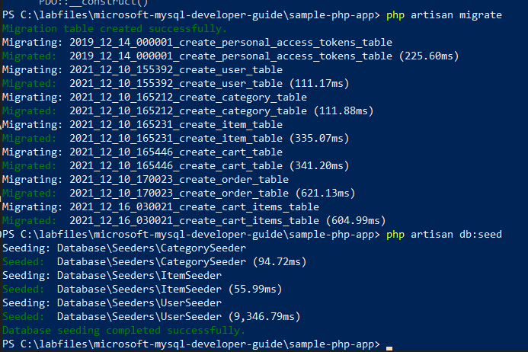
* This screen shot shows the results of the above commands.

## Test the PHP Setup

1. In the **paw-1** virtual machine, open a chrome browser window
2. Navigate to http://localhost:8080/default.php, **Hello World** should be displayed.
3. Navigate to http://localhost:8080/database.php, **12 results** should be displayed.

## Test the Store Application

1. Open a chrome browser window
2. Navigate to http://localhost:8080, the store front will load with a random user.

* 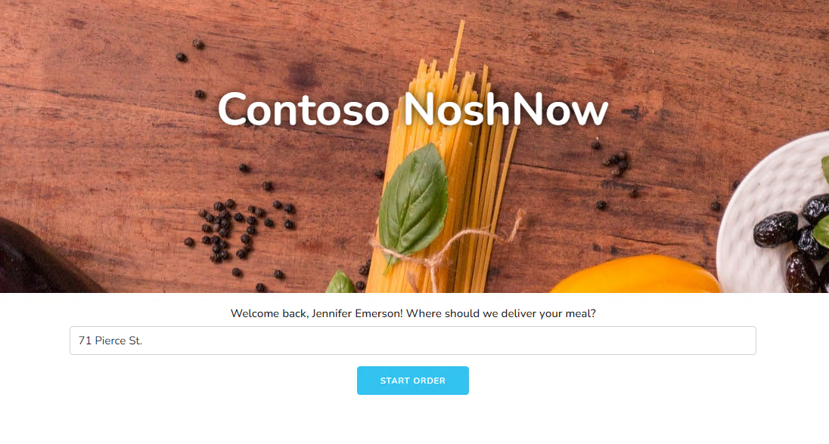
* This image demonstrates the loading screen for the Contoso NoshNow app.

## Manual Deployment

The above resources were deployed as part of the ARM template and supporting scripts. In order to setup a developer machine manually, do the following:

### Windows Setup

1. Install Composer
2. Install OpenSSL
3. Install Docker Desktop
4. Install Visual Studio Code
5. Install 7Zip
6. Install IIS
7. Install the WebPI extensions
8. Install PHP Extensions
9. Install PHP 8.x
10. Configure PHP 8.x
11. Copy the web application files to the c:\inetpub\wwwroot folder
12. Create an IIS web application that points to the web app directory
13. Install PostgreSQL and create the contosostore database

### Linux Setup

1. Update the operating system
2. Install nginx
3. Install PHP 8.x
4. Install Composer
5. Install OpenSSL
6. Install Docker
7. Install PHP Extensions (PostgreSQL, mbstring, xml, bcmath, etc)
8. Configure PHP 8.0
9. Copy the web application files to the /var/www/mydomain/htdocs/public folder
10. Update the nginx conf file for redirects
11. Install PostgreSQL and create the contosostore database

# Cloud Deployment to Azure VM

This is a simple app that runs PHP code to connect to a PostgreSQL database.

The app is running in an Azure VM and the App needs to be exposed to the internet via port 80 in order results to display.

## Test the Application #1

1. Open a browser to the Azure Portal
2. Navigate to the **paw-1** virtual machine
3. In the **Essentials** section, copy the public IP Address

* 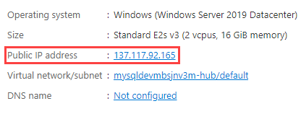
* This image demonstrates the VM IP address in the Overview tab.

1. Open a browser to the virtual machine ip address (ex http:\\IP_ADDRESS:8080)
2. A **ERR_CONNECTION_TIMED_OUT** error should occur. This is because the network security group on the virtual machine does not allow port 8080 access.

## Open Port 8080

1. Navigate to the **Paw-1** machine, select it
2. Under **Settings**, select **Networking**
3. Select **Add inbound port rule**
4. For the destination port, type **8080**
5. For the name, type **Port_8080**
6. Select **Add**

* 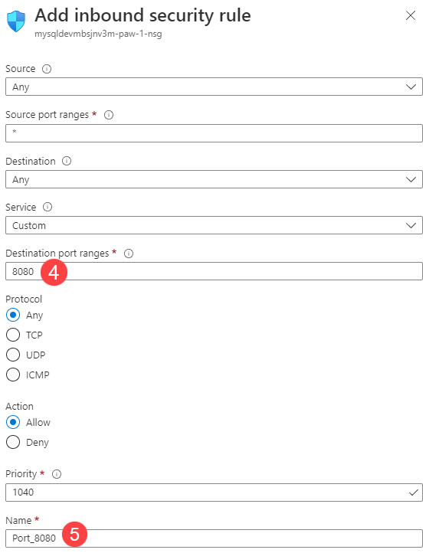
* This image demonstrates the added inbound security rule.

## Test the Application #2

1. Retry connecting to the web application (ex http:\\IP_ADDRESS:8080), notice another timeout error
2. Switch back to the **paw-1** machine, run the following PowerShell command:

* New-NetFirewallRule -DisplayName 'Port 8080' -Direction Inbound -Action Allow -Protocol TCP -LocalPort 8080

1. The application should load
2. Open a browser to the virtual machine ip address (ex http:\\IP_ADDRESS:8080)
3. The results should be displayed, but some files will not be download

## Edit .env file

1. Open the c:\labfiles\microsoft-postgres-developer-guide\artifacts\sample-php-app\.env file
2. Edit the APP_URL to the IP_ADDRESS of the virtual machine and remove the port 8080.
3. Change the http protocol to https in order to properly load the application over SSL.
4. Save the file, refresh the browser window

## Enable Port 443

As part of any secured web application, SSL/TLS should be enabled.

1. Create a certificate on web machine by running the following command in PowerShell:

* New-SelfSignedCertificate -FriendlyName ContosoNow -DnsName ContosoNow -CertStoreLocation Cert:\LocalMachine\My -KeyUsage DigitalSignature

1. Set the certificate on the site:
   * Open Internet Information Services (IIS) Manager
   * Select the server node
   * Select **Server certificates**
   * 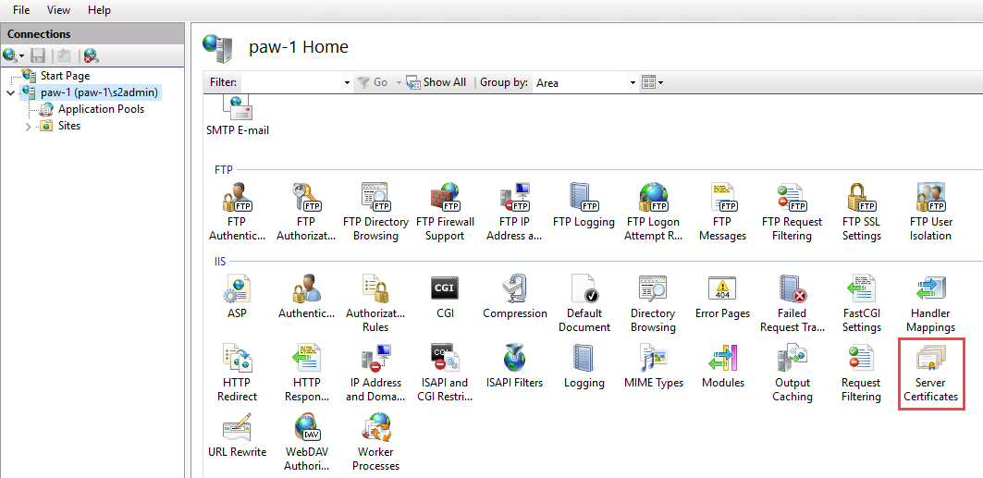
   * This image demonstrates the Server Certificates tab in IIS Manager.
2. Setup SSL
   * Expand the **Sites** node
   * Select the **ContosoStore** web site
   * In the actions, select **Bindings**
   * Select **Add**
   * For the type, select **https**
   * For the SSL certificate, select **ContosoNow**
   * Select **OK**

* 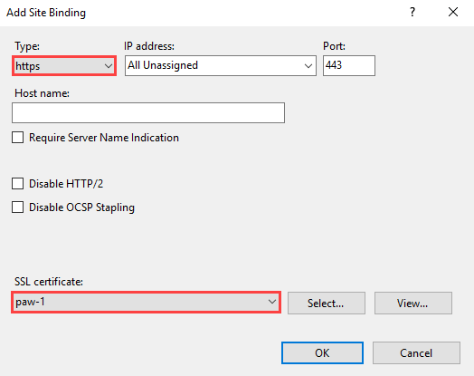
* This image demonstrates an HTTPS binding in IIS.

## Open Port 443

1. In the Azure Portal, navigate to the **Paw-1** machine, select it
2. Under **Settings**, select **Networking**
3. Select **Add inbound port rule**
4. For the destination port, type **443**
5. For the name, type **Port_443**
6. Select **Add**

## Test the Application #3

1. Retry connecting to the web application (ex https:\\IP_ADDRESS:443), an error should occur.
2. Switch back to the **paw-1** machine, run the following PowerShell:

* New-NetFirewallRule -DisplayName 'Port 443' -Direction Inbound -Action Allow -Protocol TCP -LocalPort 443

1. Select the **Advanced** button
2. Select **Proceed to IP_ADDRESS (unsafe)**
3. The application should load
4. Open a browser to the virtual machine ip address (ex https:\\IP_ADDRESS:443)
5. The results should display

# Cloud Deployment to Azure App Service

This is a simple app that runs PHP code to connect to a PostgreSQL database. The application and database must be migrated to Azure App Service and Azure Database for PostgreSQL Flexible Server.

## Basic Deployment

### Update env

1. Open the C:\labfiles\microsoft-postgresql-developer-guide folder in Visual Studio code
2. If prompted, select **Yes, I trust the authors**
3. Switch to the browser, browse to the **pgsqldevSUFFIX** app service
4. Select the **Overview** link, copy the **URL** for use later

### Deploy the Application

1. Switch to the **Paw-1** virtual machine remote desktop.
2. Open a terminal window, run the following to deploy the zip to Azure, be sure to replace the SUFFIX:

* NOTE: The virtual machine is running under a Managed Identity with owner access to the resource group.
* cd "C:\labfiles\microsoft-postgresql-developer-guide"  
    
  Connect-AzAccount -identity  
    
  $resourceGroups = Get-AzResourceGroup  
    
  $resourceGroupName = $resourceGroups[0].ResourceGroupName  
  $suffix = $resourceGroups[0].tags['Suffix']  
    
  $appName = "pgsqldev$($suffix)linux";  
  $app = Get-AzWebApp -ResourceGroupName $resourceGroupName -Name $appName  
    
  #NOTE: This can't be used this for linux based deployments  
  #Compress-Archive -Path .\sample-php-app\* -DestinationPath site.zip -force  
    
  7z a -r ./site.zip ./sample-php-app/*  
    
  #Publish-AzWebApp -WebApp $app -ArchivePath "C:\labfiles\microsoft-postgresql-developer-guide\site.zip" -force  
    
  #Reference - https://docs.microsoft.com/azure/app-service/deploy-local-git?tabs=cli  
    
  az login --scope https://management.core.windows.net//.default --identity  
    
  #setup local git  
  az webapp deployment source config-local-git --name $appName --resource-group $resourceGroupName;  
    
  #set the username and password  
  az webapp deployment user set --user-name "pgsqldev$suffix" --password "Solliance123";  
    
  #get the github link to the azure app service  
  #$url = az webapp deployment list-publishing-profiles --resource-group $resourceGroupName --name $appName  
    
  $url = az webapp deployment list-publishing-credentials --resource-group $resourceGroupName --name $appName --query scmUri  
  $url = $url.replace("`"","") + "/$appName.git"  
    
  az webapp config appsettings set --name $appName --resource-group $resourceGroupName --settings DEPLOYMENT_BRANCH='main'  
    
  #setup git  
  git config --global user.email "you@example.com"  
  git config --global user.name "Your Name"  
  git config --global http.postBuffer 524288000  
    
  #do the deployment  
  cd "C:\labfiles\microsoft-postgresql-developer-guide"  
    
  #remove current git setup  
  remove-item .git -force -Recurse  
    
  cd "C:\labfiles\microsoft-postgresql-developer-guide\sample-php-app"  
    
  #remove current git setup  
  remove-item .git -force -Recurse  
    
  git init  
  git remote rm origin  
  git remote rm azure  
  git add .  
  git commit -m "init commit"  
  git remote add azure $url  
  git branch -m azure main  
  git pull --allow-unrelated-histories  
  git push -u azure main  
    
  #only works with 7.4 PHP / Apache  
  #az webapp deploy --resource-group $resourceGroupName --name $appName --src-path "C:\labfiles\microsoft-postgresql-developer-guide\site.zip" --type zip

### Update Application Settings

1. Switch to the Azure Portal, browse to the **pgsqldevSUFFIXlinux** app service
2. Under **Development tools**, select **SSH**, then select **Go**
3. Login using your lab credentials (ex: Azure Entra)
4. Run the following:

* cp /etc/nginx/sites-available/default /home/site/default

1. Edit the default file

* nano /home/site/default

1. Modify the root to be the following:

* root /home/site/wwwroot/public

1. Add the following to the location section after the index index.php index.html index.htm hostingstart.html; line:

* try_files $uri $uri/ /index.php?$args;
* 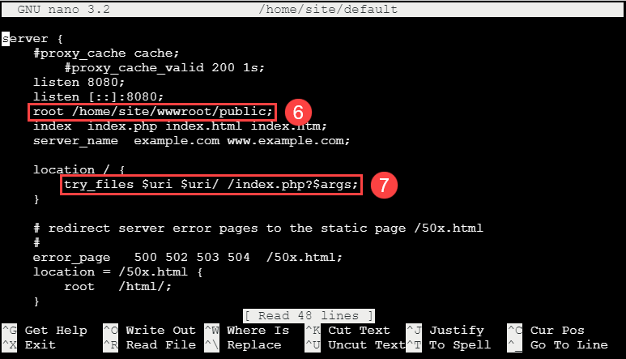
* This image demonstrates the changes made to the /home/site/default file in the SSH session.

1. Press **Ctrl-X**, then select **Y** to save the file
2. Run the following command to add a startup.sh file:

nano /home/site/startup.sh  
 ```  
  
11. Copy and paste the following:  
  
 ```bash  
 #!/bin/bash  
  
 cp /home/site/default /etc/nginx/sites-available/default  
 service nginx reload  
 ```  
  
12. Press **Ctrl-X**, then select **Y** to save the file  
13. Open the `.env` file in the text editor.  
  
 ```bash  
 nano /home/site/wwwroot/.env  
 ```  
  
14. Update the `APP_URL` parameter to the App Service URL (found on the **Overview** tab of the Azure portal). Then, set `ASSET_URL` to `APP_URL`.  
  
 ```bash  
 APP_URL=https://[APP SERVICE NAME].azurewebsites.net  
 ASSET_URL = "${APP_URL}"  
 ```  
  
15. Press **Ctrl-X**, then select **Y** to save the file  
16. Run the following commands to setup the Larvael application:  
  
 ```powershell  
 mkdir /home/site/ext   
 cd /home/site/ext   
 curl -sS https://getcomposer.org/installer | php  
  
 cp /home/site/ext/composer.phar /usr/local/bin/composer  
  
 cd /home/site/wwwroot  
  
 composer.phar update  
  
 php artisan config:clear  
  
 php artisan key:generate  
 ```  
  
15. Switch back the Azure Portal and the app service, under **Settings**, select **Configuration**  
16. Select **General settings**  
17. In the startup command textbox, type `/home/site/startup.sh`  
18. Select **Save**, then select **Continue**  
  
### Test the Application  
  
1. Browse to `https://pgsqldevSUFFIX.azurewebsites.net/` to see the app load with SSL  
  
### Add Firewall IP Rule and Azure Access  
  
1. Switch to the Azure Portal  
2. Browse to the `pgsqldevSUFFIXflex16` Azure Database for PostgreSQL Flexible Server  
3. Under **Settings**, select **Connection security**  
4. Select the **Allow access to Azure services** toggle to **Yes**  
5. Select **Save**  
  
### Migrate the Database Use the steps in [Migrate your database](./Misc/02_MigrateDatabase) article.  
  
## Update the connection string  
  
1. Use the steps in [Migrate your database](./Misc/02_MigrateDatabase) article.  
  
## Update the connection string  
  
1. Switch to the Azure Portal  
2. Browse to the **pgsqldevSUFFIX** web application  
3. Under **Development Tools**, select **SSH**  
4. Select **Go->**  
6. Edit the **/home/site/wwwroot/pubic/database.php**:  
  
 ```bash  
 nano /home/site/wwwroot/public/database.php  
 ```  
  
7. Set the servername variable to `pgsqldevSUFFIXflex16.postgres.database.azure.com`  
8. Set the username to `wsuser`  
9. Set the password to `Solliance123`  
10. Press **Ctrl-X**, then **Y** to save the file  
  
## Test new settings #1  
  
1. Browse to `https://pgsqldevSUFFIX.azurewebsites.net/database.php`, you should get results, but the connection is not secured over SSL.  
  
## Enable SSL support  
  
1. Download the `https://dl.cacerts.digicert.com/DigiCertGlobalRootCA.crt.pem` certificate by switching back to the SSH window, run the following:  
  
 ```bash  
 cd /home/site/wwwroot/public  
  
 wget https://dl.cacerts.digicert.com/DigiCertGlobalRootCA.crt.pem  
 ```  
  
3. Edit the `database.php` file  
  
 ```php  
 nano /home/site/wwwroot/public/database.php  
 ```  
  
4. Update the database connection to use ssl by uncommenting the `sslmode=verify_full` line:  
  
 ```php  
 $conn_str .= 'sslmode=verify-full ';  
 ```  
5. Also uncomment the `sslrootcert` line:  
  
 ```php  
 //$conn_str .= 'sslrootcert=/home/site/wwwroot/public/DigiCertGlobalRootCA.crt.pem ';  
 ```  
  
6. Press Ctrl-X, then Y to save the file  
  
## Test new settings #2  
  
1. Browse to `https://pgsqldevSUFFIX.azurewebsites.net/database.php`, results should display.  
  
## Update to use Environment Variables  
  
Putting credential in the PHP files is not a best practice, it is better to utilize environment variables for this.  
  
1. Switch back to the SSH window  
2. Edit the **/home/site/wwwroot/pubic/database.php**:  
  
 ```bash  
 nano /home/site/wwwroot/pubic/database.php  
 ```  
  
3. Update the connection variables to the following:  
  
 ```php  
 $servername = getenv("APPSETTING_DB_HOST");  
 $username = getenv("APPSETTING_DB_USERNAME");  
 $password = getenv("APPSETTING_DB_PASSWORD");  
 $dbname = getenv("APPSETTING_DB_DATABASE");  
 ```  
  
 > **NOTE** Azure App Service adds the `APPSETTING` prefix to all environment variables. You can see this by navigating to the `info.php` page and review the server variables.  
  
4. Edit the **/home/site/wwwroot/config/database.php** (note that this is in the `config` directory):  
  
 ```bash  
 nano /home/site/wwwroot/config/database.php  
 ```  
  
5. Update the PostgreSQL connection to utilize the environment variables:  
  
 ```php  
 'host' => env('APPSETTING_DB_HOST', '127.0.0.1'),  
 'port' => env('APPSETTING_DB_PORT', '5432'),  
 'database' => env('APPSETTING_DB_DATABASE', 'postgres'),  
 'username' => env('APPSETTING_DB_USERNAME', 'postgres'),  
 'password' => env('APPSETTING_DB_PASSWORD', ''),  
 ```  
  
6. Add the environment variables to the App Service:  
- Browse to the Azure Portal  
- Select the **pgsqldevSUFFIXlinux** app service  
- Under **Settings**, select **Configuration**  
- Select **New application setting**  
- Add the following:  
 - `DB_HOST` = `pgsqldevSUFFIXflex16.postgres.database.azure.com`  
 - `DB_USERNAME` = `wsuser`  
 - `DB_PASSWORD` = `Solliance123`  
 - `DB_DATABASE` = `contosostore`  
 - `DB_PORT` = `5432`  
 - `APP_URL` = `https://pgsqldevSUFFIXlinux.azurewebsites.net`  
 - Select **Save**, then select **Continue**  
  
## Test new settings #3  
  
1. Browse to `https://pgsqldevSUFFIXlinux.azurewebsites.net/database.php`, results should display.  
  
## Create Azure Key Vault values  
  
1. Switch to the Azure Portal  
2. Browse to the **pgsqldevSUFFIX-kv** Key Vault  
3. Under **Settings** select **Access Policies**  
4. Select **Create**  
5. For the secret permissions, select **Select all**, then select **Next**  
6. For the principal, select the lab guide user account, select **Next**  
1. On application, select **Next**  
1. Select **Create**  
1. Under **Settings**, select **Secrets**  
1. Select **Generate/Import**  
1. For the name, type **PostgreSQLPassword**  
1. For the value, type **Solliance123**  
1. Select **Create**  
  
## Create Managed Service Identity  
  
1. Switch to the Azure Portal  
2. Browse to the **pgsqldevSUFFIXlinux** app service  
3. Under **Settings**, select **Identity**  
4. For the system assigned identity, toggle to **On**  
5. Select **Save**, in the dialog, select **Yes**  
6. Copy the **Object ID** for later user  
7. Browse to the **pgsqldevSUFFIX-kv** Key Vault  
8. Under **Settings** select **Access Policies**  
9. Select **Create**  
10. For the secret permission, select **Select all**, then select **Next**  
11. For the principal, paste the **Object ID** you copied above, select **Next**  
12. For application, select **Next**  
13. Select **Create**  
14. Under **Settings**, select **Secrets**  
15. Select the **PostgreSQLPassword**  
16. Select the current version  
17. Copy the secret identifier for later use  
  
## Configure Environment Variables  
  
1. Browse to the Azure Portal  
2. Select the **pgsqldevSUFFIXlinux** app service  
3. Under **Settings**, select **Configuration**  
4. Select **New application setting**  
5. For the name, type **PostgreSQL_PASSWORD**  
6. Update it to the following, replace the `SUFFIX` value:  
  
 ```text  
 @Microsoft.KeyVault(SecretUri=https://pgsqldevSUFFIX-kv.vault.azure.net/secrets/PostgreSQLPassword/)  
 ```  
  
7. Select **OK**  
8. Select **Save**, then select **Continue**. Ensure a green check mark appears in the Source field.  
  
## Update the files  
  
1. Switch back to the SSH window  
2. Edit the **/home/site/wwwroot/pubic/database.php**:  
  
 ```bash  
 nano /home/site/wwwroot/pubic/database.php  
 ```  
  
3. Update the connection variables to the following:  
  
 ```php  
 $password = getenv("APPSETTING_POSTGRESQL_PASSWORD");  
 ```  
  
 > **NOTE** Azure App Service adds the `APPSETTING` prefix to all environment variables  
  
4. Edit the **/home/site/wwwroot/config/database.php**:  
  
 ```bash  
 nano /home/site/wwwroot/config/database.php  
 ```  
  
5. Update the PostgreSQL connection to utilize the environment variables:  
  
 ```php  
 'password' => getenv('APPSETTING_POSTGRESQL_PASSWORD')  
 ```  
  
## Test new settings #4  
  
1. Browse to `https://pgsqldevSUFFIXlinux.azurewebsites.net/database.php`, results should display.  
  
# Deployment via CI/CD  
  
This is a simple app that runs PHP code to connect to a PostgreSQL database. Both the application and database are deployed via Docker containers.  
  
## Azure DevOps Option  
  
### Create DevOps Project  
  
1. Login to Azure Dev Ops (https://dev.azure.com)  
2. Select **New project**  
3. For the name, type **contosostore**  
4. For the visibiilty, select **Private**  
5. Select **Create**  
  
### Setup Git Origin and push code  
  
1. In the new project, select **Repos**  
2. In the **Push an existing repository from command line** section, select the **Copy** button  
3. In the **Paw-1** virtual machine, switch to Visual Studio code  
4. In the terminal window, run the following:  
  
 ```powershell  
 cd c:\labfiles\microsoft-postgresql-developer-guide\sample-php-app  
  
 git remote remove origin  
 git remote remove azure  
 ```  
  
5. In the terminal window, paste the repo url copied from above (it will look something like the following):  
  
 ```powershell  
 git remote add origin https://ORG_NAME@dev.azure.com/ORG_NAME/contosostore/_git/contosostore  
 git push -f origin main  
 ```  
  
6. Press **ENTER** (be sure to replace ORG_NAME)  
7. In the dialog, login using the Microsoft Entra credentials for the repo. The files will get pushed to the repo.  
  
> NOTE: If using sensitive credentials, be sure you remove them or delete the virtual machine when you are finished with the developer guide content.  
  
8. Switch back to Azure Dev Ops, refresh the repo, all the repo files should be visible.  
  
### Create Service Connection  
  
1. In the lower left, select **Project Settings**  
2. Under **Pipelines**, select **Service Connections**  
3. Select **Create service connection**  
4. Select **Azure Resource Manager**  
5. Select **Next**  
6. For the authentication, select **Service principal (automatic)**  
7. Select **Next**  
8. Select the lab subscription and resource group  
  
 > **NOTE** If no subscriptions are displayed, open Azure Dev Ops in a in-private window and try again  
  
9. For the service connection name, type **PostgreSQLDev**  
10. Select **Grant access permission to all pipelines**  
10.Select **Save**  
  
### Create Pipeline  
  
1. In the left navigation, select **Pipelines**  
2. Select **Create Pipeline**  
3. Select **Azure Repos Git**  
4. Select the **ContosoStore** repo  
5. Select **Existing Azure Pipelines YAML file**  
6. Select the **/azure-pipelines.yaml** file  
7. Select **Continue**  
8. Select **Run**  
  
> **NOTE** Check that your Dev Ops repo is setup with the appropriate branch (`master` vs `main`). Update the YAML and supporting steps accordingly.  
  
### Create Release  
  
1. In the left navigation, select **Releases**  
2. Select **New pipeline**  
3. Select the **Azure App Service Deployment**  
4. Select **Apply**  
5. In the **Artifacts** section, select the **Add an artifact** shape  
6. For the project, select **contosostore**  
7. For the source, select **contosostore**  
8. Select **Add**  
9. Select the **Lighting** icon to add an trigger  
10. Select **Enabled** for the `Creates a release every time a new build is avaiable`  
11. Select the **1 job, 1 task** link  
12. Select the **PostgreSQLDev** connection  
13. For **App type**, select **Web App on Linux**  
14. Select the **pgsqldevSUFFIXlinux** app service  
15. Select **Save**, in the dialog, select **OK**  
  
### Commit some changes  
  
1. Switch back to the **paw-1** virtual machine  
2. Run the following:  
  
 ```powershell  
 git add -A  
 git commit -a -m "Pipeline settings"  
 git push -f origin main  
 ```  
  
### Perform the deployment  
  
1. Select **Pipelines**  
2. Select the **contosostore** pipeline, then select **Run pipeline**  
3. Select **Run**  
4. Select **Releases**  
5. Select the **PostgreSQL Dev** pipeline  
6. The release should show as being deployed, wait for the pipeline to complete execution  
  
### Test the DevOps deployment  
  
1. Browse to `https://pgsqldevSUFFIXlinux.azurewebsites.net/default.php`, the site should be displayed.  
2. Browse to `https://pgsqldevSUFFIXlinux.azurewebsites.net/database.php`, the results should display.  
  
## GitHub Option  
  
### Create Github repo  
  
1. Browse to `https://github.com`  
2. Login with GitHub credentials  
3. In the top right, select the **+** then select **New repository**  
4. For the name, type **contosostore**  
5. Select **Create repository**  
  
### Upload the application  
  
1. Switch to Visual Studio code  
2. In the terminal window, run the following:  
  
 ```powershell  
 git remote remove origin  
 ```  
  
3. In the terminal window, paste the code copied above, press **ENTER**  
  
 ```powershell  
 git remote add origin https://github.com/USERNAME/contosostore.git  
 git branch -M main  
 git push -u origin main  
 ```  
  
4. In the dialog, login using GitHub credentials for the repo. The files get pushed to the repo.  
5. Switch back to GitHub, refresh the repo, the files should display.  
  
### Generate Credentials  
  
1. Run the following commands to generate the azure credentials (be sure to replace the token values for subscription and resource group):  
  
 ```PowerShell  
 az login  
  
 az ad sp create-for-rbac --name "pgsqldevSUFFIX" --sdk-auth --role contributor --scopes /subscriptions/{subscription-id}/resourceGroups/{resource-group}  
 ```  
  
2. Copy the json that is outputted  
3. Switch back to the GitHub repository, select **Settings** then select **Secrets**  
4. Select **New repository secret**  
5. For the name, type **AZURE_CREDENTIALS**  
6. Paste the json from above as the value  
7. Select **Save**  
  
### Deploy the code  
  
1. In the GitHub browser window, select **Actions**  
2. Select **set up a workflow yourself**  
3. Copy and paste the `github-pipelines.yaml` into the `main.yml` file  
4. Update the `AZURE_WEBAPP_NAME: pgsqldevSUFFIX` line to replace the SUFFIX  
5. Select **Start commit**  
6. Select **Commit new file**  
7. Select **Actions**, then select the `Create main.yml` workflow instance, the `Contoso Store` job should be displayed, select it  
8. Review the tasks that were executed  
  
### Test the GitHub deployment  
  
1. Browse to `https://pgsqldevSUFFIXlinux.azurewebsites.net/default.php`, the application should be displayed.  
2. Browse to `https://pgsqldevSUFFIXlinux.azurewebsites.net/database.php`, results should be displayed.  
  
<!--  
## Terraform  
  
  
## Azure Bicep  
  
  
-->  
# Migrate to Docker Containers  
  
This is a simple app that runs PHP code to connect to a PostgreSQL database. Both the application and database are deployed via Docker containers.  
  
## Migrate Application to Docker  
  
### Migrate to ENV variables  
  
1. Switch to Visual Studio Code and the opening repo directory  
2. Open the `.\artifacts\sample-php-app\public\database.php` file, update the php PostgreSQL connection environment variables by removing the `APPSETTING_` from each:  
  
 ```php  
 $servername = getenv("DB_SERVERNAME");  
 $username = getenv("DB_USERNAME");  
 $password = getenv("DB_PASSWORD");  
 $dbname = getenv("DB_DATABASE");  
 ```  
  
### Download Docker container  
  
1. Open Docker Desktop, if prompted, select **OK**  
2. In the agreement dialog, select the checkbox and then select **Accept**  
3. It will take a few minutes for the Docker service to start, when prompted, select **Skip tutorial**  
4. Open a PowerShell window, run the following to download and start a php-enabled docker container  
  
 ```Powershell  
 docker run -d php:8.0-apache  
 ```  
  
5. In the `c:\labfiles\microsoft-postgresql-developer-guide\artifacts\03-00-Docker` directory, create the `Dockerfile.web` with the following:  
  
 ```text  
 # Dockerfile  
 FROM php:8.0-apache  
  
 RUN apt-get update && apt-get upgrade -y  
 RUN apt update && apt install -y zlib1g-dev libpng-dev && rm -rf /var/lib/apt/lists/*  
 RUN apt update && apt install -y curl  
 RUN apt-get install -y libcurl4-openssl-dev  
 RUN docker-php-ext-install fileinfo  
 RUN docker-php-ext-install curl  
   
 COPY ./000-default.conf /etc/apache2/sites-available/000-default.conf  
 COPY ./start-apache.sh /usr/local/bin  
  
 RUN a2enmod rewrite  
  
 COPY ./sample-php-app /var/www  
 RUN chown -R www-data:www-data /var/www  
  
 RUN chmod 755 /usr/local/bin/start-apache.sh  
  
 #CMD ["start-apache.sh"]  
  
 EXPOSE 80  
 ```  
  
6. Run the following to create the image:  
  
 ```PowerShell  
 $sourcePath = "c:\labfiles\microsoft-postgresql-developer-guide";  
  
 cd $sourcePath;  
  
 docker build -t store-web --file artifacts\Dockerfile.web .   
 ```  
  
## Migrate Database to Docker  
  
1. Run the following to export the database:  
  
 ```powershell  
 cd "c:\labfiles\microsoft-postgresql-developer-guide";  
  
 $username = "postgres";  
 $password = "Solliance123";  
 $server = "localhost";  
 $database = "ContosoStore";  
  
 pgsql -h $server -u $username $database > data.sql  
  
 #remove the weird encoding...  
 $data = get-content data.sql  
  
 set-content data.sql $data  
 ```  
  
2. In the `c:\labfiles\microsoft-postgresql-developer-guide\artifacts` directory, create a new `Dockerfile.db` docker compose file:  
  
 ```text  
 FROM PostgreSQL:8.0  
 RUN chown -R PostgreSQL:root /var/lib/PostgreSQL/  
  
 ADD data.sql /etc/PostgreSQL/data.sql  
  
 RUN cp /etc/PostgreSQL/data.sql /docker-entrypoint-initdb.d  
  
 EXPOSE 5432  
 ```  
  
3. Build the container:  
  
 ```PowerShell  
 docker build -t store-db --file Dockerfile.db .  
 ```  
  
## Run the Docker images  
  
1. Create the following `docker-compose.yml` docker compose file:  
  
 ```yaml  
 version: '3.8'  
 services:  
 web:  
 image: store-web  
 environment:  
 - DB_DATABASE=contosostore  
 - DB_USER=postgres  
 - DB_PASSWORD=root  
 - DB_PORT=5432  
 - DB_SERVERNAME=db  
 ports:  
 - "8080:80"  
 db:  
 image: store-db  
 restart: always  
 environment:  
 - PostgreSQL_ROOT_PASSWORD=root  
 ports:  
 - "5432:5432"  
 phpmyadmin:  
 image: phpmyadmin/phpmyadmin  
 ports:  
 - '8081:80'  
 restart: always  
 environment:  
 PMA_HOST: db  
 depends_on:  
 - db

1. Run the following to create the web container:

* cd Artifacts  
    
  iisreset /stop  
    
  docker compose run --service-ports web

1. Run the following to create the db container:

* stop-service PostgreSQL  
    
  docker compose run --service-ports db

1. Run the following to create the phpmyadmin container:

* docker compose run --service-ports phpmyadmin

## Migrate the database

1. Use export steps in [Migrate the database](./Misc/02_MigrateDatabase) article to export the database
2. Open a browser to http:\\localhost:8081 and the phpmyadmin portal
3. Login to the database using root and root
4. Select the **contosostore** database
5. Run the exported database sql to import the database and data
6. Select the **SQL** tab, copy and then run the following query by selecting **Go**, record the count

select count(*) from orders

## Test the Docker images

1. Open a browser to http:\\localhost:8080\index.php
2. Select **START ORDER**

**NOTE** If get an error about the application not being able to connect, do the following to attempt to debug:

* Open a new PowerShell window, run the following to start a bash shell
* docker exec -it artifacts-web-1 /bin/bash
* Run the following commands in the new bash shell, look for the database error that is displayed:
* cd /var/www  
    
  php artisian migrate

1. Once the connection is working, refresh the page then select **START ORDER**
2. Select **Breakfast**, then select **CONTINUE**
3. Select **Bacon & Eggs**, then select **ADD**
4. Select **CHECKOUT**
5. Select **COMPLETE ORDER**
6. Switch to the PowerShell window that started the containers, shutdown the images, press **CTRL-X** to stop the images
7. Restart the images:

* docker compose up

1. Switch back to the phpmyadmin window. Attemp to re-run the query, notice that the database has the same orders as when it was started before. This is because the container’s data was lost when it was stopped/removed.

## Fix Storage persistence

1. Modify the docker-compose.yml docker compose file, notice how we are creating and adding a volume to the database container. We also added the phpmyadmin continer:

version: '3.8'  
services:  
 web:  
 image: store-web  
 environment:  
 - DB_DATABASE=contosostore  
 - DB_USERNAME=postgres  
 - DB_PASSWORD=root  
 - DB_HOST=db  
 - DB_PORT=5432  
 - PostgreSQL_ATTR_SSL_CA=  
 ports:  
 - "8080:80"   
 db:  
 image: store-db  
 restart: always  
 environment:  
 - PostgreSQL_ROOT_PASSWORD=root  
 - PostgreSQL_DATABASE=contosostore  
 volumes:  
 - "db-volume:/var/lib/PostgreSQL"  
 ports:  
 - "5432:5432"  
 pgadmin:  
 image: dpage/pgadmin4  
 ports:  
 - '8081:80'  
 restart: always  
 environment:  
 PMA_HOST: db  
 depends_on:  
 - db  
volumes:  
 db-volume:  
 external: false

## Re-test the Docker images

1. Run the following:

stop service PostgreSQL  
  
docker compose up

1. Create some more orders, restart the containers. Notice that data is now persisted. It is now up to the administrators to ensure the database volume is maintained for the length of the solution. If this volume is ever deleted, the data will be lost!

## Save the images to Azure Container Registry (ACR)

1. Open the Azure Portal
2. Browse to the **pgsqldevSUFFIX** Azure Container Registry
3. Under **Settings**, select **Access keys**
4. Copy the username and password
5. In the **paw-1** virtual machine, switch to a powershell window and run the following:

* docker login {acrName}.azurecr.io -u {username} -p {password}  
    
  docker tag dpage/pgadmin4 {acrName}.azurecr.io/dpage/pgadmin4  
    
  docker tag store-db {acrName}.azurecr.io/store-db  
    
  docker tag store-web {acrName}.azurecr.io/store-web  
    
  docker push {acrName}.azurecr.io/store-db  
    
  docker push {acrName}.azurecr.io/store-web  
    
  docker push {acrName}.azurecr.io/dpage/pgadmin4

1. Three images should display in the Azure Container Registry that we will use later for deployment to other container based runtimes.

# Migrate to Azure Container Instances (ACI)

Now that containerized versions of the application exists, they can now be hosted in several resource types in Azure. Here, we explore Azure Container Instances (ACI).

## Push images to Azure Container Registry

1. If they haven’t been already, push the images to the Azure Container Registry using the [Push Images to Acr](./../Misc/01_PushImagesToAcr.md) article.

## Run images in ACI

1. Run the following commands to create two new container instances:

* $acrName = "pgsqldevSUFFIX";  
  $resourceName = $acrName;  
  $resourceGroupName = "{RESOURCE_GROUP_NAME}";  
    
  $rg = Get-AzResourceGroup $resourceGroupName;  
    
  $acr = Get-AzContainerRegistry -Name $acrName -ResourceGroupName $resourceGroupName;  
  $creds = $acr | Get-AzContainerRegistryCredential  
    
  $imageRegistryCredential = New-AzContainerGroupImageRegistryCredentialObject -Server "$acrName.azurecr.io" -Username $creds.username -Password (ConvertTo-SecureString $creds.password -AsPlainText -Force)  
    
  $storageKey = $(Get-AzStorageAccountKey -ResourceGroupName $resourceGroupName -Name $resourceName).Value[0];  
  $context = $(New-AzStorageContext -StorageAccountName $resourceName -StorageAccountKey $storageKey);  
    
  #create a new azure file share  
  New-AzStorageShare -Name "db-volume" -Context $context  
    
  $containerName = "store-db";  
  $env1 = New-AzContainerInstanceEnvironmentVariableObject -Name "PostgreSQL_DATABASE" -Value "contosostore";  
  $env2 = New-AzContainerInstanceEnvironmentVariableObject -Name "PostgreSQL_ROOT_PASSWORD" -Value "root";  
  $env3 = New-AzContainerInstanceEnvironmentVariableObject -Name "PostgreSQL_ROOT_HOST" -Value "%";  
  $port1 = New-AzContainerInstancePortObject -Port 5432 -Protocol TCP;  
  $volume = New-AzContainerGroupVolumeObject -Name "db-volume" -AzureFileShareName "db-volume" -AzureFileStorageAccountName $resourceName -AzureFileStorageAccountKey (ConvertTo-SecureString $storageKey -AsPlainText -Force);  
  $vMount = @{};  
  $vMount.MountPath = "/var/lib/PostgreSQL";  
  $vMount.Name = "db-volume";  
  $container = New-AzContainerInstanceObject -Name $containerName -Image "$acrName.azurecr.io/store-db" -Port @($port1) -EnvironmentVariable @($env1, $env2, $env3) -VolumeMount @($vMount);  
  New-AzContainerGroup -ResourceGroupName $resourceGroupName -Name $containerName -Container $container -OsType Linux -Location $rg.location -ImageRegistryCredential $imageRegistryCredential -IpAddressType Public -Volume $volume;

1. Browse to the Azure Portal
2. Search for the **store-db** Container instance and select it
3. Copy the public IP address
4. Setup the web container, replace the IP_ADDRESS with the one copied above:

* $containerName = "store-web";  
  $env1 = New-AzContainerInstanceEnvironmentVariableObject -Name "DB_DATABASE" -Value "contosostore";  
  $env2 = New-AzContainerInstanceEnvironmentVariableObject -Name "DB_USERNAME" -Value "root";  
  $env3 = New-AzContainerInstanceEnvironmentVariableObject -Name "DB_PASSWORD" -Value "root";  
  $env4 = New-AzContainerInstanceEnvironmentVariableObject -Name "DB_HOST" -Value "IP_ADDRESS";  
  $port1 = New-AzContainerInstancePortObject -Port 80 -Protocol TCP;  
  $port2 = New-AzContainerInstancePortObject -Port 8080 -Protocol TCP;  
  $container = New-AzContainerInstanceObject -Name PostgreSQL-dev-web -Image "$acrName.azurecr.io/store-web" -EnvironmentVariable @($env1, $env2, $env3, $env4) -Port @($port1, $port2);  
  New-AzContainerGroup -ResourceGroupName $resourceGroupName -Name $containerName -Container $container -OsType Linux -Location $rg.location -ImageRegistryCredential $imageRegistryCredential -IpAddressType Public;

## Test the images

1. Browse to the Azure Portal
2. Search for the **store-web** Container instance and select it
3. Copy the public IP address and then open a browser window to http://IP_ADDRESS/default.php

## Multi-container single app service deployment

In the previous steps, a container instance was created for each of the containers, however, it is possible to create a multi-container container instance where all services are encapsulated into one container instance instance using Azure CLI.

1. Create the following docker-compose-contoso.yml file, be sure to replace the SUFFIX:

* version: '3.8'  
  services:  
  web:  
   image: pgsqldevSUFFIX.azurecr.io/store-web:latest  
   environment:  
   - DB_DATABASE=contosostore  
   - DB_USERNAME=root  
   - DB_PASSWORD=root  
   - DB_HOST=db  
   - DB_PORT=5432  
   ports:  
   - "8080:80"   
   depends_on:  
   - db   
  db:  
   image: pgsqldevSUFFIX.azurecr.io/store-db:latest  
   volumes:  
   - ${WEBAPP_STORAGE_HOME}/site/database:/var/lib/PostgreSQL  
   restart: always  
   environment:  
   - PostgreSQL_ROOT_PASSWORD=root  
   - PostgreSQL_DATABASE=contosostore  
   ports:  
   - "5432:5432"  
  phpmyadmin:  
   image: phpmyadmin/phpmyadmin  
   ports:  
   - '8081:80'  
   restart: always  
   environment:  
   PMA_HOST: db  
   depends_on:  
   - db

1. In a PowerShell window, run the following command, be sure to replace the SUFFIX and other variable values:

* $acrName = "pgsqldevSUFFIX";  
  $resourceName = $acrName;  
  $resourceGroupName = "{RESOURCE_GROUP_NAME}";  
    
  $acr = Get-AzContainerRegistry -Name $acrName -ResourceGroupName $resourceGroupName;  
  $creds = $acr | Get-AzContainerRegistryCredential;  
    
  az login;  
    
  az webapp create --resource-group $resourceGroupName --plan "$resourceName-sf" --name $resourceName --multicontainer-config-type compose --multicontainer-config-file docker-compose-contoso.yml;  
    
  az webapp config appsettings set --resource-group $resourceGroupName --name $resourceName --settings DOCKER_REGISTRY_SERVER_USERNAME=$($creds.Username)  
    
  az webapp config appsettings set --resource-group $resourceGroupName --name $resourceName --settings DOCKER_REGISTRY_SERVER_URL="$resourceName.azurecr.io"  
    
  az webapp config appsettings set --resource-group $resourceGroupName --name $resourceName --settings DOCKER_REGISTRY_SERVER_PASSWORD=$($creds.Password)  
    
  az webapp config appsettings set --resource-group $resourceGroupName --name $resourceName --settings DB_HOST="DB"  
    
  az webapp config appsettings set --resource-group $resourceGroupName --name $resourceName --settings DB_USERNAME="root"  
    
  az webapp config appsettings set --resource-group $resourceGroupName --name $resourceName --settings DB_PASSWORD="root"  
    
  az webapp config appsettings set --resource-group $resourceGroupName --name $resourceName --settings DB_DATABASE="ContosoStore"  
    
  az webapp config appsettings set --resource-group $resourceGroupName --name $resourceName --settings DB_PORT="5432"  
    
  az webapp config appsettings set --resource-group $resourceGroupName --name $resourceName --settings WEBSITES_ENABLE_APP_SERVICE_STORAGE=TRUE  
    
  az webapp config container set --resource-group $resourceGroupName --name $resourceName --multicontainer-config-type compose --multicontainer-config-file docker-compose-contoso.yml

1. Switch back to the Azure Portal, browse to the Azure App Service. If troubleshooting is needed, view the container logs by browsing to https://pgsqldevSUFFIX.scm.azurewebsites.net/api/logs/docker. Copy the path to the docker file and paste it into a new window, review the logs and fix any errors.

# Migrate to Azure App Service Containers

Now that a containerized version of the applications exists, it can now be hosted in several places in Azure. Here we explore Azure App Service Containers.

## Push images to Azure Container Registry

1. If they have not been pushed already, push the images to the Azure Container Registry using the [Push Images to Acr](./../Misc/01_PushImagesToAcr.md) article.

## Run images in Azure App Service

1. Run the following to create the app service containers, be sure to replace the SUFFIX and RESOURCE_GROUP_NAME:

* $suffix = "SUFFIX"  
  $acrName = "pgsqldev$suffix";  
  $appPlan = "pgsqldev$suffix-linux";  
  $image = "$acrName.azure.io/store-web";  
  $resourceGroupName = "{RESOURCE_GROUP_NAME}";  
    
  $acr = Get-AzContainerRegistry -Name $acrName -ResourceGroupName $resourceGroupName;  
  $creds = $acr | Get-AzContainerRegistryCredential;  
    
  $name = "pgsqldev$suffix-app-web";  
  New-AzWebApp -Name $name -ResourceGroupName $resourceGroupName -AppServicePlan $appPlan -ContainerImageName $image -ContainerRegistryUrl $acr.loginserver -ContainerRegistryUser $creds.username -ContainerRegistryPassword (ConvertTo-SecureString $creds.password -AsPlainText -Force) -Location $acr.location;  
    
  $config = Get-AzResource -ResourceGroupName $resourceGroupName -ResourceType Microsoft.Web/sites/config -ResourceName $name -ApiVersion 2018-02-01  
  $config.Properties.linuxFxVersion = "DOCKER|$($image):latest"  
  $config | Set-AzResource -ApiVersion 2018-02-01 -Debug -Force  
    
  $name = "pgsqldev$suffix-app-db";  
  $image = "$acrName.azure.io/store-db";  
  New-AzWebApp -Name $name -ResourceGroupName $resourceGroupName -AppServicePlan $appPlan -ContainerImageName $image -ContainerRegistryUrl $acr.loginserver -ContainerRegistryUser $creds.username -ContainerRegistryPassword (ConvertTo-SecureString $creds.password -AsPlainText -Force) -Location $acr.location;  
    
  $config = Get-AzResource -ResourceGroupName $resourceGroupName -ResourceType Microsoft.Web/sites/config -ResourceName $name -ApiVersion 2018-02-01  
  $config.Properties.linuxFxVersion = "DOCKER|$($image):latest"  
  $config | Set-AzResource -ApiVersion 2018-02-01 -Debug -Force  
    
  az webapp create --resource-group $resourceGroupName --plan $appPlan --name $name --deployment-container-image-name $image  
  az webapp config set --resource-group $resourceGroupName --name $name --linux-fx-version "DOCKER|$image:latest"  
  az webapp config appsettings set --resource-group $resourceGroupName --name $name --settings WEBSITES_PORT=5432

## Test the containers

1. Browse to the Azure Portal
2. Select the **pgsqldevSUFFIX-app-db** app service
3. On the **Overview** tabe, record the **URL**
4. Under **Monitoring**, select **App Service Logs**
5. Select **File System**
6. For **Days**, type **7**
7. Select **Save**
8. Under **Settings**, select **Configuration**
9. Select **New application setting**, add the following, replace the DB_URL with the one recorded previously from the database container, replace the APP_URL with the one recorded for the application web:
   * PostgreSQL_ROOT_PASSWORD = Solliance123
   * WEBSITES_PORT = 5432
10. Select **Save**, then select **Continue**
11. Select the **pgsqldevSUFFIX-app-web** app service
12. On the **Overview** tabe, record the **URL**
13. Under **Monitoring**, select **App Service Logs**
14. Select **File System**
15. For **Days**, type **7**
16. Select **Save**
17. Under **Settings**, select **Configuration**
18. Select **New application setting**, add the following, replace the DB_URL with the one recorded previously from the database container, replace the APP_URL with the one recorded for the application web:
    * DB_HOST = {DB_URL}
    * DB_USERNAME = root
    * DB_PASSWORD = Solliance123
    * DB_DATABASE = contosostore
    * DB_PORT = 5432
    * APP_URL = {APP_URL}

* **NOTE** It is possible to edit multiple by selecting **Advanced edit** and then copying the below values in, be sure to replace the SUFFIX
* {  
   "name": "DB_HOST",  
   "value": "pgsqldevSUFFIX-app-db.azurewebsites.net",  
   "slotSetting": false  
  },  
  {  
   "name": "DB_USERNAME",  
   "value": "wsuser",  
   "slotSetting": false  
  },  
  {  
   "name": "DB_PASSWORD",  
   "value": "Solliance",  
   "slotSetting": false  
  },  
  {  
   "name": "DB_DATABASE",  
   "value": "contosostore",  
   "slotSetting": false  
  },  
  {  
   "name": "DB_PORT",  
   "value": "5432",  
   "slotSetting": false  
  },  
  {  
   "name": "APP_URL",  
   "value": "https://pgsqldevSUFFIX-app-web.azurewebsites.net/",  
   "slotSetting": false  
  }

1. Select **Save**
2. Browse to the **pgsqldevSUFFIX-app-web** app service url, the web site will load but it has database errors.

## Troubleshooting

1. If no results are displayed, review the logs for each container instance
   1. Browse to the app service
   2. Under **Monitoring**, select **Log stream**
   3. Review the startup logs, notice that the database instance did not respond to an HTTP request on port 5432. This is because an app service container will only work with HTTP based container images unless it is a multicontainer deployment.
2. Change the application settings for the web container to point to the Azure Database for PostgreSQL Flexible Server Single Server instance
3. Refresh the web site, it should now load successfully.

# Migrate to Azure Kubernetes Services (AKS)

Now that a containerized version of the applications exists, it can now be hosted in several places in Azure. Here we explore Azure App Service Containers.

## Push images to Azure Container Registry

1. If they haven’t already, push the images to the Azure Container Registry using the [Push Images to Acr](./../Misc/01_PushImagesToAcr.md) article.

## Run images in Azure Kubernetes Service (AKS)

1. Open the C:\labfiles\microsoft-postgresql-developer-guide\Artifacts\04-AKS directory with Visual Studio Code
2. Open a new terminal window, ensure kubectl is installed:

* $resourceGroupName = "YOUR_RESOURCEGROUP_NAME";  
    
  az aks install-cli  
    
  az aks get-credentials --name "pgsqldevSUFFIX" --resource-group $resourceGroupName

1. Run the following commands to deploy the containers (be sure to update the variable values):

* $acrName = "pgsqldevSUFFIX";  
  $resourceName = "pgsqldevSUFFIX";  
  $resourceGroupName = "RESOURCEGROUPNAME";  
    
  $acr = Get-AzContainerRegistry -Name $acrName -ResourceGroupName $resourceGroupName;  
  $creds = $acr | Get-AzContainerRegistryCredential;  
    
  kubectl create namespace PostgreSQLdev  
    
  $ACR_REGISTRY_ID=$(az acr show --name $ACRNAME --query "id" --output tsv);  
  $SERVICE_PRINCIPAL_NAME = "acr-service-principal";  
  $PASSWORD=$(az ad sp create-for-rbac --name $SERVICE_PRINCIPAL_NAME --scopes $ACR_REGISTRY_ID --role acrpull --query "password" --output tsv)  
  $USERNAME=$(az ad sp list --display-name $SERVICE_PRINCIPAL_NAME --query "[].appId" --output tsv)  
    
  kubectl create secret docker-registry acr-secret `  
  --namespace PostgreSQLdev `  
  --docker-server="https://$($acr.loginserver)" `  
  --docker-username=$username `  
  --docker-password=$password  
    
  #ensure that MSI is enabled  
  az aks update -g $resourceGroupName -n $resourceName --enable-managed-identity  
    
  #get the principal id  
  az aks show -g $resourceGroupName -n $resourceName --query "identity"

1. Create a managed disk, copy its id for later use:

az disk create --resource-group $resourceGroupName --name "disk-store-db" --size-gb 200 --query id --output tsv

1. Open and review the following storage-db.yaml deployment file:

apiVersion: v1  
kind: PersistentVolumeClaim  
metadata:  
 name: PostgreSQL-data  
 namespace: PostgreSQLdev  
spec:  
 accessModes:  
 - ReadWriteOnce  
 resources:  
 requests:  
 storage: 200Gi

1. Open and review the store-db.yaml deployment file, be sure to replace the <REGISTRY_NAME> and ID tokens:

apiVersion: v1  
kind: Pod  
metadata:  
 name: store-db  
 namespace: PostgreSQLdev  
 labels:  
 app: store-db  
spec:  
 volumes:  
 - name: PostgreSQL-data  
 persistentVolumeClaim:  
 claimName: PostgreSQL-data  
 containers:  
 - name: store-db  
 image: <REGISTRY_NAME>.azurecr.io/store-db:latest  
 volumeMounts:  
 - mountPath: "/var/lib/PostgreSQL/"  
 name: PostgreSQL-data  
 imagePullPolicy: IfNotPresent  
 env:  
 - name: PostgreSQL_DATABASE  
 value: "ContosoStore"  
 - name: PostgreSQL_ROOT_PASSWORD  
 value: "root"  
 imagePullSecrets:  
 - name: acr-secret

1. Run the deployment:

* kubectl create -f storage-db.yaml  
    
  kubectl create -f store-db.yaml

1. Create the following store-web.yaml deployment file, be sure to replace the <REGISTRY_NAME> token:

apiVersion: v1  
kind: Pod  
metadata:  
 name: store-web  
 namespace: PostgreSQLdev  
spec:  
 containers:  
 - name: store-web  
 image: <REGISTRY_NAME>.azurecr.io/store-web:latest  
 imagePullPolicy: IfNotPresent  
 env:  
 - name: DB_DATABASE  
 value: "ContosoStore"  
 - name: DB_USERNAME  
 value: "root"  
 - name: DB_PASSWORD  
 value: "root"  
 - name: DB_HOST  
 value: "store-db"  
 imagePullSecrets:  
 - name: acr-secret

1. Run the deployment:

* kubectl create -f store-web.yaml

## Add services

1. Open and review the store-db-service.yaml yaml file:

apiVersion: v1  
kind: Service  
metadata:  
 name: store-db  
spec:  
 ports:  
 - port: 5432  
 selector:  
 app: store-db

1. Open and review the store-web-service.yaml yaml file:

apiVersion: v1  
kind: Service  
metadata:  
 name: store-web  
spec:  
 ports:  
 - port: 80  
 selector:  
 app: store-web

1. Run the deployment:

* kubectl create -f store-web-service.yaml  
    
  kubectl create -f store-db-service.yaml

## Create a Loadbalancer

1. Review the store-web-lb.yaml file:
2. Execute the deployment:

kubectl create -f store-web-lb.yaml

1. Review the store-db-lb.yaml file:
2. Execute the deployment:

kubectl create -f store-db-lb.yaml

## Test the images

1. Browse to the Azure Portal
2. Navigate to the AKS cluster and select it
3. Under **Kubernetes resources**, select **Service and ingresses**
4. For the **store-web-lb** service, select the external IP link. A new web browser tab should open to the web front end. Ensure that an order can be created without a database error.

## Create a deployment

Kubernetes deployments allow for the creation of multiple instances of pods and containers in case nodes or pods crash unexpectiantly.

1. Review the store-web-deployment.yaml file be sure to replace the Azure Container Registry link:

kubectl create -f store-web-deployment.yaml

1. Review the store-db-deployment.yaml file be sure to replace the Azure Container Registry link:
2. Execute the deployment:

kubectl create -f store-db-deployment.yaml

1. This deployment is now very robust and will survive multiple node failures.

# Utilize AKS and Azure Database for PostgreSQL Flexible Server

Rather than managing the database volumes for a PostgreSQL server instance, it is possible to utilize Azure Database for PostgreSQL Flexible Server in order to use a platform as a service approach. This will remove the need to have a database server container and a volumne to be persisted.

## Push images to Azure Container Registry

1. If they haven’t already, push the images to the Azure Container Registry using the [Push Images to Acr](./../Misc/01_PushImagesToAcr.md) article.

## Run images in AKS

1. Review the store-web-development.yaml file
2. Run the following to execute the deployment, update the DB_HOST value to the Azure Database for PostgreSQL Flexible Server instance:

kubectl create -f store-web-development.yaml

# Azure Function with PostgreSQL (.NET)

https://techcommunity.microsoft.com/t5/azure-database-for-PostgreSQL-blog/how-to-connect-to-azure-database-for-PostgreSQL-using-managed/ba-p/1518196

## Setup

It is possible to utilize Visual Studio or Visual Studio Code to create Azure Functions.

### Install pre-requisites

Most of this is done already in the lab setup scripts, but is provided here for reference.

* Install [Visual Studio 2022 Community Edition](https://visualstudio.microsoft.com/downloads/)
  + Expand the **Download Visual Studio with .NET** dropdown for an installation package with the .NET SDK
  + Once Visual Studio loads, sign in with an Azure account
* Install the [Azure Functions core tools MSI](https://go.microsoft.com/fwlink/?linkid=2174087)

#### Install the Azure development workload for Visual Studio

* Open the Visual Studio installer from the Start menu.
* Select **Modify** next to the **Visual Studio Community 2022** installation
* Select the **Azure development** tile below the **Web & Cloud** header. Then, select **Modify** at the lower right-hand corner of the window

## Create the Function Application

The application here is based on an Http Trigger that will then make a call into the Azure Database for PostgreSQL Flexible Server instance and add some records. Create this function by performing the following steps.

* Open Visual Studio, if prompted, sign in
* Select **Create a new project**
* Search for **Azure Functions**
* Select **C#** for the language
* Select **Next**
* For the name, type **AddCustomerFunction**
* Select the project path
* Select **Next**
* For the functions works, select **.NET 8.0 Isloated**
* For the function type, select **Http Trigger**
* For the Storage account, select **Storage Emulator**
* For the authorization level, select **Function**
* Select **Create**
* Open the **Function1.cs** file, update the function class (in Function1.cs) to the following. This Function completes the following tasks when its HTTP endpoint receives a request:
  + Connecting to the Azure Database for PostgreSQL Flexible Server instance provisioned in the ARM template
  + Generating a list of databases on the PostgreSQL instance
  + Building a formatted response
  + Returning the formatted response to the caller
* Be sure to replace the SUFFIX connection information:

public static class AddCustomerFunction  
 {  
 [FunctionName("AddCustomerFunction")]  
 public static async Task<IActionResult> Run(  
 [HttpTrigger(AuthorizationLevel.Function, "get", "post", Route = null)] HttpRequest req,  
 ILogger log)  
 {  
 NpgsqlConnectionStringBuilder builder = new NpgsqlConnectionStringBuilder  
 {  
 Host = "pgsqldevSUFFIXflex16.postgres.database.azure.com",  
 Username = "wsuser",  
 Password = "Solliance123",  
 Database = "postgres",  
 SslMode = SslMode.Require  
 };  
  
 string responseMessage = "";  
  
 using (var conn = new NpgsqlConnection(builder.ConnectionString))  
 {  
 conn.Open();  
  
 using (var command = conn.CreateCommand())  
 {  
 command.CommandText = "SELECT datname FROM pg_catalog.pg_database;";  
 NpgsqlDataReader r = command.ExecuteReader();  
  
 while (r.Read())  
 {  
 responseMessage += r["datname"] + "\r\n";  
 }  
 }  
 }  
  
 return new OkObjectResult(responseMessage);  
 }  
 }

* Right-click the project, select **Manage Nuget Packages**
* Select the **Browse** tab
* Search for **Npgsql**, select it, then select **Install**
* Select **Apply**
* Select **Ok** if prompted
* At the top of Function1.cs file, add a using reference to Npgsql by adding the following statement.
* using Npgsql;
* Press **F5** to start the function
* When prompted, select **Allow**
* Open a browser window to the function endpoint, it will be similar to the following:

http://localhost:7071/api/AddCustomerFunction

* You should see a list of databases displayed.

## Deploy the Function Application

Now that the function app is created and working locally, the next step is to publish the function app to Azure.

* Right click the project, select **Publish**
* Select **Azure**, then select **Next**
* For the target, select **Azure Function App (Linux)**
* 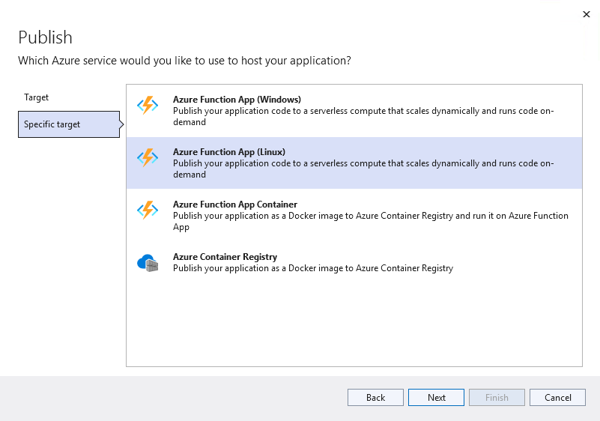
* This image demonstrates choosing the Azure Function App Linux deployment option.
* Select **Next**
* Select the **Sign in** button, login using your lab credentials
* Select the account, subscription and resource group
* Select the **pgsqldevSUFFIX-AddCustomerFunction** function app
* Select **Finish**
* Select **Publish**, and if prompted, select **Yes** to update the runtime version.
* Switch to the Azure portal, browse to your lab resource group
* Select the **pgsqldevSUFFIX-addcustomerfunction** Function App instance
* Under **Functions**, select **App keys**
* Copy the function default app key value
* It should now be possible to browse to the function endpoint and see data, replace the APPKEY with the one you copied:

https://pgsqldevSUFFIX-addcustomerfunction.azurewebsites.net/api/addcustomerfunction?code=APPKEY

## Test the Function App in the Azure portal

* Switch to the Azure portal, browse to your lab resource group
* Select the **pgsqldevSUFFIX-addcustomerfunction** Function App instance
* On the **Overview** page, select the **AddCustomerFunction** link
* On the **AddCustomerFunction** page, select **Code + Test**. Then, select **Test/Run** to access the built-in testing interface
* If prompted, select the warning to enable CORS
* Issue a simple GET request to the Function App endpoint using the master key.
* **NOTE** It is possible to use a *function key*, which is scoped to an individual Function App, or a *host key*, which is scoped to an Azure Functions instance.
* 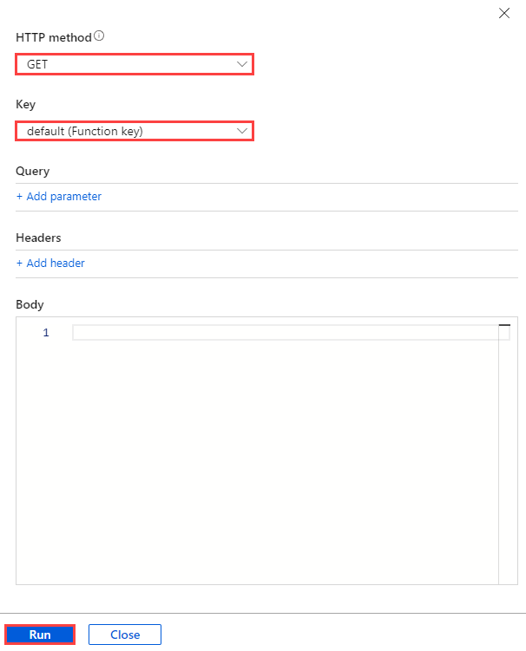
* This image demonstrates how to configure a GET request to the Function App endpoint from the Azure portal.
* The Function App should execute successfully and a list of items should display

## Troubleshooting

* If the application builds successfully, but deployment fails, try restarting Visual Studio and publishing the Function App again to avoid transient errors
* Enabling Application Insight logs is a useful way to debug Function Apps deployed to Azure. As Application Insights cannot be configured from the Visual Studio publish profile, consult the [Microsoft documentation](https://docs.microsoft.com/azure/azure-functions/configure-monitoring?tabs=v2#enable-application-insights-integration) for the manual setup steps

# Azure Function with PostgreSQL (Python)

https://techcommunity.microsoft.com/t5/azure-database-for-PostgreSQL-blog/how-to-connect-to-azure-database-for-PostgreSQL-using-managed/ba-p/1518196

## Setup

It is possible to utilize several different tools including Visual Studio or Visual Studio Code to create Azure Functions.

### Visual Studio Code

**Note** that these steps have already been performed in the virtual machine environment.

* Install the [Azure Functions](https://marketplace.visualstudio.com/items?itemName=ms-azuretools.vscode-azurefunctions) and [Python](https://marketplace.visualstudio.com/items?itemName=ms-python.python) extensions
* Install [Python 3.11.x](https://www.python.org/downloads/)
* Install the [Azure Functions core tools MSI](https://go.microsoft.com/fwlink/?linkid=2174087)

## Create the Function Application

The application here is based on an HTTP Trigger that will then make a call into the Azure Database for PostgreSQL Flexible Server instance and add some records. To create this function perform the following steps.

* Open Visual Studio Code, type **Ctrl-Shift-P**
* Select **Azure Functions: Create New Project**
* 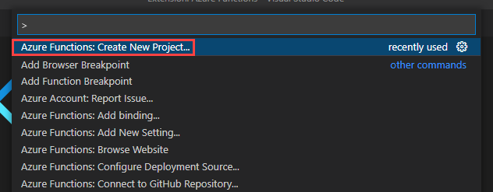
* This image demonstrates how to create a new Function App project.
* Select the project path (ex c:\temp\python-function)
* For the language, select **Python**
* For the model, select **Model V2**
* Select the **python 3.11.x** option
* Select the **HTTP trigger**
* 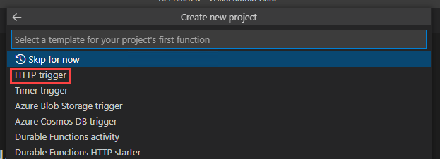
* This image demonstrates configuring the HTTP Trigger for the new Function App.
* For the name, type **AddCustomerFunction**, press **ENTER**
* For the authorization level, select **FUNCTION**
* Select **Open in current window**
* Update the function code in function_app.py to the following, ensuring that the connection information is replaced. This Function completes the following tasks when its HTTP endpoint receives a request:
  + Connecting to the PostgreSQL Flexible Server instance provisioned in the ARM template
  + Generating a list of databases on the PostgreSQL instance
  + Building a formatted response
  + Returning the formatted response to the caller

import logging  
import azure.functions as func  
import psycopg2  
import ssl  
  
app = func.FunctionApp(http_auth_level=func.AuthLevel.FUNCTION)  
  
@app.route(route="AddCustomerFunction")  
def AddCustomerFunction(req: func.HttpRequest) -> func.HttpResponse:  
 logging.info('Python HTTP trigger function processed a request.')  
  
 crtpath = 'BaltimoreCyberTrustRoot.crt.pem'  
 #crtpath = 'DigiCertGlobalRootCA.crt.pem'  
  
 ctx = ssl.SSLContext(ssl.PROTOCOL_TLSv1_2)  
  
 # Connect to PostgreSQL  
 cnx = psycopg2.connect(database="postgres",  
 host="pgsqldevSUFFIXflex16.postgres.database.azure.com",  
 user="wsuser",  
 password="Solliance123",  
 port="5432")  
  
 logging.info(cnx)  
 # Show databases  
 cursor = cnx.cursor()  
 cursor.execute("SELECT datname FROM pg_catalog.pg_database;")  
 result_list = cursor.fetchall()  
 # Build result response text  
 result_str_list = []  
 for row in result_list:  
 row_str = ', '.join([str(v) for v in row])  
 result_str_list.append(row_str)  
 result_str = '\n'.join(result_str_list)  
 return func.HttpResponse(  
 result_str,  
 status_code=200  
 )

* Open a terminal window (Select **Terminal->New Terminal**)
  + Install the PostgreSQL connector:
  + pip install psycopg2
  + 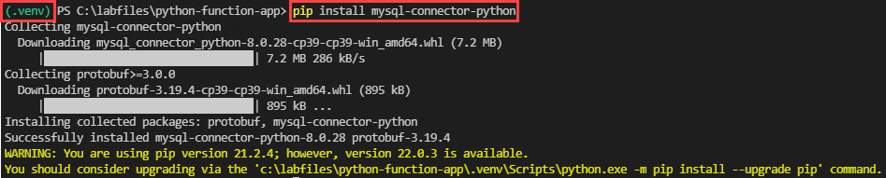
  + This image demonstrates the Virtual Environment and PostgreSQL connector installation in the PowerShell terminal.
  + Run the function app (your can also press F5):
  + func start run
* In the dialog, select **Allow**
* Open a browser window to the following. A list of databases should load:
* http://localhost:7071/api/AddCustomerFunction
* The data will be displayed, however it is over non-SSL connection. Azure recommends that Flexible Server clients use the service’s public SSL certificate for secure access. Download the [Azure SSL certificate](https://www.digicert.com/CACerts/BaltimoreCyberTrustRoot.crt.pem) to the Function App project root directory
* Add the following lines to the Python code to utilize the Flexible Server public certificate and support connections over TLS 1.2:

crtpath = '../BaltimoreCyberTrustRoot.crt.pem'  
#crtpath = '../DigiCertGlobalRootCA.crt.pem' #THIS IS THE OLD CERT, USE THE BALTIMORE CERT  
  
ctx = ssl.SSLContext(ssl.PROTOCOL_TLSv1_2)  
  
# Connect to PostgreSQL  
cnx = psycopg2.connect(database="postgres",  
 host="pgsqldevSUFFIXflex16.postgres.database.azure.com",  
 user="wsuser",  
 password="Solliance123",  
 port="5432",  
 sslmode='require',  
 sslrootcert=crtpath)

* Call the endpoint again in a browser. The Function App should still operate

## Deploy the Function Application

Now that the Function App is created and working locally, the next step is to publish the Function App to Azure. This will require some small changes.

* Add the following to the Python code:

import pathlib  
  
def get_ssl_cert():  
 current_path = pathlib.Path(__file__).parent.parent  
 return str(current_path / 'BaltimoreCyberTrustRoot.crt.pem')

* Modify the ssl_ca parameter to call the get_ssl_cert() function and get the certificate file path

ssl_ca=get_ssl_cert(),

* Open the requirements.txt file and modify to the following. The Azure Functions runtime will install the dependencies in this file

azure-functions  
psycopg2

* Switch to the terminal window and run the following. Follow the instructions to log in to the Azure subscription:

az login

* If necessary, switch to the target subscription:

az account set --subscription 'SUBSCRIPTION NAME'

* Switch to the terminal window and run the following from the repository root:

func azure functionapp publish pgsqldevSUFFIX-addcustomerfunction

* If you previously deployed the dotnet version, you should get an error about the function runtime. Run the following to force the deployment and change the runtime to python:

az functionapp config set --name pgsqldevSUFFIX-addcustomerfunction --resource-group RESOURCEGROPUNAME --linux-fx-version '"Python|3.11"'

* Retry the deployment:

func azure functionapp publish pgsqldevSUFFIX-addcustomerfunction --force

## Test the Function App in the Azure portal

* Navigate to the Azure portal and select **AddCustomerFunction** from the **PostgreSQLdev[SUFFIX]-addcustomerfunction** Function App instance
* 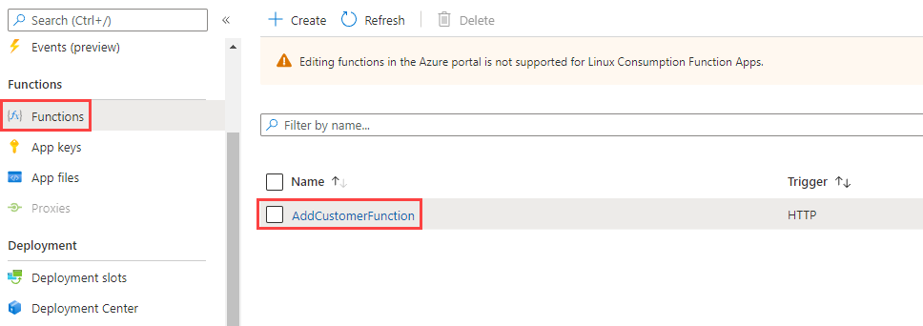
* This image demonstrates how to select the AddCustomerFunction from the Function App instance.
* On the **AddCustomerFunction** page, **Code + Test**. Then, select **Test/Run** to access the built-in testing interface
* Issue a simple GET request to the Function App endpoint.
* **NOTE** It is possible to use a *function key*, which is scoped to an individual Function App, or a *host key*, which is scoped to an Azure Functions instance.
* 
* This image demonstrates how to configure a GET request to the Function App endpoint from the Azure portal.
* The Function App should execute successfully, with logs indicating a successful connection to PostgreSQL Flexible Server
* 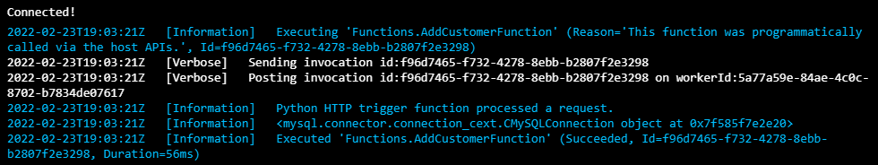
* This image demonstrates the logs of a successful Function App invocation.

## Troubleshooting

* If the Function App works locally, but fails in the cloud, ensure that the Azure environment is configured properly:
  + The requirements.txt file must reference the PostgreSQL Python connector
  + The Flexible Server instance must provide access to all Azure resources
  + The Azure Function Apps instance must be using extension version 4, as that is the what the local core tools support

# Deploy Azure Function App to Azure Kubernetes Service (AKS)

Function apps can be containerized and deployed to AKS. These steps will walk through this process so it can be applied later if this is something the architecture demands.

## Ensure Docker is started

* Open Docker Desktop, ensure that it is running.

## Setup AKS (KEDA)

* Open a new Visual Studio Code window to the C:\labfiles\microsoft-postgresql-developer-guide\Artifacts\06-03-FunctionApp-AKS folder
* Open a new terminal window, ensure that an AKS connection is present:

$resourceGroupName = "YOUR_RESOURCEGROUP_NAME";  
  
az aks install-cli  
  
az aks get-credentials --name "pgsqldevSUFFIX" --resource-group $resourceGroupName

* Run the following command to install KEDA on the AKS cluster:

kubectl create namespace keda  
  
func kubernetes install

## Ensure Docker Connection

1. Open the Azure Portal
2. Browse to the **pgsqldevSUFFIX** Azure Container Registry
3. Under **Settings**, select **Access keys**
4. Copy the username and password
5. In the terminal windows, run the following:

* docker login {acrName}.azurecr.io -u {username} -p {password}

## Configure Function App as Container

* Run the following command to setup the docker file

func init --docker-only --python

* Deploy the function app using the following, be sure to replace the function name and SUFFIX value:

func kubernetes deploy --name "addcustomerfunction" --registry "pgsqldevSUFFIX.azurecr.io"

* After following the above steps, the function app has been turned into a container and pushed to the target registry. It should also now be deployed to the AKS cluster in the keda namespace.

# Securing Azure Function Apps

In the previous function apps the connection information was embedded into the function app code. As was covered in the traditional deployment models, it is a best practice to remove this information and place it into Azure Key Vault. Here we will utilize the features of Azure to use Managed Identities to connect to the database.

**NOTE** This is currently only supported on Azure Database for Single Server.

## Enable PostgreSQL Microsoft Entra Authentication

* Switch to the Azure Portal
* Browse to the **pgsqldevSUFFIXflex16** Azure Database for PostgreSQL Flexible Server instance
* Under **Security**, select **Authentication**
* Ensure **Assign access to** is set to PostgreSQL and Microsoft Entra authentication
* Select **Add Microsoft Entra Admins**
* Select your lab credentials
* Select **Select**
* Select **Save**

## Create Managed Identity

* Browse to the **pgsqldevSUFFIX-addcustomerfunction** Function App
* Under **Settings**, select **Identity**
* For the **System assigned** identity, toggle to **On**
* Select **Save**, then select **Yes**
* Run the following to get the application id, replace the SUFFIX:

az ad sp list --display-name pgsqldevSUFFIX-addcustomerfunction --query [*].appId --out tsv

* Copy the value for later use

## Login to the Azure Database with Microsoft Entra credentials

* Switch to the **paw-1** virtual machine
* Create a file called c:\temp\GetAzADTOken.ps1 and paste the following into it:

If ($null -eq (Get-AzContext)) {  
 # User Account  
 Connect-AzAccount -WarningAction SilentlyContinue | Out-Null  
}  
   
$AzAccessTokenSplat = $null  
$AzAccessTokenSplat = @{  
 ResourceUrl = "https://ossrdbms-aad.database.windows.net"  
}  
   
$AzAccessToken = $null  
$AzAccessToken = Get-AzAccessToken @AzAccessTokenSplat  
   
$AzAccessToken.Token

* Open the pgAdmin
* Create a new server connection, right click **Servers**, select **Register**
* For the name, type **azureadPostgreSQL**
* For the hostname, type the DNS of the Azure Database for PostgreSQL Flexible Server (ex pgsqldevSUFFIXflex16.postgres.database.azure.com)
* For the username, type your user UPN (aka your email address for your lab account)
* Select the **Advanced** tab, for the password exec command, type:

powershell -file "C:\temp\GetAzADToken.ps1"

* For the password exec expiration, type 3480
* Select **Save**
* Right click the new server, select **Connect**

## Add MSI to Database

* Switch to the Azure Portal
* Browse to the `` Azure Database for PostgreSQL Flexible Server
* Under **Security**, select **Authentication**
* Select **Add Microsoft Entra Admin**
* Search for the APP_ID from above. Select it and the select **Select**
* Select **Save**
* The same could be performed using psql. From a psql connection, run the following, replace the APP_ID with the one copied from above:
* select * from pgaadauth_create_principal('APP_ID', false, false);

## Modify the code

* Open the C:\labfiles\microsoft-postgresql-developer-guide\Artifacts\06-04-FunctionApp-MSI function app folder in Visual Studio Code
* Add the following code to get an access token  password for the managed identity:
* from azure.identity import DefaultAzureCredential, AzureCliCredential, ChainedTokenCredential, ManagedIdentityCredential  
  managed_identity = ManagedIdentityCredential()  
  scope = "https://management.azure.com"  
  token = managed_identity.get_token(scope)  
  access_token = token.token
* Update the connection code to use the application id and the access token:
* # Connect to PostgreSQL  
   cnx = psycopg2.connect(database="postgres",  
   host="pgsqldevSUFFIXflex16.postgres.database.azure.com",  
   user="APP_ID",  
   password=access_token,  
   port="5432",  
   sslmode='require',  
   sslrootcert=crtpath)
* Run the following to deploy the updated Azure Function App:

func azure functionapp publish pgsqldevSUFFIX-addcustomerfunction --force --python

Browse to the function endpoint and see the data (the output of the previous command will include this information). The function app is now running as a managed identity and connecting to the database using that identity:

https://pgsqldevSUFFIX-addcustomerfunction.azurewebsites.net/api/addcustomerfunction?code=APPKEY

# Logic Apps with PostgreSQL

Logic Apps can be used to connect to Azure Database for PostgreSQL Flexible Server instances and perform actions such as SELECT, INSERT, DELETE and UPDATE. However, Logic Apps do not have any direct integrations that allow for triggers that fire from PostgreSQL DDL or DML events. In order for the PostgreSQL actions to connect to the PostgreSQL instance, it is necessary to install a Logic Apps Gateway. This can be done with Azure instances, but the Azure Database for PostgreSQL Flexible Server will need private endpoints enabled and the gateway will need to run in a virtual machine that can access that private endpoint.

## Create a Private Endpoint Flexible Server

* Open the Azure Portal
* Browse to the lab resource group
* Find the **pgsqldevSUFFIX-db** virtual network, take note of its region location
* In the top navigation menu, select **+Create**
* Search for **Azure Database for PostgreSQL Flexible Server**
* Select **Create**
* Under **Flexible Server**, select **Create**
* 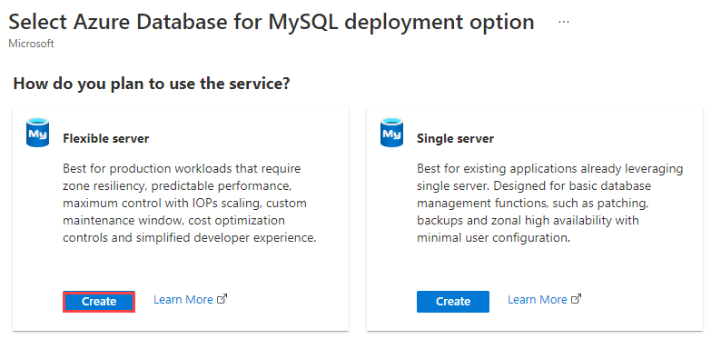
* This image demonstrates the first provisioning screen for Azure Database for PostgreSQL Flexible Server.
* Select the target subscription and resource group
* For the name, type **pgsqldevSUFFIXflexpriv**
* Select the resource group region (it must be in the region that the VNet is in)
* For **Workload type**, select **Development** to save costs
* For **Availability zone**, select **No preference**
  + Co-locating the VM and the Flexible Server instance will improve network performance, but it is not strictly necessary
* For the **PostgreSQL Version**, select **16**
* Do not enable high availability
* For the admin username, type **wsuser**
* For the password, type **Solliance123**
* Select **Next: Networking >**
* Select **Private access (VNet Integration)**
* Select the lab subscription
* Select the **PostgreSQLdev[SUFFIX]-db** vnet
* Select the **default** subnet, which is delegated to hold just Flexible Server instances
* 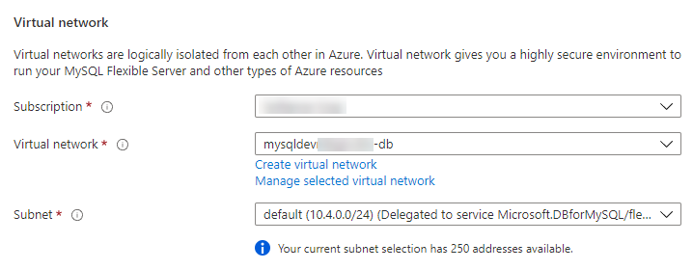
* This image demonstrates the Azure VNet integration.
* Select the **private.postgres.database.azure.com** private DNS zone
* Select **Review + create**
* Select **Create**
* Navigate to the new Azure Database for PostgreSQL Flexible Server instance
* Under **Settings** select **Server parameters**
* Search for the require_secure_transport setting
* Change the value to **OFF**
* Select **Save**
* 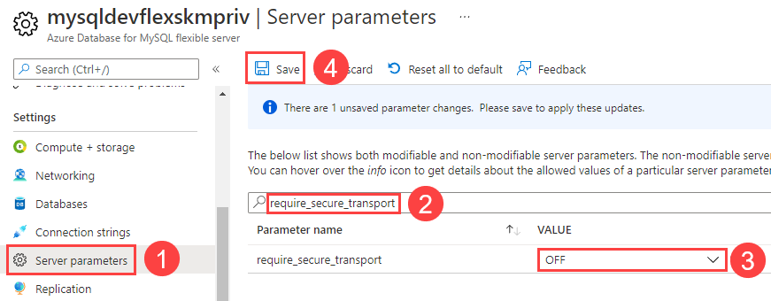
* This image demonstrates how to disable SSL transport for Flexible Server.

**NOTE** The Log App Gateway can currently only do non-SSL connections to PostgreSQL

**NOTE** It is also possible to use the Azure CLI [az PostgreSQL flexible-server create](https://docs.microsoft.com/cli/azure/PostgreSQL/flexible-server?view=azure-cli-latest#az-PostgreSQL-flexible-server-create) command to provision a Flexible Server instance in a virtual network.

## Private DNS - Virtual network link

Several private DNS Zones were created as part of the ARM template deployment, here it will be necessary to link those to the virtual networks so DNS resolution of private vnet and private endpoint resources become resolvable by other resources (such as virtual machines).

* Browse to the **private.postgres.database.azure.com** private dns zone
* Under **Settings**, select **Virtual network links**, notice an auto-created link (from the resource creation above)
* Select the **Overview** link
* Record the database IP Address for later use
* It can take some time for the DNS to become available, on the **paw-1** virtual machine
* Open the C:\Windows\System32\drivers\etc\HOSTS file in notepad++
* Add the following to the file:

10.4.0.6 pgsqldevSUFFIXflexpriv.private.postgres.database.azure.com

## Configure the new Flexible Server instance

* Switch to the **paw-1** virtual machine
* Open a command prompt window and enter the following command to initiate a connection to the Flexible Server instance. Provide Solliance123 as the password, when prompted. Be sure to replace the SUFFIX:
* "C:\Program Files\PostgreSQL\PostgreSQL Workbench 8.0 CE\PostgreSQL.exe" -h pgsqldevSUFFIXflexpriv.private.postgres.database.azure.com -u wsuser -p
* Create a new database, titled noshnowapp. Then, create a new table for orders. It is a simplified version of the table used by the Contoso NoshNow application.
* CREATE DATABASE noshnowapp;  
  USE noshnowapp;  
    
  CREATE TABLE orders (  
   id int NOT NULL AUTO_INCREMENT PRIMARY KEY,  
   name varchar(20) NOT NULL,  
   address varchar(80) NOT NULL  
  );

## Install the PostgreSQL .NET Connector

* Log in to the **pgsqldevSUFFIX-paw-1** virtual machine using **wsuser** and **Solliance123**
* [Download](https://go.microsoft.com/fwlink/?LinkId=278885) the connector
* Run the **PostgreSQL-installer…** installer
* Click through all the default values of all dialogs
* Select **Next**
* Select **Finish**

## Install the Logic Apps Gateway

* [Download](https://www.microsoft.com/download/details.aspx?id=53127) the Logic Apps Gateway
* Install the Logic Apps Gateway by running the **gatewayinstall.exe**
* Select **I accept the terms…** checkbox
* Select **Install**
* Enter the lab user email, then select **Sign in**
* When prompted, log in to the lab Azure account
* Select **Register a new gateway on this computer**
* Select **Next**
* For the name, type **gateway-PostgreSQL-SUFFIX**
* For the recovery key, type **Solliance123**
* Ensure that the region is the same as where the virtual network for the database instance is located
* Select **Configure**
* 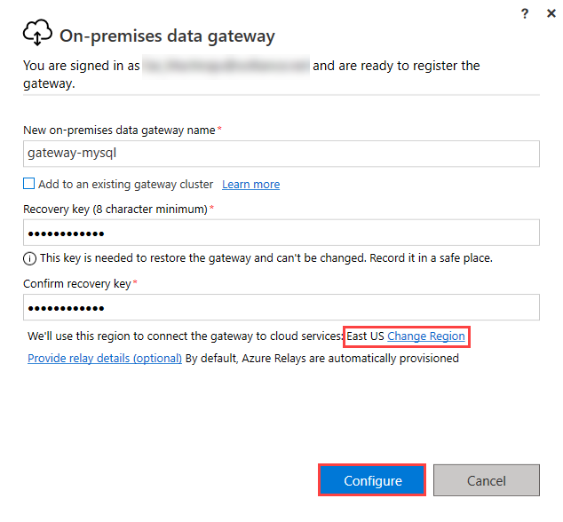
* This image demonstrates the configuration for the on-premises data gateway.

## Configure the Logic Apps Gateway

* In the **On-premises data gateway** dialog, select **Create a gateway in Azure**
* Select the subscription and the resource group
* For the name, type **logic-app-gateway**
* Select the region used above
* Select the **gateway-PostgreSQL-SUFFIX** gateway
* Select **Review + create**
* Select **Create**
* 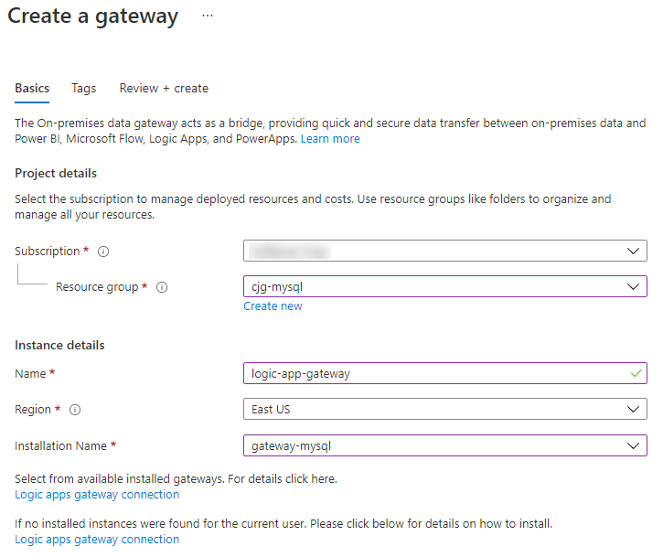
* This image demonstrates how to configure the on-premises data gateway Azure connection.

## Configure the Logic App

We have already created a Logic App that uses a timer trigger to check for new Orders in the database and then send an email.

### Configure deployed Logic App

* Browse to the **pgsqldevSUFFIX-logic-app**
* Under **Development Tools**, select **API connections**
* Select **office365**
* Under **General**, select **Edit API Connection**
* Under the **Display Name** to your lab user email address
* Select **Authorize**, login using the lab credentials
* Select **Save**
* Select the **azureblob** connection
* Under **General**, select **Edit API Connection**
* Enter the **pgsqldevSUFFIX**, azure storage account name and access key
* Select the **PostgreSQL** connection
* Under **General**, select **Edit API Connection**
* Enter the following information:
  + Server : pgsqldevSUFFIXflexpriv.private.postgres.database.azure.com
  + Database name : contosostore
  + Username : wsuser
  + Password : Solliance123
  + Gateway : gateway-PostgreSQL-SUFFIX
* Select **Save**

### Create a Logic App (Optional)

This step has already been done for you, but if you’d like to create the logic app from scratch the steps are provided here.

* Select **Blank template**
* For the trigger, select **Recurrence**. Keep the default values
* 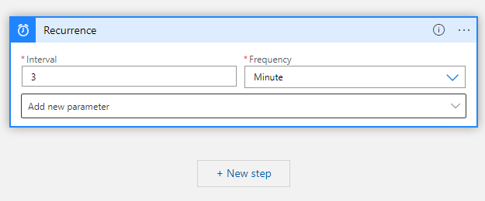
* This image demonstrates the recurrence trigger parameters for the Logic Apps instance.
* Select **+ New step**, search for **PostgreSQL**
* Select **Get Rows**
* Update the step variables:
  + For the name, type **PostgreSQLflex**
  + For the server, type **pgsqldevSUFFIXflexpriv.postgres.database.azure.com**.
* **Note** It may be necessary to put the private IP address if DNS resolution does not kick in in a reasonable amount of time.
  + For the database, type **noshnowapp**
  + For username, type **wsuser**
  + For password, type **Solliance123**
  + For the gateway, select **gateway-PostgreSQL-SUFFIX**
* Select **Create**
* For the table name, enter **noshnowapp.orders**
* Add the **Filter Query** and the **Select Query** parameters
* Set the following:
  + Filter Query = name eq 'John'
  + Leave Select Query blank
* Search for the **Office 365 Outlook : Send an email** action
* Select **Sign in**
* Sign in with the lab user credentials
* For the To, type the lab user email
* For the subject, enter **New Order Recieved**
* For the body, select **Add dynamic content**, then select **Current item**
* For the logic app, select **Save**

## Configure supporting items

### Add private endpoint to App Service

* Browse to the **pgsqldevSUFFIX-web** app service
* Under **App Service plan**, select **App Service plan**
* Under **Settings**, select **Scale up (App Service plan)**
* Select **Production** tab
* Select the **P1V2** pricing tier
* Select **Apply**
* Switch back to the app service
* Under **Settings**, select **Networking**
* In the **Inbound Traffic** section, select **Private endpoints**
* Select **Add**
* For the name, type **pgsqldevSUFFIX-web-pe**
* For the virtual network, select **pgsqldevSUFFIX-web**
* Select the **default** subnet
* Select **OK**
* Browse to the **pgsqldevSUFFIX-web** virtual network, record the new IP Address of the private endpoint.

### Set the Database Host

* Switch back to the main blade for the app service
* Under **Settings**, select **Configuration**
* Edit the app setting value for **DB_HOST** to the ip address recorded above.
* Select **Save**

### Add virtual network peering

* Browse to the **pgsqldevSUFFIX-web** virtual network
* Under **Settings**, select **Peerings**
* Select **+Add**
* For the name, type **web-to-db**
* For the peering link name, type **db-to-web**
* For the virtual network, select **pgsqldevSUFFIX-db**
* Select **Add**, after a couple minutes the link should to **Connected**
* Under **Settings**, select **Subnets**, ensure that a virtual network called **vnet-web-int**, if not create it
  + Select **+Subnet**
  + For the name, type **vnet-web-int**
  + Select **Save**

### Add VNet Integrate

* Browse back to the app service
* Under **Settings**, select **Networking**
* Under **Outbound Traffic**, select **VNet integration**
* Select **Add VNet**
* Select the **pgsqldevSUFFIX-web** virtual network
* Select the **vnet-web-int** subnet
* Select **OK**

### Add the lastOrder.txt file

* Browse to the **pgsqldevSUFFIX** storage account
* Select **Containers**, then select **logicapp**
* Upload the **lastOrder.txt** file

## Test Trigger

* On the **paw-1** virtual machine
* Add the following to the hosts file:

10.3.0.4 PostgreSQLdev-app-web.azurewebsites.net  
10.3.0.4 PostgreSQLdev-app-web.scm.azurewebsites.net

* Open a new Chrome browser window
* Browse to the Contoso Store app service - https://PostgreSQLdev-app-web.azurewebsites.net/
* Create a new order
* Browse to Outlook Online (https://outlook.office.com), wait for 5 minutes for an email to show up with the order details.

# Azure Data Factory with PostgreSQL

## Setup

## Create Linked Services

* Switch to the Azure Portal, browse to the **pgsqldevSUFFIX** Azure Data Factory instance
* Select **Launch Studio**
* In the left navigation, select the **Manage** tab
* Select **Linked servics**, select the **+ New** button
* For the type, select **Azure Database for PostgreSQL**, then select **Continue**
* For the name, type **ContosoStore**
* For the account selection, select **From Azure Subscription**
* Select the subscription
* Select the **pgsqldevSUFFIXflex16** Azure Database for PostgreSQL Flexible Server server
* For the database name, select **ContosoStore**
* For the username, type **wsuser**
* For the password, type **Solliance123**
* For the encryption methods, select **RequestSSL**
* Select **Test connection**, ensure that a success message is displayed.
* Select **Create**
* Select **Linked services**, select the **+ New** button
* For the type, select **Azure Data Lake Storage Gen2**
* Select **Continue**
* For the name type **AzStorage**
* Select the subscription
* Select the **pgsqldevSUFFIX** storage account
* Select **Create**

## Create Dataset (PostgreSQL)

* Seelct the **Author** tab
* Select the **+** button, then select **Data Set**
* For the type, select **Azure Database for PostgreSQL**
* Select **Continue**
* For the name, type **orders_database**
* For the linked service, select **ContosoStore**
* For the table name, select **public.orders**
* Select **OK**

## Create Dataset (Storage)

* Select the **+** button, then select **Data Set**
* For the type, select **Azure Data Lake Storage Gen2**
* Select **Continue**
* For the data format, select **JSON**
* Select **Continue**
* For the name, type **orders_storage**
* For the linked service, select **AzStorage**
* For the file system, type **orders**
* Select **OK**

## Create a Pipeline

* Select the **+** button, then select **Pipeline->Pipeline**
* On the right dialog, for the name, type **PostgreSQL_to_storage**
* In the middle navigation, expand **Move & transform**
* Drag the **Copy data** activity to the design surface
* In the **General** tab on the bottom middle, for the pipeline name, type **PostgreSQL_to_storage**
* Select the **Source** tab, then select the **orders_database** data set
* For the **Use query**, select **Query**
* Place the mouse in the text area, select **Add dynamic content**
* For the query text, type **select * from orders where created_at >= ‘@pipeline().parameters.LastCreateDate’**
* Select **OK**
* Select the **Sink** tab, then select the **orders_storage** data set
* Select the main pipeline canvas (click the white area around the copy data activity), then select **Parameters**
* Select **+ New**
* For the name, tyep **LastCreateDate**
* For the type, select **String**
* For the default value, type **@trigger().scheduledTime**

## Add a trigger

* In the top middle, select the **Add trigger** button
* Select **New/Edit**
* Select the **Choose trigger** dropdown, then select **+New**
* For the name, type **UserScheduleTrigger**
* For the recurrance, select **1 day**
* Select **OK**
* For the pipeline parameter value, type **@trigger().scheduledTime**
* Select **OK**

## Publish

* Select **Publish all**, in the dialog you should see four artifacts.
* Select **Publish**

## Test the pipeline

* In the middle top area, select the **Trigger (1)** button
* Select **Trigger now**
* For the LastCreateDate, type the begining of the current year (ex. 1/1/2024)
* Select **OK**
* Open a new browser window to the Azure Portal
* Browse to the **pgsqldevSUFFIX** storage account
* Under **Data storage**, select **Containers**
* Select the **orders** container
* Notice that a new file is created that contains the exported data.

# Azure Synapse Analytics with PostgreSQL

## Create PostgreSQL Linked Service

* Create a new Azure Synapse Analytics workspace
* Navigate to the **pgsqldevSUFFIX** Azure Synapce Analytics Workspace
* Under **Security**, select **Networking**
* Check the **Allow Azure services and resources to access this workspace** checkbox
* Select the **+ Add client IP**
* Select **Save**
* Select **Overview**, then n the **Getting started** area, select the **Open** link for Synapse Studio
* Login if prompted.
* Select the **Manage** tab
* Under **External connections** select **Linked services**
* Select **+ New**
* For the type, select **Azure Database for PostgreSQL**, select **Continue**
* For the name, type **ContosoStore**
* For the account selection, select **From Azure Subscription**
* Select the subscription
* Select the **pgsqldevSUFFIX** Azure Database for PostgreSQL Flexible Server server
* For the database name, type **ContosoStore**
* For the username, type **wsuser**
* For the password, type **Solliance123**
* Select **Test connection**, ensure a success message is displayed.
* Select **Create**

## Create PowerBI Workspace

* Open the Power BI Portal, https://powerbi.microsoft.com
* Sign in with your lab credentials
* In the left navigation, expand **Workspaces**
* Select **Create a workspace**
* For the name, type **PostgreSQL**
* Select **Apply**

## Create PowerBI Linked Service

* Switch back to Azure Synapse
* Select the **Manage** tab
* Under **External connections** select **Linked services**
* Select **+ New**
* For the type, select **Power BI**, select **Continue**
* For the name, type **PowerBI**
* Select the lab tenant
* Select the **PostgreSQL** workspace
* Select **Create**

## Create Integration Dataset

* Select the **Data** tab
* Select the **+** button
* Select **Integration Dataset**
* For the type, select **Azure Database for PostgreSQL**, select **Continue**
* For the name, type **ContosoStore_Orders**
* For the linked service **ContosoStore**
* Select **OK**
* Select **Publish all**, then select **Publish**

## Create PowerBI Desktop Report (Dataset)

* Switch to the **paw-1** virtual machine
* Open **Power BI Desktop**
* Select **Get data**
* Select **PostgreSQL database**
* Select **Connect**
* For the servername, enter **pgsqldevSUFFIXflex16**
* For the database, select **contosostore**
* Select **OK**
* Select the **Database** tab
* For the user name, type **wsuser**
* For the password, type **Solliance123**
* Select **Connect**
* Check all the checkboxes
* Select **Load**
* Select **File->Save as**, save the report to the desktop as **PostgreSQL**
* Select **Save**

## Publish the PowerBI report to Power BI Online

* Select **File->Publish**
* Select **Publish to Power BI**
* When prompted, login with your lab credentials
* Select the **PostgreSQL** workspace
* Select **Select**
* Select the **Open ‘PostgreSQL.pbix’ in Power BI** link
* Login using your lab credentials.
* Ensure the **PostgreSQL** workspace is selected
* Select the **PostgreSQL** semantic model
* In the **Tables** window, select the **public users** table
* Select **Create paginated report**
* Select **File->Save**, save the report as **Contoso Users**
* Select **Save**, the report should load in the synapse workspace.

## Create PowerBI Report in Azure Synapse

* Select the **Develop** tab
* Select the **+** button
* Select **Power BI report**
* Select the **PostgreSQL** data set
* Select **Create**
* In the **Data** window, expand the **contosostore categories** table
* Select the id, name and img fields.
* Select **File->Save as**
* Save the report as **Contoso Categories**
* Select **Save**, the report should load in the synapse workspace.

# Azure Batch with PostgreSQL

## Setup

* Create a Batch Service in Azure (one is created via the arm templates)
* Set the PostgreSQL instance to have private endpoint

## Configure Batch Service

* Browse to the Azure Portal
* Select the pgsqldevSUFFIX batch service
* Under **Features** select **Pools**
* Ensure a pool called **main** is displayed, if not create it.
* Select the **main** pool
* Under **Settings**, select **Scale**
* Modify the Target Spot/low-priority nodes to **1**
* Select **Save**
* Navigate back to the Azure Batch instance
* Under **Settings**, select **Identity**
* Select **System assigned**
* Select **Save**, in the dialog select **Yes**

## Create a Batch Job

* Under **Features**, select **Jobs**
* Select **+ Add**
* For the name, type **PostgreSQL_job**
* For the current pool, select the **main** pool
* For **ADVANCED SETTINGS**, select **Custom**
* Select the **Environment Settings** link
* Add the following environment variables:
  + DB_HOST = pgsqldevSUFFIXflex16.postgres.database.azure.com
  + DB_DATABASE = contosostore
  + DB_PORT = 5432
  + DB_USER = wsuser
  + DB_PASSWORD = Solliance123
* Select **Select**
* Select **OK**

## Create an application

* Zip the C:\labfiles\microsoft-postgresql-developer-guide\Artifacts\07-03-AzureBatch\applications folder, notice the contents
* Switch to the Azure Portal and the Azure Batch instance
* Under **Features** select **Applications**
* Select **+Add**
* For the name, type **app01_PostgreSQL**
* For the version, type **1.0.0**\*
* For the applciation package, browse to the zip file that was just created.
* Select **Submit**

## Create a Batch Task

* Under **General** select **Jobs**
* Select the new **PostgreSQL_job**
* Under **General**, select **Tasks**
* Select **+ Add**
* For the task id, type **main_01**
* For the display name, type **PostgreSQL_copy_orders**
* For the command line, type the following:
* powershell powershell -command ("(Get-ChildItem Env:AZ_BATCH_APP_PACKAGE_app01_PostgreSQL#1.0.0).Value" + '\applications\PostgreSQL_copy_orders.ps1')
* For the **User identity**, select **Pool autouser, Admin**
* Select **Application packages** link
* Select the **app01_PostgreSQL** package and version **1.0.0**
* Select **Select**
* Select **Submit**, after a few seconds, the state will show **Running**

## Review the job status

* Select the **main_01** task
* Review the results in the stdout.txt file, it should contain data, if no data is present, review the stderr.txt and fix any issues

## Setup Managed Identity (certificate)

The steps above utilize hardcoded values to gain access to the target database instance. It is possible to setup a managed identity with Azure Batch such that credentials can be retrieved at runtime using a managed identity of the Azure Batch node pool.

* On the **paw-1** virtual machine, run the following:

choco install openssl -y  
  
cd c:\temp  
  
$env:Path = [System.Environment]::GetEnvironmentVariable("Path","Machine") + ";C:\Program Files\OpenSSL-Win64\bin"  
  
openssl genrsa -out server.pem 2048  
  
openssl req -new -key server.pem -out server.csr

* When prompted, enter the requested information (press ENTER to select all the defaults)

openssl x509 -req -days 365 -in server.csr -signkey server.pem -out server.crt  
  
openssl pkcs12 -export -out certificate.pfx -inkey server.pem -in server.crt

* Enter the certificate password, **Solliance123**\*
* Run the following to create a service principal based on the certificate, be sure to replace the SUFFIX:

Connect-AzAccount  
  
Select-AzSubscription "SUBSCRIPTION_NAME";  
  
$certificateFilePath = "c:\temp\server.crt";  
$now = [System.DateTime]::Now;  
  
# Set this to the expiration date of the certificate  
$expirationDate = [System.DateTime]::now.Addyears(1);  
  
# Point the script at the cer file created $cerCertificateFilePath = 'c:\temp\batchcertificate.cer'  
$cer = New-Object System.Security.Cryptography.X509Certificates.X509Certificate2  
$cer.Import($certificateFilePath)  
  
# Load the certificate into memory  
$credValue = [System.Convert]::ToBase64String($cer.GetRawCertData())  
  
#create a new app registration...  
$newADApplication = New-AzADApplication -DisplayName "Batch Key Vault Access" -certValue $credValue -StartDate $cer.NotBefore -EndDate $cer.NotAfter  
  
# Create new AAD service principal that uses this application  
$newAzureAdPrincipal = New-AzADServicePrincipal -DisplayName $newAdApplication.AppId -CertValue $credValue -StartDate $cer.NotBefore -EndDate $cer.NotAfter;

* Run the following to grant permission to the new service principal:

Set-AzKeyVaultAccessPolicy -VaultName 'pgsqldevSUFFIX-kv' -ServicePrincipalName $newAzureAdPrincipal.AppId -PermissionsToSecrets 'Get'

* Get the needed information for the environment variables:

$thumbprint = $cer.Thumbprint  
$tenantId = $(Get-AzContext).Tenant.Id  
$appId = $newAzureAdPrincipal.AppId  
  
write-host "Thumbprint: $thumbprint"  
write-host "TenantId: $tenantId"  
write-host "AppId: $appId"

* Upload the PFX certificate to Azure Batch
  + Browse to the Batch instance
  + Under **Features**, select **Certificates**
  + Select **+Add**
  + Browse to the c:\temp\certificate.pfx file
  + Type the password, **Solliance123**
  + Paste the thumprint into the thumbprint textbox
  + Select **Create**, a dialog showing the certificate as **Active** should be displayed
  + Under **Features**, select **Pools**
  + Select the **main** pool
  + Under **Settings**, select **Certificates**
  + For the thumbprint, select the certificate thumbprint that was just created
  + For the store location, select **LocalMachine**
  + Select **Save**
  + Under **General**, select **Nodes**
  + Select the ellipses for the single node, select **Reboot**
  + Select **Reboot**, continue on with the next few steps

### Create Key Vault values

* Browse to the pgsqldevSUFFIX key vault
* Under **Settings**, select **Access Policies**
* Select **Add Access Policy**
* For **Key permissions**, select **Get** and **List**
* For **Secret permissions**, select **Get**, **List** and **Set**
* For the **Select principal**, select **None selected**
* Add your username
* Select **Save**
* Select **Add**
* Select **Secrets**
* Select **Generate/Import**, create the following secrets:
  + DB-PASSWORD = Solliance123
  + DB-SERVER = localhost
  + DB-USER = wsuser
  + DB-DATABASE = contosostore

### Create a new task with secure settings

* Navigate back to the Azure Batch instance
* Under **General**, select **Jobs**
* Select the **PostgreSQL_job**
* Under **General**, select **Tasks**
* Select **+ Add**
* For the task id, type **main_02**
* For the display name, type **PostgreSQL_copy_orders_secure**
* For the command line, type the following:
* powershell powershell -command ("(Get-ChildItem Env:AZ_BATCH_APP_PACKAGE_app01_PostgreSQL#1.0.0).Value" + '\applications\PostgreSQL_copy_orders_secure.ps1')
* For the **User identity**, select **Pool autouse, Admin**
* Select **Application packages** link
* Select the **app01_PostgreSQL** package and version **1.0.0**
* Select **Select**
* Select **Environment settings**, create the following replacing the values from the PowerShell window:
  + Batch_Thumbprint = {THUMBPRINT}
  + Batch_TenantId = {TENANT_ID}
  + Batch_AppId = {APP_ID}
  + Batch_VaultName = {pgsqldevSUFFIX-kv}
* Select **Submit**
* Select the **main_02** task
* Review the results in the stdout.txt file, data should be present, if there is no data, review the stderr.txt and fix any issues

# Push images to Azure Container Registry

1. If they haven’t already, push the images to the Azure Container Registry.

* $acrName = "pgsqldevSUFFIX";  
  $resourceGroupName = "";  
  $subscriptionName = "";  
    
  Connect-AzAccount  
    
  Select-AzSubscription $subscriptName;  
    
  $acr = Get-AzContainerRegistry -Name $acrName -ResourceGroupName $resourceGroupName;  
    
  $creds = $acr | Get-AzContainerRegistryCredential  
    
  $acrPassword = $creds.password;  
  $acrurl = $acr.loginserver;  
    
  docker login -u $ACRNAME -p $ACRPASSWORD $ACRURL  
    
  docker tag store-web "$ACRNAME.azurecr.io/store-web"  
    
  docker tag store-db "$ACRNAME.azurecr.io/store-db"  
    
  docker push "$ACRNAME.azurecr.io/store-web"  
    
  docker push "$ACRNAME.azurecr.io/store-db"

# Migrate the on-premises database

## pgAdmin

### Export the data

1. In the **paw-1** virtual machine, open **pgAdmin**
2. Connect to the local Postgres 16 instance using wsuser with Solliance123 password
3. Expand **Databases->ContosoStore**
4. Export the ContosoStore database
   1. Right-click the ContosoStore database, select **Backup…**
   2. For the filename, select the folder icon
   3. Type ContosoStore.backup, select **Save**
   4. On the **Objects** tab, select the public schema
   5. Select **Backup**

### Import the data

1. Connect to the target PostgreSQL instance
   1. Right-click **Servers**, select **Register->Server**
   2. For the hostname, type the dns of the Azure Database for PostgreSQL Flexible Server single server (ex pgsqldevSUFFIXflex16.postgres.database.azure.com)
   3. Switch to the Connection tab
      1. For the username, type **wsuser**
      2. For the password type **Solliance123**
      3. Toggle the **Save password?** button
      4. Select **Save**
2. Import the backup
   1. Expand the **pgsqldevSUFFIXflex16.postgres.database.azure.com->Databases->contosostore** nodes
   2. Right-click the **contosostore** node, select **Restore…**
   3. For format, select **Custom or tar**
   4. For the filename, select the folder icon.
   5. Select the C:\temp\ContosoStore\ContosoStore.backup file, then select **Open**
   6. Select **Restore**, after a few momemts, the database will be imported into Azure PostgreSQL

# Flexible Server deployment sample ARM template

## Create public network Flexible Server

Utilize the ARM template provided in this directory (PostgreSQL-flexible-server-template.json) to quickly deploy a PostgreSQL Flexible Server instance to Azure. When deploying, simply provider the serverName, administratorLogin, and administratorLoginPassword for the template to deploy successfully. It is possible to edit these values in the provided parameter file (PostgreSQL-flexible-server-template.parameters.json).

Once completed, use the Azure CLI to deploy the template.

az deployment group create --resource-group [RESOURCE GROUP] --template-file ./PostgreSQL-flexible-server-template.json --parameters @PostgreSQL-flexible-server-template.parameters.json

## Create private network Flexible Server

* Browse to the Azure Portal
* Select your lab resource group
* Select **Create**
* Search for **PostgreSQL**, then select **Azure Database for PostgreSQL Flexible Server**
* Select **Create**
* In the drop down, select **Flexible Server**
* Select **Create**
* Select your lab subscription and resource group
* For the name, type **pgsqldevSUFFIXflex**
* For the PostgreSQL version, select **16**
* For the admin username, type **wsuser**
* For the password and confirm password, type **Solliance123**
* Select **Next: Networking>**
* Select **Private Network access**
* Select the lab subscription
* Select the **pgsqldevSUFFIX-db** virtual network
* Select the **default** subnet
* For the private dns zone, select **private.postgres.database.azure.com**
* Select **Review + create**
* Select **Create**